TEACHER’S GUIDE

***Dogzilla* Narrative Curriculum Challenge**

Constructing a Dog Bone Slinger

**Disciplinary Area:** STEM  
  
**Grade Level:** 3rd Grade



**Literacy Connection**: *Dogzilla* by Dav Pilkey

**STEM Standards:**

**Next Generation Science Standards**

PS3.C Relationship between energy and forces

When objects collide, contact forces transfer energy so as to change the objects’ motions.

PS2.A Forces and motion

The effect of unbalanced forces on an object results in a change of motion. Patterns of motion can be used to predict future motion. Some forces act through contact, some forces act even when the objects are not in contact. The gravitational force of Earth acting on an object near Earth’s surface pulls that object toward the planet’s center.

**Standards for Technological Literacy**

Standard 6 - Students will develop an understanding of the role of society in the development and use of technology.

1. Products are made to meet individual needs and wants.
2. Because people’s needs and wants change, new technologies are developed, and old ones are improved to meet those changes.

Standard 7 - Students will develop an understanding of the influence of technology on history.

B. People have made tools to provide food, to make clothing, and to protect themselves

Standard 8 - Students will develop an understanding of the attributes of design.

1. The design process is a purposeful method of planning practical solutions to problems.

**Common Core State Math Standards**

Measurement & Data

* Represent and interpret data.
  + Generate measurement data by measuring lengths using rulers marked with halves and fourths of an inch. Show the data by making a line plot, where the horizontal scale is marked off in appropriate units— whole numbers, halves, or quarters.

Geometry

* Reason with shapes and their attributes.

**Common Core English Language Arts**

CCSS.ELA-Literacy.SL.3.1

Engage effectively in a range of collaborative discussions (one-on-one, in groups, and teacher-led) with diverse partners on grade 3 topics and texts, building on others' ideas and expressing their own clearly.

**“Big Ideas”:**

* role of brain storming to problem solve
* applied creative thinking for innovation
* interactions of matter and energy and the energy transformations effective use of resources as technology
* engineering design

**Essential Question:** How can you design a machine that will shoot a dog bone to keep Dogzilla’s puppies distracted from invading the town?

**Scenario:**   
The mice of Mousopolis have realized they need a new plan of attack in order to defeat the dreadful puppies who threaten to ruin their beautiful city and precious second annual barbeque cook-off. They thought up the idea of using a machine that will shoot dog bones as far away as possible so that the pups will chase them and never return. The only problem is that the mice don’t know how to build such an incredible machine. Help the mice by building them a machine that can fling dog bones as far away as possible from the city while still remaining easy enough for a mouse to operate. This should be done in groups of 4 using the resources available below. Be creative in your ideas and use your resources wisely. You must plan out your idea on the Brain Blast sheets before any materials will be passed out.

**Materials & Resources:** (assigned teams of 3-4)

(6) rubber bands        (2) sheets of paper        (1) clothes hanger 24”duct tape

(2) pencils/dowel rods (2) small cups        (4) plastic spoons    (2) cardboard pieces

*Additional found and recycled materials may be used with teacher permission.   
  
**Content Information:**

According to Newton’s first law of physics, an object in motion will stay in motion and an object at rest will stay at rest unless acted upon by an outside, unbalanced force.  This means that any object will not accelerate on its own or decelerate on its own. An object will actually resist change in its motion. It could be said that an object will keep on doing what it is doing. This tendency is called inertia. However, as stated earlier, an object will change its motion if acted on by an unbalanced force.

To understand an unbalanced force, we must know that there are always two forces acted upon an object at rest, gravity (the force that pulls all objects down towards Earth’s surface) and the force from the base of the object (such as the floor) pushing it up. These two forces are balanced and allow the object to stay at rest. Whenever a new force is introduced though, such as a push from the side, there is no force to compensate for it, or balance it out. Therefore, the force is unbalance and the object will move. This is also true when an object is in motion. This is why a ball that is rolling will eventually stop. The force of friction is acting upon the ball causing it to slow down.

(Source: <http://www.physicsclassroom.com/class/newtlaws/u2l1a.cfm>)

*Dogzilla* video: <https://www.youtube.com/watch?v=A5u96lvVB-g>   
  
**Deliverables:**  
In your designated groups, design and create a machine using the materials given that effectively shoots a dog bone as far as possible from the machine. Each design will be tested in a competition to see which machine would best be suited for the mice of Mousopolis.  
  
**Parameters:** The completed machine must:

* be capable of shooting a dog bone as far as possible from the machine
* be easy to operate
* be designed with the engineering design model in mind
* be turned in to instructor along with brain blast activity sheets, showing that the ideas were purposeful, thoughtful, and creative
* demonstrate the knowledge of force and motion through design

**Evaluation:**

**Constructing a Dog Bone Slinger Grading Sheet**

Machine Name: _______________________________

Group Members:_____________________________________________________________________________  
  
Assessment Criteria:

|  |  |
| --- | --- |
| 1) Machine was submitted along with Engineering Design Loop | _________/20 |
| 2) Machine demonstrated creative, thoughtful and intentional use of materials  to carry out design | _________/15 |
| 3) Students in group clearly and effectively presented their project to the class | _________/15 |
| 4) Machine shot the dog bone some distance across the room | _________/15 |
| 5) Machine was easy to operate | _________/10 |
| 6) Demonstrated understanding of learning; completed all activity sheets | _________/25 |
|  | Total___________/100 |

C:\Users\Pi Phi4\AppData\Local\Microsoft\Windows\Temporary Internet Files\Content.IE5\TSGQ5SLR\MC900187587[1].wmf

STUDENT’S GUIDE

Dog Bone Slinger Design Challenge

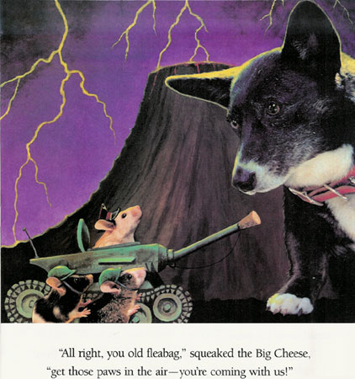

Situation:

The city of Mousopolis is in trouble once again now that Dogzilla’s puppies are free! The Big Cheese and all the other mice must find a new way to keep the puppies away from their precious city and of course the Second Annual Barbeque Cook-Off! They decide to create the incredible Dog Bone Slinger to run the pups far, far away from the city. The only problem is that the mice don’t know how to build it!

Challenge:

In your assigned engineering design team, you will help the mice design the most incredible Dog Bone Slinger. Using the design loop and the materials below, create a machine that is easy to operate and will fling dog bones as far away as possible from the city. Each team will be supplied with an additional piece of cardboard to use as a base. Your machine must be easily transportable, free-standing, and able to launch from the testing table.

Materials:

(6) rubber bands        (2) sheets of paper        (1) clothes hanger 24”duct tape (2)pencils/dowel rods (2) small cups        (4) plastic spoons    (2) cardboard pieces

*Additionally each team will be given a pair of scissors and a ruler. Tools may not be used as part of the solution to the problem.

Test:

1. Test out your solution and make any needed adjustments.
2. Once your design is at its very best, your group will present to the class
3. Then we will put all the designs to the test and see which group’s Dog Bone Flinger could shoot the bones the farthest away

*Engineering Design Loop*

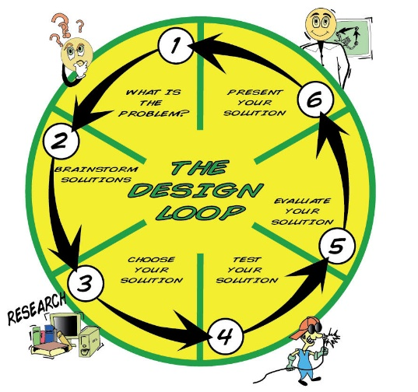

My Idea Sketch

Team Idea Sketch

What do you understand about energy and forces that contributed to your design? ______________________________________________________________________________________________________________________________________________________________________________________________________________________________________________________________________________

What do you know about shapes that contributed to your design? _____________________________________________________________________________________________________________________________________________________________________________________________________________________________________________________________________

What were your trial launch distances? 1.___________________________

2.___________________________

3.___________________________

How did my design work?

____________________________________________________________________________________________________________________________________________________________________________________________________________________________________________________________________________________________________________________

My Idea Sketch

What is the question asking? What are my parameters? _______________________________________________________________________________________________________________________________________________________________________________________________________________________________________________________________________________________

Sketch your final design or attach photo on backside of design loop!

What can I improve and share? ____________________________________________________________________________________________________________________________________________________________________________________________________________________________________________________________________________________________________________________________________________________________________________________________________________________________________________________________________________________________________________________________________________________________________________