ENGINEERING DESIGN JOURNAL
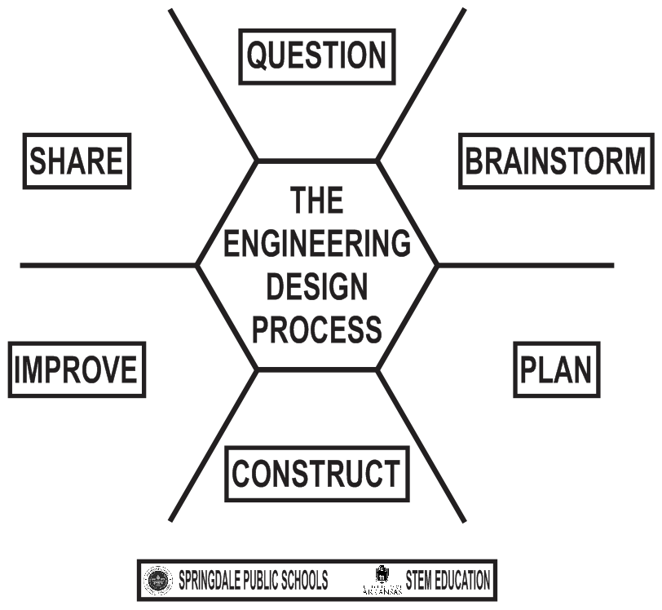

Name:

__________________________________________
Design Team Members:

__________________________________________
__________________________________________
Design Challenge:

__________________________________________

Identify the problem that you have been asked to solve? State the problem in your own words.
__________________________________________________________________________________________________
__________________________________________________________________________________________________
__________________________________________________________________________________________________
__________________________________________________________________________________________________

What questions do you need to ask in order to better understand the problem?

__________________________________________________________________________________________________
__________________________________________________________________________________________________
__________________________________________________________________________________________________
__________________________________________________________________________________________________

Analyze the constraints for the design challenge.

__________________________________________________________________________________________________
__________________________________________________________________________________________________
____________________________________________________________________________________________________________________________________________________________________________________________________

Conduct research.
What do you need to find out?

__________________________________________________________________________________________________
__________________________________________________________________________________________________
__________________________________________________________________________________________________
__________________________________________________________________________________________________

What did you find out?

__________________________________________________________________________________________________
__________________________________________________________________________________________________
__________________________________________________________________________________________________
__________________________________________________________________________________________________

Imagine what is possible. Generate as many ideas as possible

Make sketches

Choose the best solution. Sketch what you will build.

What tools and materials will you use?

__________________________________________________________________________________________________
__________________________________________________________________________________________________
__________________________________________________________________________________________________

Create your model.

NOTES:

How will you test your model?

__________________________________________________________________________________________________
__________________________________________________________________________________________________
__________________________________________________________________________________________________
__________________________________________________________________________________________________

Collect data from your test.

__________________________________________________________________________________________________
__________________________________________________________________________________________________
__________________________________________________________________________________________________
__________________________________________________________________________________________________

Analyze and interpret the data from your test.

__________________________________________________________________________________________________
__________________________________________________________________________________________________
__________________________________________________________________________________________________
__________________________________________________________________________________________________
How can you improve or modify your design?

__________________________________________________________________________________________________
__________________________________________________________________________________________________
__________________________________________________________________________________________________
__________________________________________________________________________________________________
Retest your model. How did your improvements and modification work?

__________________________________________________________________________________________________
__________________________________________________________________________________________________
__________________________________________________________________________________________________
__________________________________________________________________________________________________

What do you need to prepare before you present your design to others?

__________________________________________________________________________________________________
__________________________________________________________________________________________________
__________________________________________________________________________________________________
__________________________________________________________________________________________________

What questions do you think others will ask you about your design?

__________________________________________________________________________________________________
__________________________________________________________________________________________________
__________________________________________________________________________________________________
__________________________________________________________________________________________________

Prepare to defend your solution. What do you like about your design?

__________________________________________________________________________________________________
__________________________________________________________________________________________________
__________________________________________________________________________________________________
__________________________________________________________________________________________________

How could you make further improvements to your design/solution?

__________________________________________________________________________________________________
__________________________________________________________________________________________________
__________________________________________________________________________________________________
__________________________________________________________________________________________________

