Standards for Technological and Engineering Literacy: The Role of Technology and Engineering in STEM Education

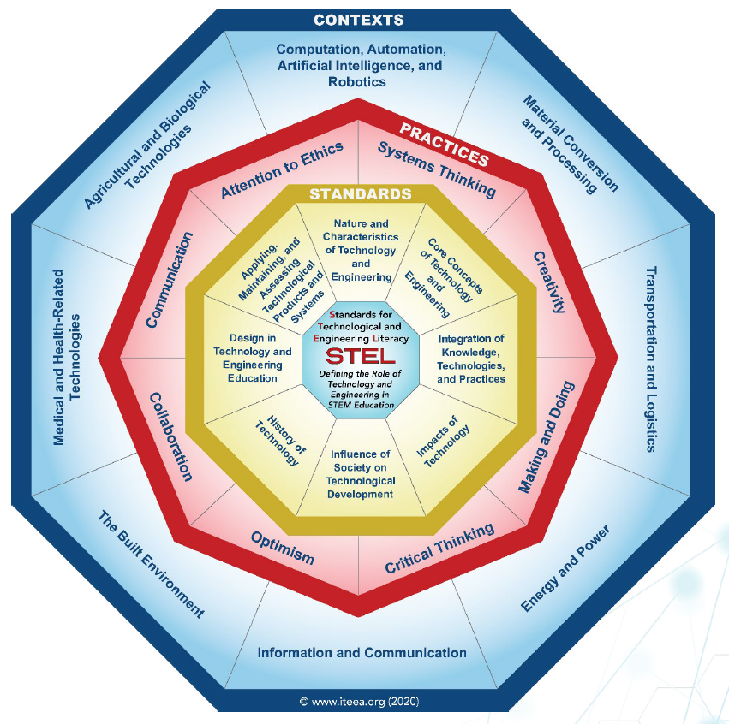

Standard 1: Nature and Characteristics of Technology and Engineering

Grades PreK-2
- Compare the natural world and human-made world.
- Explain the tools and techniques that people use to help them do things.
- Demonstrate that creating can be done by anyone.
- Discuss the roles of scientists, engineers, technologists, and others who work with technology

Grades 3-5
- Compare how things found in nature differ from things that are human-made, noting differences and similarities in how they are produced and used.
- Describe the unique relationship between science and technology, and how the natural world can contribute to the humanmade world to foster innovation.
- Differentiate between the roles of scientists, engineers, technologists, and others in creating and maintaining technological systems.
- Design solutions by safely using tools, materials, and skills.
- Explain how solutions to problems are shaped by economic, political, and cultural forces.

Grades 6-8
- Develop innovative products and systems that solve problems and extend capabilities based on collective needs and wants
- Compare and contrast the contributions of science, engineering, mathematics, and technology in the development of technological systems.
- Explain how technology and engineering are closely linked to creativity, which can result in both intended and unintended innovations.
- Apply creative problem-solving strategies to the improvement of existing devices or processes or the development of new approaches

Grades 9-12
- Explain how the world around them guides technological development and engineering design
- Assess how similarities and differences among scientific, mathematical, engineering, and technological knowledge and skills contributed to the design of a product or system.
- Analyze the rate of technological development and predict future diffusion and adoption of new technologies.
- Conduct research to inform intentional inventions and innovations that address specific needs and wants.
- Develop a plan that incorporates knowledge from science, mathematics, and other disciplines to design or improve a technological product or system.

Standard 2: Core Concepts of Technology and Engineering

Grades PreK-2
- Illustrate how systems have parts or components that work together to accomplish a goal.
- Safely use tools to complete tasks.
- Explain that materials are selected for use because they possess desirable properties and characteristics.
- Develop a plan in order to complete a task.
- Collaborate effectively as a member of a team.

Grades 3-5
- Describe how a subsystem is a system that operates as part of another, larger system.
- Illustrate how, when parts of a system are missing, it may not work as planned.
- Identify the resources needed to get a technical job done, such as people, materials, capital, tools, machines, knowledge, energy, and time.
- Describe the properties of different materials.
- Demonstrate how tools and machines extend human capabilities, such as holding, lifting, carrying, fastening, separating, and computing.
- Describe requirements of designing or making a product or system.
- Create a new product that improves someone’s life.

Grades 6-8
- Differentiate between inputs, processes, outputs, and feedback in technological systems.
- Illustrate how systems thinking involves considering relationships between every part, as well as how the system interacts with the environment in which it is used.
- Create an open-loop system that has no feedback path and requires human intervention.
- Create a closed-loop system that has a feedback path and requires no human intervention.
- Predict outcomes of a future product or system at the beginning of the design process.
- Compare how different technologies involve different sets of processes.
- Defend decisions related to a design problem.

Grades 9-12
- Demonstrate the use of conceptual, graphical, virtual, mathematical, and physical modeling to identify conﬂicting considerations before the entire system is developed and to aid in design decision making.
- Diagnose a flawed system embedded within a larger technological, social, or environmental system.
- Analyze the stability of a technological system and how it is inﬂuenced by all the components in the system, especially those in the feedback loop.
- Select resources that involve tradeoffs between competing values, such as availability, cost, desirability, and waste, while solving problems.
- Cite examples of the criteria and constraints of a product or system and how they affect ﬁnal design.
- Implement quality control as a planned process to ensure that a product, service, or system meets established criteria.
- Use management processes in planning, organizing, and controlling work.

Standard 3: Integration of Knowledge, Technologies, and Practices

Grades PreK-2
- Apply concepts and skills from technology and engineering activities that reinforce concepts and skills across multiple content areas.
- Draw connections between technology and human experiences.

Grades 3-5
- Demonstrate how simple technologies are often combined to form more complex systems.
- Explain how various relationships can exist between technology and engineering and other content areas.

Grades 6-8
- Analyze how different technological systems often interact with economic, environmental, and social systems.
- Apply a product, system, or process developed for one setting to another setting.
- Explain how knowledge gained from other content areas affects the development of technological products and systems.

Grades 9-12
- Analyze how technology transfer occurs when a user applies an existing innovation developed for one function to a different purpose.
- Evaluate how technology enhances opportunities for new products and services through globalization.
- Connect technological progress to the advancement of other areas of knowledge, and vice versa.

Standard 4: Standard 2: Impacts of Technology

Grades PreK-2
- Explain ways that technology helps with everyday tasks.
- Illustrate helpful and harmful effects of technology.
- Compare simple technologies to evaluate their impacts.
- Select ways to reduce, reuse, and recycle resources in daily life.
- Design new technologies that could improve their daily lives.

Grades 3-5
- Describe the helpful and harmful effects of technology.
- Judge technologies to determine the best one to use to complete a given task or meet a need.
- Classify resources used to create technologies as either renewable or non-renewable.
- Explain why responsible use of technology requires sustainable management of resources.
- Predict how certain aspects of their daily lives would be different without given technologies.

Grades 6-8
- Examine the ways that technology can have both positive and negative effects at the same time.
- Analyze how the creation and use of technologies consumes renewable and non-renewable resources and creates waste.
- Devise strategies for reducing, reusing, and recycling waste caused from the creation and use of technology.
- Analyze examples of technologies that have changed the way people think, interact, and communicate.
- Hypothesize what alternative outcomes (individual, cultural, and/or environmental) might have resulted had a different technological solution been selected.

Grades 9-12
- Evaluate ways that technology can impact individuals, society, and the environment.
- Critique whether existing and proposed technologies use resources sustainably.
- Assess a technology that minimizes resource use and resulting waste to achieve a goal.
- Develop a solution to a technological problem that has the least negative environmental and social impact.
- Evaluate how technologies alter human health and capabilities.

Standard 5: Influence of Society on Technological Development

Grades PreK-2
- Explain the needs and wants of individuals and societies.
- Explore how technologies are developed to meet individual and societal needs and wants.
- Investigate the use of technologies in the home and community.

Grades 3-5
- Determine factors that influence changes in a society’s technological systems or infrastructure.
- Explain how technologies are developed or adapted when individual or societal needs and wants change.

Grades 6-8
- Analyze how an invention or innovation was influenced by its historical context.
- Evaluate trade-offs based on various perspectives as part of a decision process that recognizes the need for careful compromises among competing factors.

Grades 9-12
- Evaluate a technological innovation that arose from a specific society’s unique need or want.
- Evaluate a technological innovation that was met with societal resistance, impacting its development.
- Design an appropriate technology for use in a different culture.

Standard 6: History of Technology

Grades PreK-2
- Discuss how the way people live and work has changed throughout history because of technology.

Grades 3-5
- Create representations of the tools people made, how they cultivated food, made clothing, and built shelters to protect themselves.

Grades 6-8
- Compare various technologies and how they have contributed to human progress.
- Engage in a research and development process to simulate how inventions and innovations have evolved through systematic tests and reﬁnements.
- Verify how specialization of function has been at the heart of many technological improvements.

Grades 9-12
- Relate how technological development has been evolutionary, often the result of a series of reﬁnements to basic inventions or technological knowledge.
- Verify that the evolution of civilization has been directly affected by, and has in turn affected, the development and use of tools, materials, and processes.
- Evaluate how technology has been a powerful force in reshaping social, cultural, political, and economic landscapes throughout history.
- Analyze how the Industrial Revolution resulted in the development of mass production, sophisticated transportation and communication systems, advanced construction practices, and improved education and leisure time.
- Investigate the widespread changes that have resulted from the Information Age, which has placed emphasis on the processing and exchange of information.

Standard 7: Design in Technology and Engineering Education

Grades PreK-2
- Apply design concepts, principles, and processes through play and exploration.
- Demonstrate that designs have requirements.
- Explain that design is a response to wants and needs.
- Discuss that all designs have different characteristics that can be described.
- Illustrate that there are different solutions to a design and that none are perfect.
- Differentiate essential skills of the technology and engineering design process.
- Apply skills necessary for making in design.

Grades 3-5
- Illustrate that there are multiple approaches to design.
- Apply the technology and engineering design process.
- Evaluate designs based on criteria, constraints, and standards.
- Interpret how good design improves the human condition.
- Apply universal principles and elements of design.
- Evaluate the strengths and weaknesses of existing design solutions, including their own solutions.
- Practice successful design skills.
- Apply tools, techniques, and materials in a safe manner as part of the design process.

Grades 6-8
- Illustrate the benefits and opportunities associated with different approaches to design.
- Apply the technology and engineering design process.
- Refine design solutions to address criteria and constraints.
- Create solutions to problems by identifying and applying human factors in design.
- Assess design quality based upon established principles and elements of design.
- Evaluate the strengths and weaknesses of different design solutions.
- Improve essential skills necessary to successfully design.

Grades 9-12
- Determine the best approach by evaluating the purpose of the design.
- Document trade-offs in the technology and engineering design process to produce the optimal design.
- Optimize a design by addressing desired qualities within criteria and constraints.
- Apply principles of human-centered design.
- Illustrate principles, elements, and factors of design.
- Implement the best possible solution to a design.
- Apply a broad range of design skills to their design process.
- Apply a broad range of making skills to their design process.

Standard 8: Applying, Maintaining, and Assessing Technological Products and Systems

Grades PreK-2
- Analyze how things work.
- Identify and use everyday symbols
- Describe qualities of everyday products.

Grades 3-5
- Follow directions to complete a technological task.
- Use appropriate symbols, numbers, and words to communicate key ideas about technological products and systems.
- Identify why a product or system is not working properly.
- Examine information to assess the trade-offs of using a product or system.

Grades 6-8
- Research information from various sources to use and maintain technological products or systems.
- Use tools, materials, and machines to safely diagnose, adjust, and repair systems.
- Use devices to control technological systems.
- Design methods to gather data about technological systems.
- Interpret the accuracy of information collected.
- Use instruments to gather data on the performance of everyday products.

Grades 9-12
- Use various approaches to communicate processes and procedures for using, maintaining, and assessing technological products and systems.
- Develop a device or system for the marketplace.
- Apply appropriate methods to diagnose, adjust, and repair systems to ensure precise, safe, and proper functionality.
- Synthesize data and analyze trends to make decisions about technological products, systems, or processes.
- Interpret the results of technology assessment to guide policy development.

