Hex Bug Nano-Bot Ultimate Maze Design Challenge
ASK What do we need to know to get started? What are we trying to accomplish?

Challenge: How can you engineer a Hex Bug Nano-Bot Ultimate Maze for a robotic bug to complete without your assistance (aside from turning it on) with the goal of including the most elements and completing the maze in the shortest time possible?
EXPLORE How are we going to complete the task? What materials will you use?

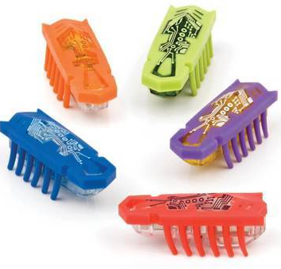
Criteria/Constraints
- Maze should include the following elements:
- Path of 'bug" at least 12 inches long
- Travel from start to finish without escaping or being touched
- Make at least 2 right angle turns (90 degrees)
- Make a sound it does not naturally make
- Elevation change (up, down, over, at least height of Hex Bug)
- Travel through a tunnel (at least length of Hex Bug)
Materials:
- Aluminum Foil (1 sheet or 6" X 6")
- Copy Paper (1 sheet)
- Construction Paper (1 sheet)
- Sticky Notes (5 notes)
- Craft Sticks (1 jumbo)
- Pipe Cleaners (1 regular)
- Empty Toilet Paper Rolls (2)
- Empty Paper Towel Roll (1)
- 1 Yard of Masking Tape
Tools (Not allowed in solution): Scissors, Ruler, Timer
MODEL Draw a technical sketch of your design. Make sure to label the materials. Carry out your plan and test your maze.
You have ______ minutes to brainstorm your design as a group. Once the ______ minutes is up, only those with a sketch that is labeled will be able to start to build the model that was created. You will have ______minutes to build and test your solution to the challenge.
Your Idea:

Your "1+1=3" Collaborative Idea:

EVALUATE Was it successful? Why or why not?

To test the design, make sure that your maze solution meets most of the following criteria. If you don't have all the boxes checked, please think about how to try to redesign your model to include what is missing.
Test Checklist:
- Path of 'bug" at least 12 inches long
- Travel from start to finish without escaping or being touched
- Make at least 2 right angle turns (90 degrees)
- Make a sound it does not naturally make
- Elevation change (up, down, over, at least height of Hex Bug)
- Travel through a tunnel (at least length of Hex Bug)
Draw a technical sketch of your FINAL design below.
Your Final Maze:

EXPLAIN: What was good about your maze design? What can you make better?

What piece of the maze demonstrates the most creativity? (GLOW!)

What is one area to improve? (GROW!)

What did you see that you liked in another group's design?

How could you change your design to make it even better?

