Geometric Creatures

We have been studying various geometric shapes. Think about the shapes you see in people and animals.

Design Challenge:
Create a two-dimensional creature that has a minimum of two moving parts.

Limitations/Constraints/Criteria: Your creature must have -
- At least 5 different shapes
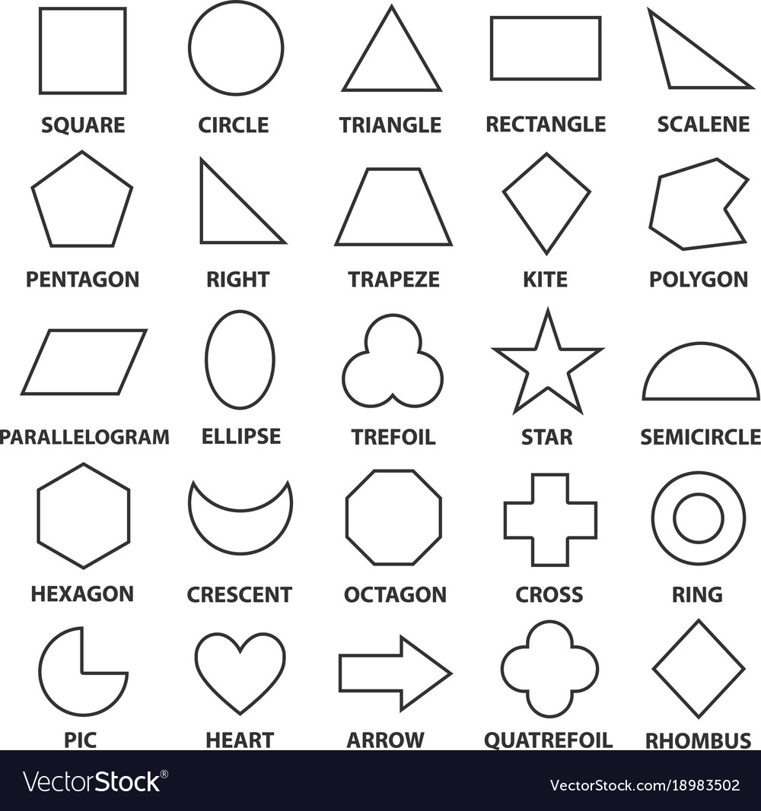
- No more than 20 shapes in total
- Two moving parts (levers, etc.)

Materials:
- Paper
- Glue stick/white glue
- 1 - paper fasteners
- 1 - paper clip
- 1 – craft stick
- String
- Crayons, markers, colored pencils

Tools:
- Crop-a-Dile or Hole punch
- Quick Cutter/saw for cutting wood
- Plyers for cutting metal
- Scissors for cutting paper and string
- Ruler

What’s Next:
Make up a story about your creature to share with the class!

Due _____________________

- Completed Geometric Creature (physical 2D model)
- Story describing your creature and presentation sharing the story and showing the function of your creature’s moving parts (Word or similar document – typewritten text).

