Not a Box Design Challenge!
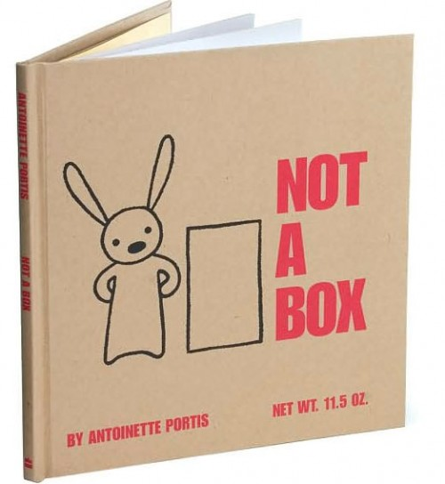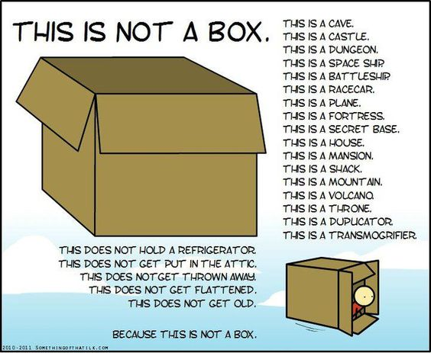
What do you see when you look at a box? Let your creativity roam and reimagine your box.
It’s not a box. It’s a ____________________.
Challenge:
Become inspired by children’s literacy by going to the library and checking out a children’s book. Based on the book that you find and inspired by, transform your box into a connection to the story.
Limitations/Constraints/Criteria:
- Use only the materials and tools listed below
- Must include decorations/accessories such as paper or cardboard cut with the laser (at least one decoration or accessory cut on the laser.

Materials:
- Box
- Additional cardboard, paper, cardstock
- Crayons, markers, colored pencils
- Materials from your making and tinkering toolbox/bag
- Miscellaneous decorative items (found or recycled) that you may have at home or that you have from the take-apart project.
Tools:
- Crop-a-Dile or Hole punch
- Canary Cutter
- Scissors
- Ruler

Due Date: Tuesday, January 30th. Bring the book with you to class along with your completed Not a Box design to share with the class.

