STEM 4043 Creativity and Innovation in STEM Education - Introduction Video Assignment (25 points)
Throughout the semester you may be required to share videos of your work with the instructor and the class. The most efficient way to do this is for you to create both a YouTube Channel and accompanying STEM 4043 or Creativity and Innovation Playlist that will be used to organize the videos that you submit for class. I will need to be able to access the link that you submit to Blackboard and I would suggest that you make your videos Unlisted.
If you need assistance with privacy settings or need more information - https://support.google.com/youtube/answer/157177?hl=en&co=GENIE.Platform%3DDesktop

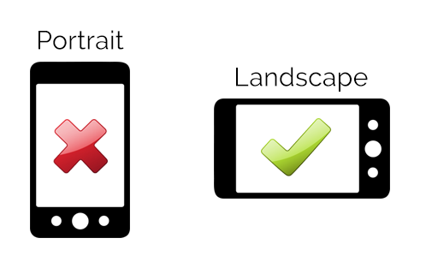
When you create a video using your phone, be sure that your phone is horizontal so that your video is recorded in landscape mode. Try to keep your videos short (1-2 minutes). You will need to save this video file to your phone or computer and then upload to the YouTube App on your phone or computer.

For this first assignment you will create a short video (1-2 minute) to introduce yourself. You will need to use a green or blue screen background to shoot your video. You can use one at home or use the green screens in the STEM lab. Then add pictures and videos related to your introduction.

I prefer to use iMovie on my phone, primarily because it is free and easy to use – here is a 2 minute video that can help you learn this simple process - https://www.youtube.com/watch?v=RKDAba4nsh0

You can also find step-by-step directions at Apple Support.

Your introduction video should include the following information –

Name

Hometown – Where are you from or where do you call home?

Tell us about yourself – special skills, hobbies, fun facts, etc. - what makes you – YOU!
- What do I need to know about you to help me be a better teacher for you this semester?

