3D Printing Technology Design Challenge (100 points) Name:

For this design challenge, each candidate will individually redesign your 2D geometric creature using both plane and solid geometric figures. Your geometric creature must stand by itself and have at least two moving parts.

Additionally your creature must:

Have at least 5 different plane shapes (typically used to decorate your creature – eyes, spots, etc.) However, you can create extruded geometry on your 3D shapes to include these design elements.

Have at least 3 different solid shapes (these must be 3D printed)

The 3D printed creature components must fit within the constraints of 10 cm X 10 cm X 2 cm or

in X in X in

See https://www.mathsisfun.com/geometry/ for examples of plane vs. solid geometry.

The 3D shapes must fit together with appropriate tolerances (we will discuss strategies for doing this in class).

Have two moving parts (using levers, pneumatics, pulleys, etc.)

The moving parts of your creature can be created with the addition of a variety of fasteners such as 3D printed parts that snap together and move, pen springs, etc. (no brads are allowed on this project).

Be freestanding

Be neat and attractive

Sketch two ideas for your geometric creature.

Sketch your best idea for your geometric creature in a perspective view.

*If you need more space to sketch you may use additional paper.
Now it is time to begin your CAD drawing.
- Complete your TinkerCAD drawing and begin 3D printing by exporting your .STL for printing.
*note – if class time does not allow for you to complete your print, you may need to arrange time to use the 3D printer during open lab hours. Additionally, we will discuss how you can check out a 3D printer from CMASE.
Grading Criteria – 100 points
- Completed all sketches with appropriate details (25 points)
- Designed figure within the given parameters/constraints (25 points)
- Completed assembly of the 3D printed creature and presentation to the class (50 points)

My Geometric Creature (100 points)
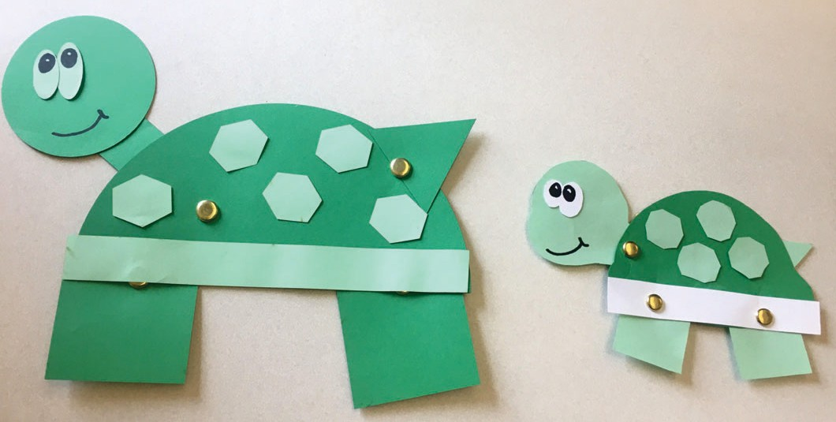
To conclude our on the Geometric Creature Project you will need to create a design in Canva with a document size of 8.5” X 11”. Next, use the text tool to copy and paste your creature story onto your design. Using the Elements tool feature draw a likeness of your creature. Additionally, you will upload images of your handmade geometric creature and your laser cut creature (made with cardboard). Finally, insert images of your 3D printed geometric creature into the document.
Submit your final work as a .PDF to Blackboard.
