A Bridge to Nowhere
Literacy Connections:


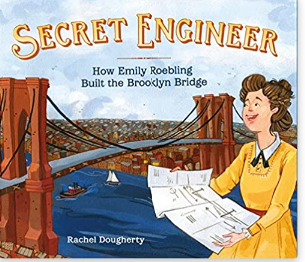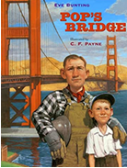
Introduction:
A cantilever is an architectural component widely used in the building industry. A cantilever is a beam anchored at only one end. The beam carries the load to the support where it is forced against by a moment and shear stress. Cantilever construction allows for overhanging structures without external bracing. Cantilevers are widely found in construction, notably in cantilevered bridges and balconies. One architectural application, is Frank Lloyd Wright's Fallingwater which used cantilevers to project large balconies.
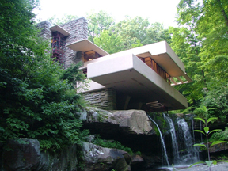
Another use of the cantilever is in fixed-wing aircraft design.
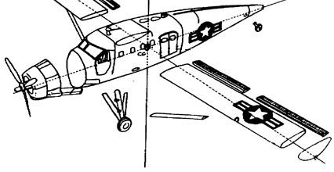

Design Challenge:
Working as a member of an engineering design team, design and build a cantilevered structure that will extend the furthest distance possible from a vertical surface that can support the weight of a golf ball.
Design Requirements:
Your team’s cantilever bridge must be fully supported from the vertical surface of a wall and must not touch the ground or floor.
Materials:
1 ft. - Masking Tape
2 - 8 ½ x 11 Sheets of Paper
1 ft. - Masonry Line (braided-string)
Tools:
Scissors and a writing instrument. These items may not be used as part of the final design.
(*Materials can only be applied to the surface of the wall and extended outward. The total horizontal distance of the structure away from the wall will be measured.)
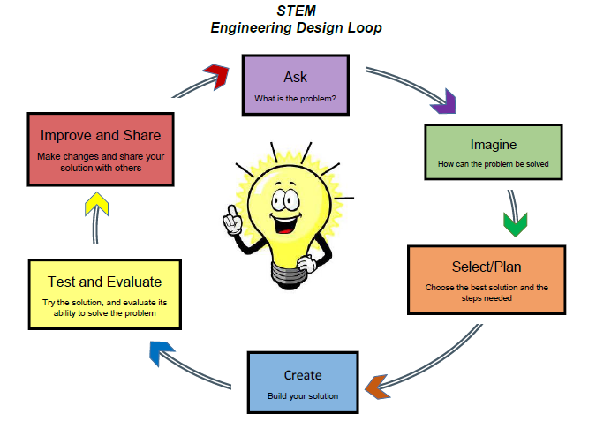
STEM DESIGN JOURNAL
Name:
Engineering Design Team Names:

What problem are you solving?

SELECT/PLAN the best solution and draw it here
IMAGINE how you can solve this problem—Draw two or three sketches
CREATE your solution—What materials will you use?
TEST your solution
Did you solve the problem?
IMPROVE & SHARE: How can you improve your solution?

What will you tell others about your solution (Present your solution to others)?

