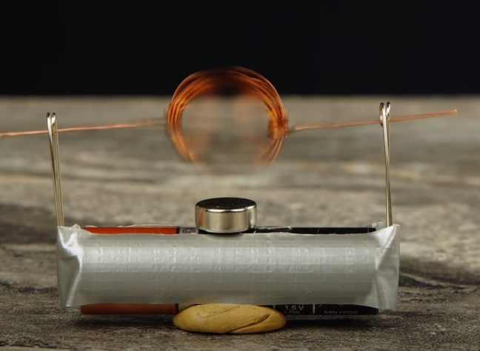
The Simplest Electric Motor
It's difficult to picture our modern world without electric energy. But do you know how to convert electricity into motion? It’s quite simple! Let's look at how to make the simplest electric motor.
https://www.youtube.com/watch?v=OKpmp7R6vBU
Equipment: AA battery, adhesive tape, clay (or sticky tack), two safety pins, neodymium magnet (or similar), copper wire, sandpaper.
- First, make an induction coil out of 18” of copper wire. Wind the wire tightly around an AA battery.
- Secure the coil by wrapping the ends of the wire through and around it several times (leaving an inch of wire protruding at 0 and 180 degrees).
- Use sandpaper to remove the upper half of the wire isolation on each end of the coil. Be sure to expose the same side of the wire on both ends.
- Use adhesive tape to fasten a safety pin on each pole of the battery.
- Attach the battery to a flat surface using clay.
- Place a neodymium magnet (or similar) on top of the battery.
- Thread the coil contacts through the loops in the safety pins. The coil starts spinning! The engine is running!
When the exposed sections of the coil touch the safety pins, the coil, battery, and pins together form a closed circuit that current can flow through. As current flows through the coil, it creates a magnetic field both inside and outside, turning the coil into an electromagnet. The interaction with the neodymium magnet's field causes the coil to rotate as it tries to reach a position of equilibrium. But as it turns, the circuit opens, and induction current runs through the coil in the opposite direction to the initial current. In other words, the polarity of the electromagnet, and its position of equilibrium change. The coil turns once more, and the contacts close again. The current switches directions again, back to the way it was. Due to the current's cyclical reversal in direction, the coil makes a full turn each time. This results in continuous rotation.
This is an example of the simplest electric motor, which somewhat reveals the basics of how electrical energy converts to mechanical energy.
Safety precautions: Do not leave the circuit closed for more than 1 minute! This may cause the battery to get hot and burn out!
Perform this experiment only under adult supervision.

