STEM 40303 Introduction to STEM Education – Introduction Video Assignment (25 points)

Throughout the semester you may be required to share videos of your work with the instructor and the class. The most efficient way to do this is for you to create both a YouTube Channel and accompanying STEM 40303 Playlist that will be used to organize the videos that you submit for class. I will need to be able to access the link that you submit to Blackboard and I would suggest that you make your videos Unlisted.
If you need assistance with privacy settings or need more information - https://support.google.com/youtube/answer/157177?hl=en&co=GENIE.Platform%3DDesktop

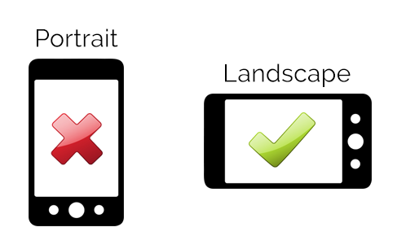
When you create a video using your phone, be sure that your phone is horizontal so that your video is recorded in landscape mode. Try to keep your videos short (1.5 - 2 minutes). You will need to save this video file to your phone or computer and then upload to the YouTube App on your phone or computer.

For this first assignment you will create a short video (1.5 - 2 minute) to introduce yourself.

Your introduction video should include the following information –

Name

Major and concentration

Hometown – Where are you from or where do you call home?

Tell me about yourself – special skills, hobbies, fun facts, etc. - what makes you – YOU!

What are your thoughts related to integrated STEM education?
- What do I need to know about you to help me be a better teacher for you this semester?

Introduction Video Assignment Rubric
Criteria | Exemplary (5 points) | Proficient (4 points) | Developing (2-3 points) | Needs Improvement (0-1 points)
Content: Personal Information | Clearly and creatively introduces name, major/concentration, and hometown with enthusiasm and clarity. | Includes name, major/concentration, and hometown adequately but without much detail. | Provides partial or unclear information about name, major, or hometown. | Omits key details or presents the information in a confusing or unclear manner.
Content: Personal Details | Shares engaging and thoughtful personal details (skills, hobbies, fun facts) that showcase personality. | Shares personal details but lacks depth or engagement. | Provides limited or vague personal details. | Omits or provides minimal and unclear personal details.
Content: STEM Education Thoughts | Offers insightful and thoughtful reflections on integrated STEM education. | Shares general but relevant thoughts about integrated STEM education. | Provides limited or unclear reflections on STEM education. | Omits or provides irrelevant or superficial thoughts about STEM education.
Content: Teacher Support | Clearly articulates specific and meaningful ways the instructor can support their learning. | Provides general or moderately clear suggestions for teacher support. | Offers vague or unclear suggestions for teacher support. | Omits or provides no information about how the instructor can help.
Video Quality | Video is clear, in landscape mode, with good lighting, sound, and professional presentation. | Video is in landscape mode with adequate lighting and sound. | Video is not in landscape mode or has noticeable lighting/sound issues. | Video quality significantly detracts from understanding or engagement.
Length | Video is within the 1.5–2-minute range, well-paced, and concise. | Video is slightly over or under the time limit but maintains clarity. | Video is too short/long, affecting clarity or engagement. | Video is far from the required length, significantly affecting the submission.
Technical Submission | Video is uploaded as unlisted to YouTube, with a functional playlist link submitted to Blackboard. | Video is uploaded and submitted but minor technical issues are present. | Video is uploaded but contains notable technical errors or omissions. | Video is not uploaded or submission link is non-functional.

