STEM 40403 Creativity and Innovation in STEM Education - Introduction Video Assignment (25 points)

Throughout the semester you may be required to share videos of your work with the instructor and the class. The most efficient way to do this is for you to create both a YouTube Channel and accompanying STEM 40403 or Creativity and Innovation Playlist that will be used to organize the videos that you submit for class. I will need to be able to access the link that you submit to Blackboard and I would suggest that you make your videos Unlisted.
If you need assistance with privacy settings or need more information - https://support.google.com/youtube/answer/157177?hl=en&co=GENIE.Platform%3DDesktop

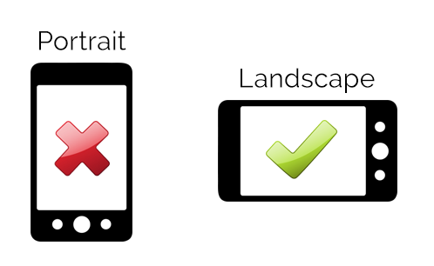
When you create a video using your phone, be sure that your phone is horizontal so that your video is recorded in landscape mode. Try to keep your videos short (2-3 minutes). You will need to save this video file to your phone or computer and then upload to the YouTube App on your phone or computer.

For this first assignment you will create a short video to introduce yourself to me. You will need to use a green or blue screen background to shoot your video. You can use one at home or use the green screens in the STEM lab. Then add pictures and videos related to your introduction.

I prefer to use iMovie on my phone, primarily because it is free and easy to use – here is a 2 minute video that can help you learn this simple process - https://www.youtube.com/watch?v=RKDAba4nsh0.

Another good tutorial can be found at - https://www.youtube.com/watch?v=C8575BjXd14

You can also find step-by-step directions at Apple Support.

At a minimum, your introduction video should include the following information –

Name

Hometown – Where are you from or where do you call home?

Tell me about yourself – special skills, hobbies, fun facts, etc. - what makes you – YOU!
- What do I need to know about you to help me be a better teacher for you this semester?

Introduction Video Assignment Rubric – STEM 40403 Creativity and Innovation in STEM Education (25 Points)

Criteria | Exemplary (5 points) | Proficient (4 points) | Developing (2-3 points) | Needs Improvement  (0-1 points)
Content: Personal Information | Clearly and creatively introduces name and hometown with enthusiasm and clarity. | Includes name and hometown adequately but without much detail. | Provides partial or unclear information about name or hometown. | Omits key details or presents the information in a confusing or unclear manner.
Content: Personal Details | Shares engaging and thoughtful personal details (skills, hobbies, fun facts) that showcase personality. | Shares personal details but lacks depth or engagement. | Provides limited or vague personal details. | Omits or provides minimal and unclear personal details.
Content: Teacher Support | Clearly articulates specific and meaningful ways the instructor can support their learning. | Provides general or moderately clear suggestions for teacher support. | Offers vague or unclear suggestions for teacher support. | Omits or provides no information about how the instructor can help.
Video Quality and Creativity | Uses a green/blue screen effectively with smooth integration of relevant pictures/videos that enhance the introduction. | Uses a green/blue screen with pictures/videos but lacks creativity or smooth editing. | Attempts to use a green/blue screen but with significant technical issues. | Does not use a green/blue screen or fails to incorporate any additional media.
Editing and Visual Appeal | Video is well-edited using tools like iMovie (or similar), with seamless transitions, clear visuals, and good pacing. | Video is edited with minor flaws in transitions, visuals, or pacing. | Video shows basic editing but with noticeable flaws or distractions. | Video is unedited or editing issues detract significantly from clarity.
Length | Video is within the 1.5–2-minute range, well-paced, and concise. | Video is slightly over or under the time limit but maintains clarity. | Video is too short/long, affecting clarity or engagement. | Video is far from the required length, significantly affecting the submission.
Technical Submission | Video is uploaded as unlisted to YouTube, with a functional playlist link submitted to Blackboard. | Video is uploaded and submitted but minor technical issues are present. | Video is uploaded but contains notable technical errors or omissions. | Video is not uploaded or submission link is non-functional.

