The Water Princess Engineering Design Challenge
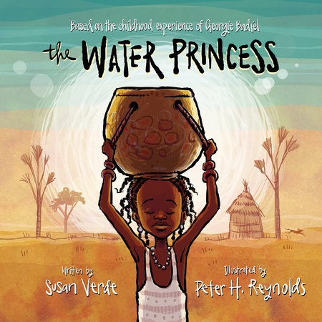
Scenario
In The Water Princess, Princess Gie Gie and her family live in a rural African village surrounded by a vast, dry landscape and few sources of water. In the village, obtaining water is a challenge. Every day, Gie Gie and her mother must walk a long way to a well and carry water in containers on their heads. Today, you are an ENGINEER who wants to solve this problem by making transporting water easier for Gie Gie and her family.
Challenge
Let’s help Princess Gie Gie. Working as members of an engineering design team, use KEVA planks to design and build a system that can transport water (represented by a marble) from one location to another. Your goal is to keep the water safe during the journey and move the water as far as possible.
Materials
Keva Planks – ping pong balls
Limitations
You may not touch the marble once it is released.
The ball must stay on/in your transportation system.
Test
- Transported the ball from a starting point toward the village.
- Kept the ball safely contained during its journey.
- Ball moved without being touched after it was released.
- Constructed only with Keva Planks.
Extension:
How could you extend this challenge for students to really transport water? What types of materials could you use? What tools would you need?

