A BALANCING ACT
STEM Design Challenge

Disciplinary Area: STEM

Unit: Energy, Power, and Transportation

Standards
- Common Core Math Standards (Geometry): Solve problems involving scale drawings of geometric figures, including computing actual lengths and areas from a scale drawing and reproducing a scale drawing at a different scale.
- Standards for Technological Literacy: Develop the abilities to apply the design process.
- ELA Common Core Standards (writing): Follow precisely a complex multistep procedure when carrying out experiments, taking measurements, or performing technical tasks, attending to special cases or exceptions defined in the text

“Big Ideas”
- Science is a process for producing knowledge
- Engineering is the application of science and technology
- Tools & techniques
- The role of creativity and problem solving
- Engineering design
- Design under constraint
- Fundamental concepts of science and technology

Essential Question: Can an attractive mobile be designed that will illustrate the relationships and differences between nature and technology?
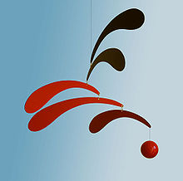
Scenario: It’s the first day of class and you’ve just finished a lesson on the relationship between the natural world and the human-made world. You were trying to teach the concept that Americans live in an increasingly artificial world made by humans and that they typically have a very limited exposure to nature. It’s clear that the students didn’t get the point, so you decide to design an art project that will clarify the point for the students. You decide to create a mobile that will clearly illustrate the relationship (and differences) between the natural world and the human-made world. The completed mobile will hand prominently in the classroom as a constant reminder.
Content: A mobile is a type of kinetic sculpture constructed to take advantage of the principle of equilibrium. It consists of a number of rods, from which weighted objects or additional rods hang. The objects hanging from the rods balance each other, so that the rods remain more or less horizontal. Each rod hangs from only one string, which gives it freedom to rotate around the string. Mobiles are often noted as one of the only art forms created in the United States. The meaning of the term "mobile" as applied to sculpture has evolved since it was first suggested by Marcel Duchamp in 1931 to describe the early, mechanized creations of Alexander Calder. At this point, "mobile" was synonymous with the term "kinetic art", describing sculptural works in which motion is a defining property. While motor or crank-driven moving sculptures may have initially prompted it, the word "mobile" later came to refer more specifically to Calder’s free-moving creations.
Influenced by the abstract work of Piet Mondrian, Joan Miro, and Sophie Taeuber-Arp, Calder in many respects invented an art form where objects (typically brightly coloured, abstract shapes fashioned from sheet metal) are connected by wire much like a balance scale. By the sequential attachment of additional objects, the final creation consists of many balanced parts joined by lengths of wire whose individual elements are capable of moving independently or as a whole when prompted by air movement or direct contact. Thus, "mobile" has become a more well-defined term referring to the many such hanging constructs Calder produced in a prolific manner between the 1930s until his death in 1976. A succinct definition of the term "mobile" in a visual art sense could be a type of kinetic sculpture in which an ensemble of balanced parts capable of motion are hung freely in space but which never come into contact with each other.

Materials and Resources (Per team of 2 candidates)
1. 1 – 3’ length of soft wire 6. Misc. natural materials
2. 8 – fishing swivels 7. 3 - Feet of string
3. Misc. paper/card stock 8. Dowel rods
4. Wire cutters/pliers 9. Misc. tape/paints
5. Misc. recycled materials 10. Hot glue gun/glue

Resource: Use the following website as a guide: http://bigredhat.com/art-info-05.html
Deliverables:
Using only the materials supplied by your instructor, you and your teammate must build a mobile that illustrates the differences and relationship between natural and human-made items.

Parameters: The completed mobile must:
- Reach a state of equilibrium when hung from the ceiling.
- Include at least three “limbs” on each side (although the sides need not be equal).
- Not exceed the following dimensions 3’ x 3’ x 3’ in size
- Clearly illustrate the relationship and differences between the natural and human-made world.
- Be designed using the engineering design model and include the brainstorming sheet and working drawings that illustrates how the mobile was designed.

Assessment:

Mobile Assessment Form
Team Name: ____________________________________________________________

Group Members: ________________________________________________________

Mobile Name: ___________________________________________________________

Scoring Criteria:

- _____ (0 – 20%) Completed mobile submitted with working drawings and brainstorming sheet that includes alternate ideas.

- _____ (0 – 20%) Completed mobile showed evidence of creative use of materials.

- _____ (0 – 30%) Mobile clearly illustrated the relationship/differences between natural and human-made world.

- _____ (0 – 20%) Team utilized the engineering design loop to solve the problem

- _____ (0 – 10%) Team adhered to the design parameters outlined above.

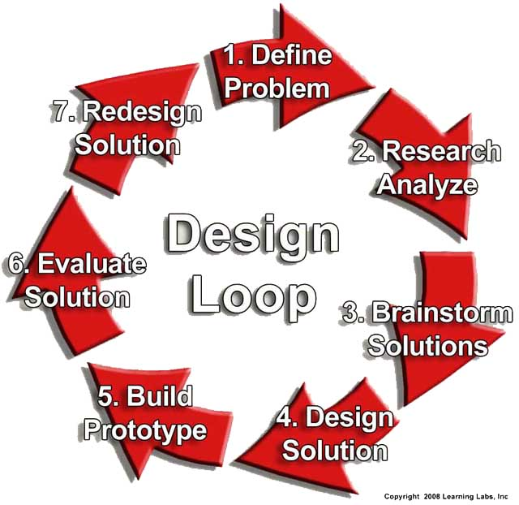
Brainstorming Sheet

Directions: Before your team starts construction of your mobile, conduct some Internet research and then conduct a brainstorming session where you attempt to identify at least four different potential solutions. Record those ideas below and submit this with your final product.

