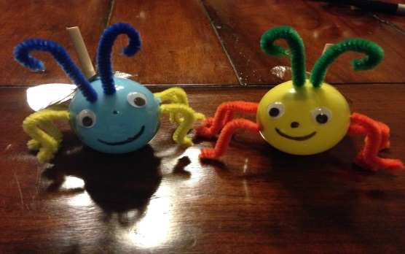
Unit: STEM - Basic circuits and electricity

Grade Level: 5

STEM Standards

SCIENCE:
Next Generation Science Standards 4-PS3-4, Apply scientific ideas to design, test, and refine a device that converts energy from one form to another
Arkansas Frameworks PS.7.4.3, Construct simple circuits from circuit diagrams

TECHNOLOGY/ENGINEERING:
Standards for Technological Literacy Standard 12, Students will develop the abilities to use and maintain technological products and systems
- Follow step-by-step directions to assemble a product.

MATH:
Common Core State Standards CCSS.MATH.CONTENT.5.MD.A.1, Convert among different-sized standard measurement units within a given measurement system, and use these conversions in solving multi-step, real world problems

ENGLISH/LANGUAGE ARTS
Common Core State Standards CCSS.ELA-LITERACY.RI.5.1, Quote accurately from a text when explaining what the text says explicitly and when drawing inferences from the text

Big Ideas:
- Understand simple circuits
- Understand how a switch works to complete a circuit
- Follow detailed instructions to complete an experiment

Essential Question: How can you create a glowing firefly using your knowledge of electricity and simple circuits?

Scenario: Circuit and Volt, best firefly friends, have lost their light. They are very sad, because the thing fireflies like to do most, as you can imagine, is light up. Today you will help restore Circuit and Volt’s lights. Follow the instructions to create a simple circuit to put the “fire” back in the firefly.

Challenge: After being introduced to basic circuits by the teacher and watching a short video, students will create a simple circuit firefly with a switch and test it to make sure it works.

Tools:
Drill Press | Scissors
Thumb Tacks | Erasers
Wood Cutter | Needle Nose Pliers
Single Hole Punch

Materials (per student):
Plastic Eggs (1) | Wooden Dowel Rod (1)
Pipe Cleaners (3- 2 for legs and 1 for antennas) | Coin Cell Batteries (3V- CR 2025)(1)
LED Light Bulbs (1)

Materials (Consumables):
Metallic Duct Tape | Masking Tape
Googly Eyes | Sharpies or Markers
Cardboard box pieces | Tacky Glue

Content Information:
- Introduce simple circuits to your class. The video at http://youtu.be/VnnpLaKsqGU is a great starting point! After watching with your class, define and explain the terms included in the Vocabulary section of this lesson.
- Using a battery and an LED light bulb, demonstrate to your students how touching the electrodes (the wires sticking out of the bulb) to the sides of the battery lights the bulb.
- Explain that each bulb will have a positive electrode and a negative electrode. Usually, the longer wire will be the positive, but this is not always the case. Because of polarity, the electrodes must be pressed to the correct sides of the battery or the bulb will not light.
- Introduce the situation to your students and explain that everyone will be building their own firefly to experience electrical circuits for themselves and cement their learning.
- Pass out supplies and facilitate bug making!

Vocabulary:
- Circuit- a pathway for the flow of electricity
- Current- the flow of electricity through a conductor
- Electrons- the negatively charged part of an atom
- Filament- the part of a light bulb that gets hot and makes light
- Conductor- a substance through which electricity will flow
- Insulator- a material that prevents flow of electricity; common insulators are plastic, rubber, glass, and air
- Electrode- the negative or positive part of an electric cell
- Polarity- the direction of an electric field; it will be either negative or positive
- Switch- a device used to interrupt the flow of electrons in a circuit

Circuit and Volt: Electric Fireflies
An Introduction to Circuits
Teacher Instructions

- Preparation: Prepare materials for class. An electric drill press will yield the best results, but it is possible to drill the eggs using a hand-operated drill press.
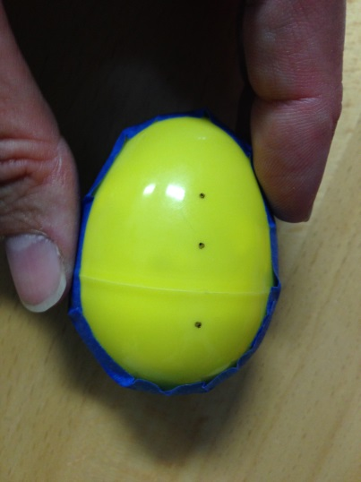
Each egg will need:
- 6 “leg” holes (3 on each side of the egg)
- 1 “switch” hole for the dowel rod to stick out of (on the top, slightly behind where the egg snaps together)
Leg holes
- 2 “antenna holes” (on the top, front of the egg).
  - It is easier to drill the eggs when they are stuffed with a piece of scrap paper and taped closed.
  - NOTE: We used a 1/16” drill bit for the pipe cleaner holes (legs and antennas), and a 1/4” drill bit for the dowel rod hole.

Circuit and Volt: Electric Fireflies
An Introduction to Circuits
Student Handout

Circuit and Volt, best firefly friends, have lost their light. They are very sad, because the thing fireflies like to do most, as you can imagine, is light up. Today you will help restore Circuit and Volt’s lights. Follow the instructions to create a simple circuit to put the “fire” back in the firefly.

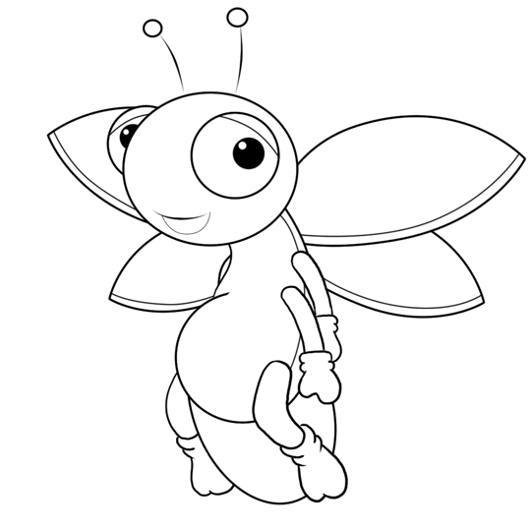
Thanks so much for helping us light up!
Your Friends,
Circuit and Volt

Instructions:
Plastic Eggs (1) | Wooden Dowel Rod (1)
Pipe Cleaners (3- 2 for legs and 1 for antennas) | Coin Cell Batteries (3V- CR 2025)(1)
LED Light Bulbs (1) | Cardboard box pieces
Shiny Silver Duck Tape | Masking Tape
Goggly Eyes | Sharpies or Markers
Tacky Glue | Scissors
Wood Cutters | Pliers
Single Hole Punch
- Gather the following supplies from your teacher:

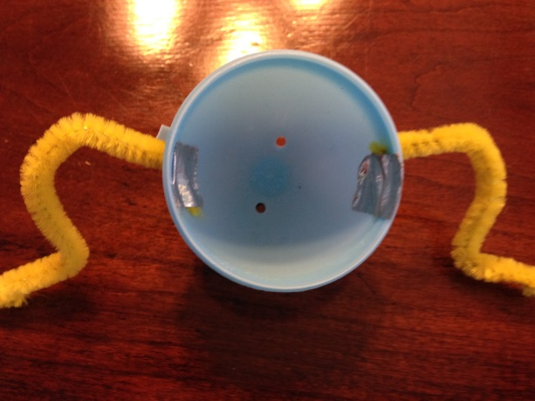
- Cut your pipe cleaners to length (2-3 inches) and put them through the leg holes to give your bug legs. Cut a longer piece for the antenna. You will thread this through the 2 antenna holes and curl the ends.

TIP:
Secure the legs inside the egg with a small piece of tape. This will make your legs more stable.
Fold the “foot” piece under with pliers to keep the sharp edge of the pipe cleaner from hurting someone!

- Test your LED light bulb to see which way it needs to go on the battery to light up.

- It’s time to start building your circuit! In the back half of the egg (the one with the big hole in top for your switch), carefully tape the sides of your battery to the egg. You will then slide the LED in with one wire under the battery, and one on top. You can push down on the top wire to make sure your bulb lights.
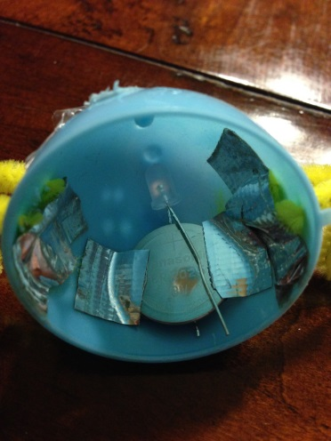

TIP:
Make sure you don’t tape over too much of the top surface of the battery. You want plenty of surface area for your top wire to make contact and your bug to light up!

- Cut a small circle out of your cardboard scraps. It should be about the size of your battery. This is part of your switch!

- Cut your dowel rod to 2.5- 3 inches long. Make sure you can insert it in the egg from the inside. If not, it is too long.

- Cut strips of tape and use them to tape the dowel rod to your cardboard circle.

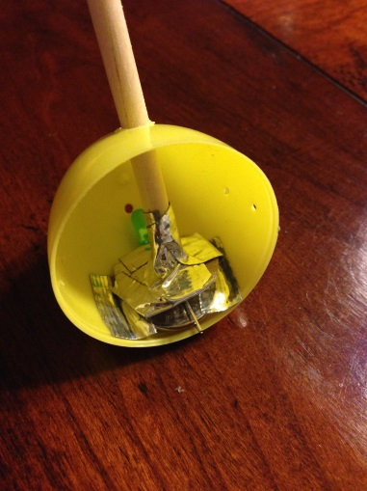 | 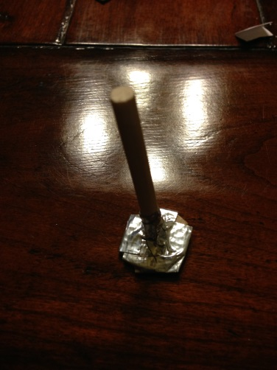
Tip: Your switch should look similar to this

- Insert the top of the switch through the hole in the top of your egg. It should line up so that it can be easily pressed down and make the light bulb light up. If pressing down on the switch does not easily light the bulb, you might need a small cardboard shim under your battery.
- Tape the sides of the switch to the sides of the egg. This will keep your switch from becoming misaligned and not working.

- Snap the two pieces of your egg together, making sure your bug legs are lined up.

- Attach googly eyes to your bug and draw on a happy face with your markers. You are almost there!

- Cut wings out of your shiny tape. First fold the tape over on itself so that the sticky sides stick together. Then cut out your wing shapes.
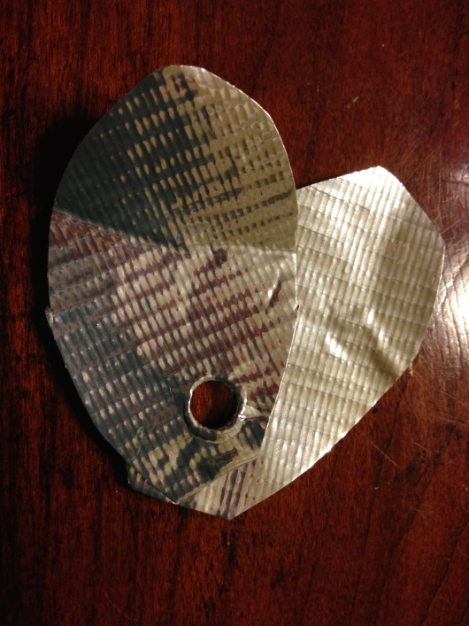
TIP:
After your wings are cut out, use a single hole punch to make a hole through them- this is where the switch will stick out of your egg. You can attach the wings to your egg with a tiny dab of tacky glue.

- Hold the egg in the palm of your hand and carefully press down on the switch to light up your firefly!
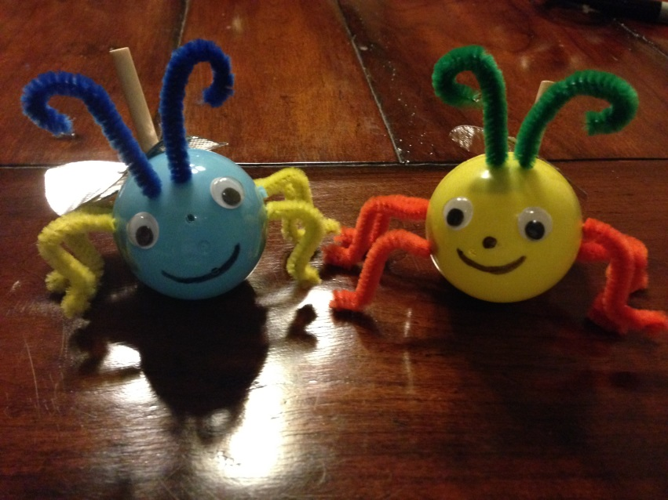

Circuit and Volt: Electric Fireflies
An Introduction to Circuits
Student Worksheet

- Why does pressing down on the switch cause the bulb to light up?
_________________________________________________________________________________________________________________________________________________________________________________________________________________________________

- How can you tell the difference from the positive (+) electrode and the negative (-) electrode on the LED light bulb?
_________________________________________________________________________________________________________________________________________________________________________________________________________________________________

- Did you find any errors in your work as you made your bug? If yes, how did you fix them?
_________________________________________________________________________________________________________________________________________________________________________________________________________________________________

Circuit and Volt’s Amazing Word Search
CIRCUIT | CONDUCTOR | CURRENT
ELECTRODE | ELECTRONS | FILAMENT
INSULATOR | POLARITY | SWITCH



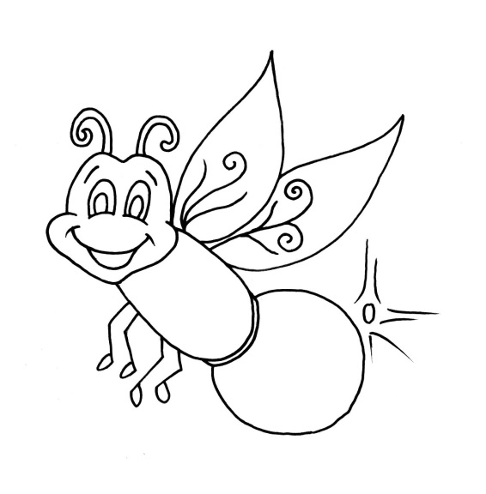
Fun Firefly Facts

- Fireflies, also called lightning bugs, are neither flies or
bugs.
- They are actually beetles!

- Fireflies are the world's most efficient light producers.
- Have you ever touched a light bulb that's been on for a while? If you did, you probably burned your finger! An average electric light bulb gives off 90% of its energy as heat, and only 10% as light. All 100% of the firefly’s energy goes into making light.

- Fireflies "talk" to each other using light signals.

- Firefly eggs glow.

- Not all adult fireflies flash.

- Firefly larvae feed on snails.

- Some fireflies are cannibals.

- Female fireflies sometimes mimic the flashes of other species.

- Firefly luciferase (the enzyme that releases their light) is used in all kinds of medical research.

- Some fireflies synchronize their flash signals.
Adapted from: http://insects.about.com/od/beetles/a/10-Cool-Facts-About-Fireflies.htm

Circuit and Volt: Electric Fireflies
An Introduction to Circuits

Evaluation and Assessment

Grading Rubric

Objective | Points awarded
Demonstrates knowledge of simple circuits (0-25pts): Student is able to describe how a simple circuit works and implement a switch into a circuit’s design.

Followed procedural instructions to complete experiment (0-25pts): Student is able to follow multi-step instructions to create a simple circuit with switch.

Effective use of tools (0-25pts): Student is able to use tools recommended in procedural instructions to complete given task.

Completion of provided handouts for evaluation (0-25pts): Student completed all questions and demonstrate knowledge and comprehension of simple circuits.

Total Points: ________/100

