Using an Engineering Journal

Having students use an engineering journal or portfolio is a great tool to help them stay on task, keep their research and planning ideas organized in one area, and provide a place for them to reflect on and evaluate their work. The components of an engineering journal would vary according to the teacher’s preferences, the grade level of the student and the complexity of the project. Listed below are possible components of an engineering journal for design and engineering projects.

        - State problem, criteria, constraints
        - Space for research/investigation notes
        - List of tools and materials
        - Outline of steps to follow
        - Brainstorming space
        - Final design sketch
        - Special worksheets (data collection)
        - Presentation organizer
        - Personal reflections
        - Redesign space and time
        - Assessment (teacher, student)

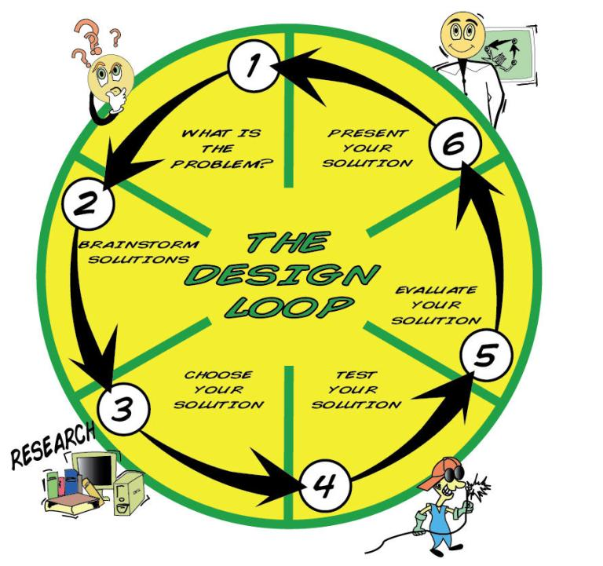
Name: __________________________

Date Started: ____/______/_____

Date Completed: ____/______/_____

Design Brief Title: ________________________________

- What is the problem?
What do I need to do?

- Brainstorm solutions –
What do I already know?

What do I need to find out?

What did I find out?

My First Ideas:

- Choose your solution:
My best idea is ……

The steps I will use:

The tools and materials I will use:

NOTES:

4. Test your solution

Thinking About My Idea

Name ______________

Design Title: ____________________

How did you test your solution?

How do you know if your idea works?

5. Evaluate your solution

How would you change your idea?

What did you learn?

What did you like about this project?

What did you not like about this project?

Prepare to present your solution
How Did I Do? | Points | Teacher | Student
I understood the problem I was to solve
I learned things to help me make my project
I made drawings to show my ideas
I solved the problem in a way new to me
My project followed the rules
I used materials and tools correctly
I wrote my ideas in my project notebook
I worked well with my group
My project was neat and attractive
My classmates could hear and see my presentation
I used my time wisely
Total

