Name: ________________________________ Date: __________________

Innovation and Invention

The Problem: Using your critical thinking skills, create a product using the provided materials, other found materials, and simple tools and fabrication techniques.

- How could I create a product using the provided materials, other found materials, and simple tools and fabrication techniques?
- What features from other familiar tools could be added to improve the product?
- How could I create more “curb appeal” for the product?
- What is the most people would pay for an improved product?

The Challenge: Work individually to create an improved product that incorporates the provided materials.

Resources: Provided materials, found materials or devices you can locate.

Limitations: Individuals will be required to remain within the following design parameters while completing the design challenge:

- Individuals must complete the four steps included in the Design Log (next page) prior to beginning construction.
- Individuals must provide typed responses to all of the questions outlined above and submit them with the completed design log and prototype.
- The prototype should be constructed in a neat fashion.
- You will complete the Design Log, construct the prototype, conduct a trial of the device, and record the data in the Invention Assessment Rubric.

Objectives: After completing the lesson, students will illustrate a greater understanding of the role of creativity in the development of new technologies.

Curriculum Standards: Standards for Technological Literacy (Stand. #6, #8)

Name: ________________________________ Date: __________________

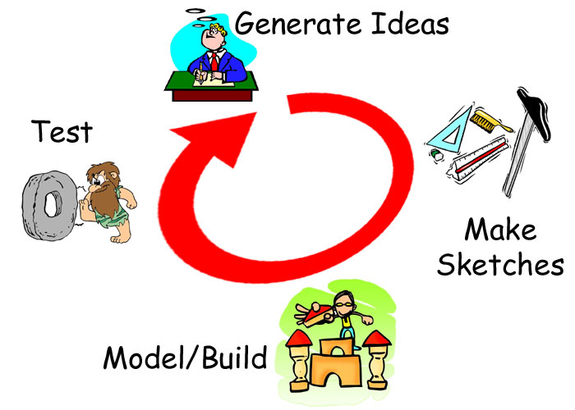The Design Log: Complete each of the steps outlined
below as you work to create a prototype.

Generate Ideas: Carefully consider
the challenge that you have been given.
Generate and record as many ideas as
possible during the limited time you
have been provided. Record your
initial ideas in the spaces below:

Sketches: Using the initial, create a final drawing that includes the best ideas from all of the initial ideas.

Modeling/Testing: Use the sketch (above) to construct the prototype. Test your product. After testing your prototype complete the Invention Assessment Rubric.

Name: ________________________________ Date: __________________

Invention Assessment Rubric

Rating: 5 = Excellent/1 = Needs Improvement

1. Completion of Design Log 5 4 3 2 1
2. Neatness of Final Product 5 4 3 2 1
3. Functionality of Final Product 5 4 3 2 1
4. Written Discussion Questions 5 4 3 2 1

Total Points: ____________________

Initial Questions

How could I create a product using the provided materials, found materials, simple tools, and fabrication techniques?

What features from other familiar tools could be added to improve the product?

How could I create more “curb appeal” for the product?

What is the most people would pay for an improved product?

