It’s a Minefield up Here


Grade Level: 3rd – 5th Grade
Unit: Scientific Inquiry and Engineering Design
Literacy: Professor Astro Cat’s Frontiers of Space by Dominic Walliman & Ben Newman
STEM Standards:
Next Generation Science Standards:
PS3.C Motion and Stability: Forces and Interactions
- When objects collide, contact forces transfer energy, which results in a change in the objects motion.
4-PS3-4 Energy:
- Apply scientific ideas to design, test, and refine a device that converts energy from one form to another.

Common Core Mathematics Standards:
Measuring & Data
- Represent and interpret data: generate measurement data by measuring lengths using rulers marked with halves and fourths of an inch.
- Express the length of an object as a whole number of length units.

Standards for Technological Literacy:
Standard 10: Students will develop an understanding of the role of troubleshooting, research and development, invention and innovation and experimentation in problem solving.
- Asking questions and making observations helps a person to figure out how things work.
- All products and systems are subject to failure. Many products and systems, however, can be fixed.
Standard 11: Students will develop the abilities to apply the design process.
- Brainstorm people's needs and wants and pick some problems that can be solved through the design process.
- Build or construct an object using the design process.
- Investigate how things are made and how they can be improved.

Big Ideas:
- Understanding types of energy and energy transfers
- Understanding Newton’s 1st law of physics
- Understanding how weight affects velocity
- Use scientific inquiry to adapt potential solutions for differing circumstances
- Use engineering design to solve technological problems

Essential Question: How can you build a space debris capture device that can be adapted to easily grasp space debris and then launch that debris on a trajectory to burn up in some planet’s atmosphere?

Scenario:
During a routine mining mission to an asteroid in the year 2052, your team of astronauts encounters a pesky piece of space junk. Your team will be making several trips through this sector and you’d like to remove this dangerous obstacle by capturing it and then thrusting it toward a nearby planet to burn up in that planet’s atmosphere. You only have one problem: You don’t know the exact mass, size or shape of the space debris. Build a space debris capture device that can be used to capture most any space junk so that it can be removed safely from your path.

Content Information:
During this STEM lesson, students will need to have background knowledge related to measurement (both length and mass) so that they will be able to accurately create a workable solution. The students will also need information related to Newton’s Laws, how energy can be transferred from one object to another and related content knowledge (see below). The students will be practicing the use of the engineering design process and scientific inquiry, if this is their first experience with these learning tools, prior coverage will be necessary. Students will also need to practice using gram scales prior to starting the design challenge.
Motion | The process of continual change in the physical position of an object.
Distance | The extent of space between two objects or places.
Friction | The force of friction acting on a rolling objects by the ground to slow it down.
Acceleration | The rate of change of velocity or speed with respect to time.
Velocity | The rate of speed of action. Velocity = Distance/Time
Law of conservation of energy | Energy can neither be created no destroyed; rather, it transforms form one form to another.
Energy | The strength required for sustained physical or mental activity.
Kinetic Energy | Energy that an object possesses by virtue of being in motion.
Potential Energy | Energy that is stored in an object due to its position relative to some zero position.
Newton’s First Law | An object at rest stays at rest and an object in motion stays in motion with the same speed and in the same direction unless acted upon by an unbalanced force.
Newton’s Second Law | The acceleration of an object as produced by a net force is directly proportional to the magnitude of the net force, in the same direction as the net force, and inversely proportional to the mass of the object.
Force | Strength or energy as an attribute of physical action or movement.
Since the dawn of the space race, humans have encountered increasing challenges as they have struggled to explore our solar system and beyond. Some of those challenges are presented by the very nature of the vacuum of space. Space is simply more hostile to human life than anything on the surface of the earth. Unfortunately, as we expand our exploration of space, we add to the risks associated with space exploration by leaving behind space debris. Space debris is a very real and life threatening problem for manned space exploration and can quickly end unmanned space exploration. The US Space Surveillance Network routinely monitors 17,000 objects orbiting the earth—each at least the size of a softball. These objects rotate around the earth at speeds of more than 17,500 mph. If you count pieces under 10 centimeters, it’s closer to 500,000 objects. Launch adapters, lens covers, even a fleck of paint can punch a hole in critical systems.
Whipple shields—layers of metal and Kevlar—can protect against the small pieces, but nothing can save a space vehicle from an entire satellite. Some 4,000 orbit Earth, most dead in the air. NASA Mission control avoids dangerous paths, but tracking isn’t perfect (Leckie, 2016).
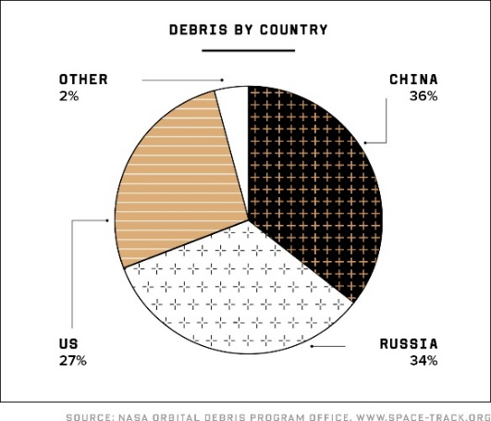
Retrieving satellites and bringing them back to earth isn’t realistic—it would take a whole mission to capture just one and blowing them up would create even more space debris. By international agreement, newly launched satellites must be designed to fall out of orbit on their own. They’ll jettison extra fuel, then use rocket boosters or solar sails to angle down and burn up on Earth reentry. Without such decommissioning programing, you get the Kessler syndrome: One collision leads to more collisions until there’s so much debris in space that no one can fly at all (Schartz, 2010; Kehe, 2016). So, perhaps these decommissioning protocols will prevent future space littering, but it doesn’t remove the 500,000 objects currently orbiting the Earth. Maybe, in the future space explorers will be able to easily capture space debris and launch them on a trajectory to burn up in some planet’s atmosphere. Possibly, you’ll design that system.

Design Challenge
Design a scale model of an experimental debris capture device that can be adapted to grasp, capture, and retrieve floating objects regardless of mass, diameter, length, or surface characteristics. The device must be capable of being adapted for varying circumstances (i.e., a large heavy object will have to be maneuvered differently than a tiny lightweight object).

Teacher Preparation
After discussing content (above), practicing using measuring tools and gram scales, then reading Professor Astro Cat’s Frontiers of Space by Dominic Walliman & Ben Newman, place the students in small design teams and set up the testing apparatus (see diagram 1). The students will have to use engineering design and scientific inquiry to design a device that can adapt to given situations presented by the teacher at the last minute. Design teams should utilize the engineering
design loop to design the debris capture device, and then use scientific inquiry to plan for deferent potential scenarios. During testing, each team will be presented with three different
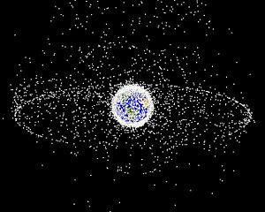
samples of space debris that they must capture and retrieve. The three samples should vary in mass, length, diameter, and surface characteristics. During testing teams will have five minutes to reconfigure their debris capture device after being provided with each sample of space debris. They will then have an additional five minutes to capture the debris. The team that successfully captures all three samples will be successful.

Figure 2. Computer generated image of space debris

Materials & Equipment

Quantity | Description
1 per class | Testing apparatus (see diagram 2)
1 per team | 1 testing dowel (with press fir connection for the testing apparatus)
3 per team | 3 space debris samples made from aluminum foil (see diagram 1)
1 per team | 12” x 12” corrugated cardboard
1 per team | Empty plastic water bottle
1 per team | 12” of flexible wire
1 per team | 12” of woven cotton string
1 per team | 12” of Duct tape
3 per team | 6” Pipe cleaners
3 per team | Tongue depressors
3 per team | Large rubber bands
1 per team | Additional materials: mouse trap, clothes pin, paper clips, paper cup, paper plate, and additional recycled/repurposed materials as needed
1 per team | Miscellaneous tools: Scissors, wire cutters, hot glue gun, needle nose pliers, gram scales

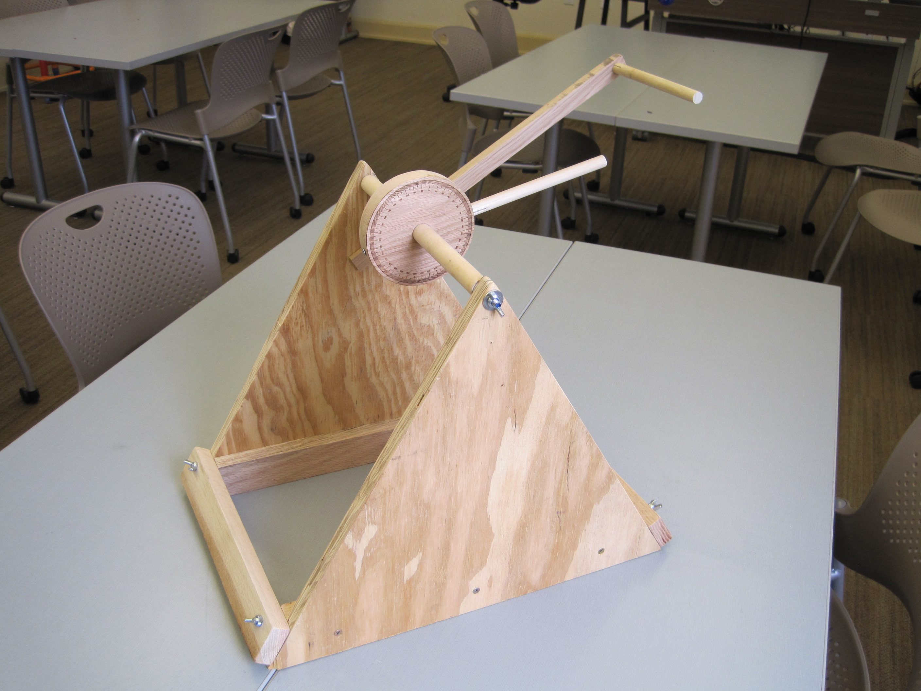
Diagram 2. Homemade testing apparatus.

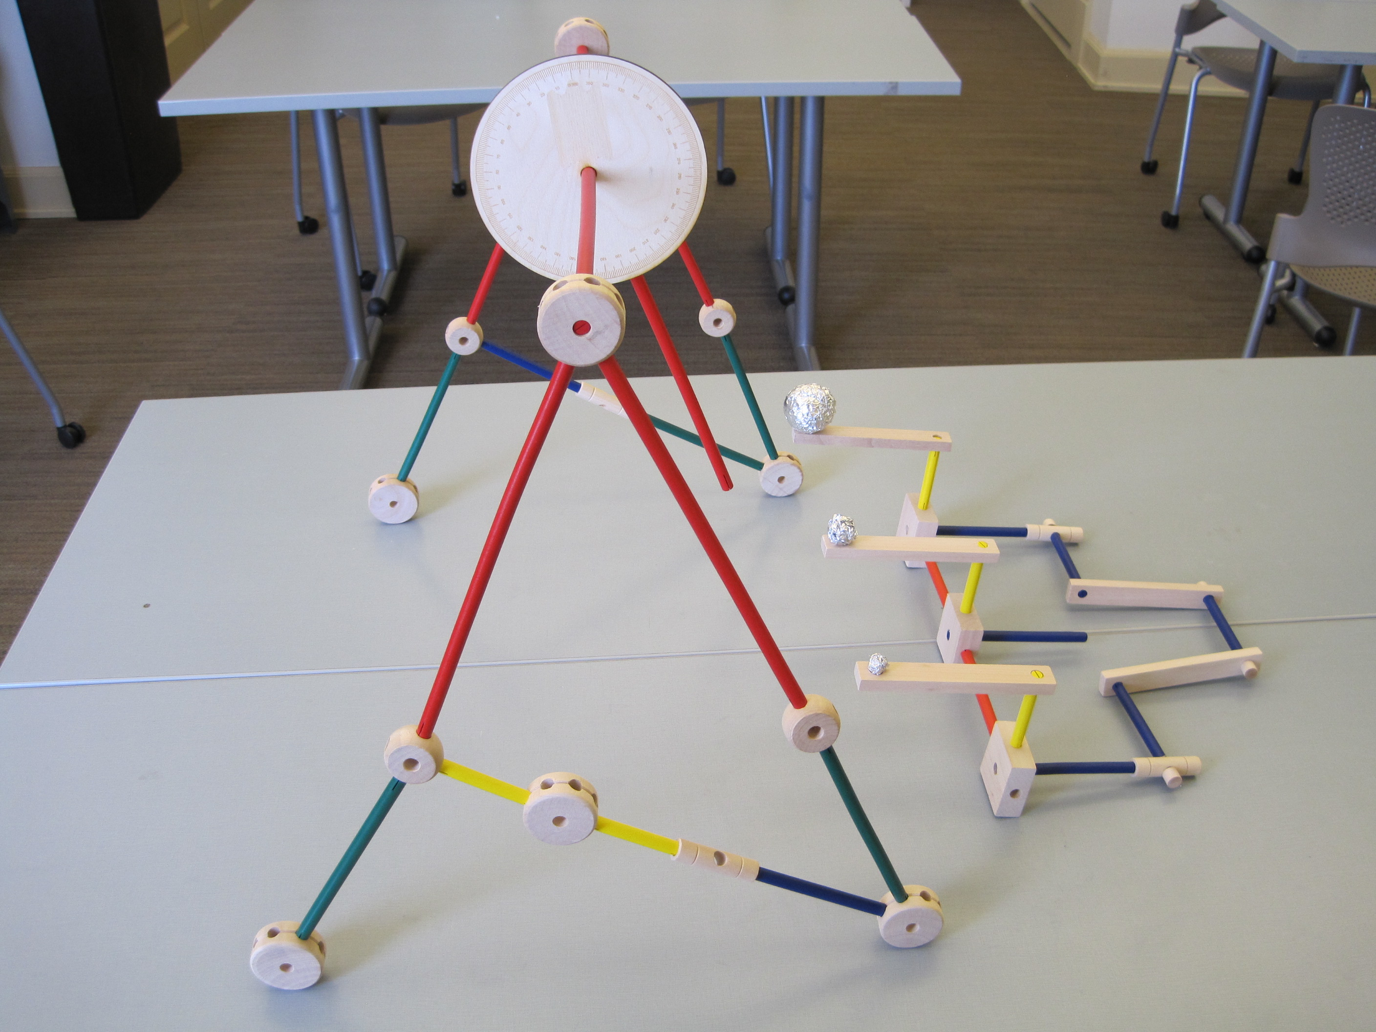
Diagram 1. Testing apparatus and debris samples built from Tinker toys.

Parameters
- The space debris capture device may be no larger than 4” in diameter and weigh no more than 40 grams. Size and weight matter in space travel.
- The space debris capture device must quickly affix to the end of the testing apparatus arm and be easily removed after testing.
- During testing, the space debris capture device must both capture the space debris sample and retrieve it (bring it back) to be considered successful
- Teams must complete the “team evaluation” column of the Space Debris Capture System Evaluation Checklist/Scoring Guide before submitting their completed device for evaluation.
- Teams must complete the engineering design journal below to record research and activities while completing this challenge.

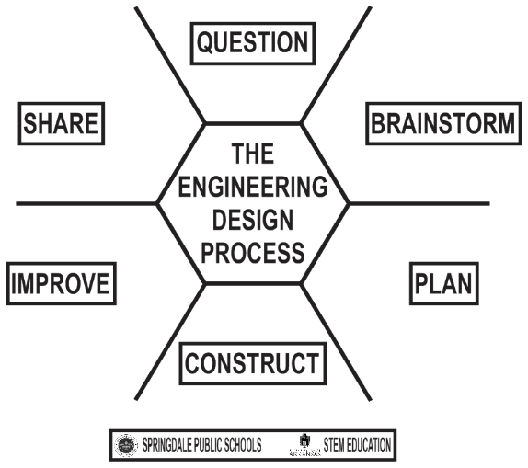
Engineering Design Journal:
Team Name: _________________________________
Design Team Members: ________________________
_____________________________________________
Design Challenge: _____________________________

Question
Identify the problem that your team has been asked to solve? State the problem in your own words. _______________________________________________________________________
______________________________________________________________________________
What questions do you need to ask in order to better understand the problem? _______________
____________________________________________________________________________________________________________________________________________________________
What are the parameters for the design challenge that you must meet? _____________________
______________________________________________________________________________
Brainstorm
Conduct research. What do we know and what do we need to find out? ____________________
____________________________________________________________________________________________________________________________________________________________
What did we find out? ___________________________________________________________
____________________________________________________________________________________________________________________________________________________________
Imagine what is possible. Generate (draw) as many ideas as possible

Plan
Make 4 Sketches (more detailed than before)

Choose the best solution. Sketch what your team will build using ideas from above.

What tools and materials will you use? ______________________________________________
____________________________________________________________________________________________________________________________________________________________
Construct
Create your model.
NOTES:

How will you test your model? ____________________________________________________
____________________________________________________________________________________________________________________________________________________________

Collect data from your test.
- Does it work? __________________________________________________________
- Does it work with different types of space debris? _____________________________
- Describe how the device works with small, medium, and large space debris? ________
______________________________________________________________________
- Describe how the device might need to be adapted to operate effectively with different types of space debris? ___________________________________________________

Improve
Analyze and interpret the data from your test.

How can you improve or modify our design? _________________________________________
____________________________________________________________________________________________________________________________________________________________
Retest your team model. Did your improvements and modifications work? _________________
____________________________________________________________________________________________________________________________________________________________
Share
What do you need to prepare before you present your design to others? ____________________
____________________________________________________________________________________________________________________________________________________________

What questions do you think others will ask you about your team design? __________________
____________________________________________________________________________________________________________________________________________________________
Prepare to defend your team solution. What do you like about your team design? ____________
____________________________________________________________________________________________________________________________________________________________
How could you make further improvements to your team design/solution? __________________
____________________________________________________________________________________________________________________________________________________________

Criteria | Team-Evaluation  (Place check mark next to each item completed) | Teacher Evaluation
Completed space debris capture device creatively |  | ______/15
Completed Engineering Design Journal |  | ______/15
Used materials and tools wisely and correctly. |  | ______/ 10
Stayed within the parameters of the challenge. |  | ______/ 20
Device captured the small space debris sample effectively |  | ______ / 10
Device captured the medium space debris sample effectively |  | ______ / 10
Device captured the large space debris sample effectively |  | ______ / 10
Bonus: Device captured the all space debris samples effectively |  | ______ / 10
Team presentation provided high-quality details concerning the process used to solve the challenge and defended their research |  | ______/ 10
TOTAL: |  | _____/ 100
Space Debris Capture System Evaluation Checklist/Scoring Guide

Space Debris Capture System Evaluation Rubric

Up to 12.5 Points | Up to 25 Points | Up to 37.5 Points | Up to 50 Points
Team showed little understanding of concepts from lesson and were unable to build device | Team shows some understanding of concepts from the lesson and were able to build a device | Team applied concepts from the lesson and created a debris capture device that caught 2 samples | Team effectively applied concepts from the lesson and created a debris capture device that caught 3 samples
Team completed one or two aspects of the engineering design journal | Team completed many aspects of the engineering design journal | Team completed most aspects of the engineering design journal | Team completed every aspect of the engineering design journal
Team demonstrated little understanding of lesson content and scientific inquiry | Team demonstrated some understanding of lesson content, but little ability to utilize scientific inquiry to modify initial design ideas | Team applied many concepts from the lesson content and made some modification to their initial device | Team demonstrated the ability to use content and scientific inquiry to adapt their device to perform different functions
Team was unable to apply concepts related to energy, velocity, and Newton’s Laws to solving the challenge | Team applied some concepts related to energy, velocity, and Newton’s Laws toward solving the challenge | Team applied many concepts related to energy, velocity, and Newton’s Laws toward solving the challenge | Team applied most concepts related to energy, velocity, and Newton’s Laws toward solving the challenge
Students did not collaborate as a team. Communication was lacking and conflicts were not resolved | Students worked together, but did not share work equally. Conflicts were not resolved on the team | Students worked equally as a cohesive group, may have shown some signs of conflict without resolution | Students worked equally as a cohesive group and communicated well with each other as a team
Capture System Testing
Test # | Length of Arm | Angle of Rotation (Release) | Mass of the End Effector | Results | Modifications Needed
1
2
3
4
5
6
7
8
9
10

