Pop-Up Card Assignment (10pts) – Due Tuesday, December 1

Each candidate will develop a 3-dimensional pop-up card solution to one of the four themes listed below: Survival of the Seasons, Ocean Layers, State of Matter, or Resources. You will need to conduct research on the best way to develop your pop-up card solution. Some excellent resources can be found at:

http://www.childrensengineering.com/linkspopups.htm

https://www.youtube.com/watch?v=T-FFeBAV9Y0&feature=related

http://wp.robertsabuda.com/category/how-to-make-a-pop-up/pop-up-basics/

Survival of the Seasons

Background: We have just discussed the First American adaptations for survival during the four seasons of the year: winter, spring, summer, and fall.

Challenge: Design a pop-up card that depicts your knowledge of the Native Americans survival throughout the seasons.

Criteria: Your pop-up card should include:
- Show survival techniques in at least two different seasons
- A minimum of two different pop-up mechanisms
- A brief explanation describing the adaptation chosen on the card
- Should be neat and attractive

Materials: Unlimited

- File Folders | - Glue | - Fuzzy Sticks
- Construction paper | - Craft sticks | - Card stock

Tools: Unlimited

- Scissors | - Hole Punch | - Ruler
- Markers, Crayons, Colored Pencils

Ocean Layers

Background: We have just learned about the different characteristics of the ocean environment.

Challenge: Design a pop-up card that depicts your knowledge of the ocean environment such as: continental shelf, continental slope, continental rise, abyssal plain, and trenches.
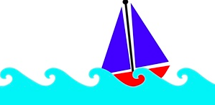
Criteria: Your pop-up card should include:
- Demonstrate at least three of the above terms
- A minimum of two different pop-up mechanisms
- A brief explanation describing the terms chosen
- Should be neat and attractive

Materials: Unlimited

- File Folders | - Glue | - Fuzzy Sticks
- Construction paper | - Craft sticks | - Card stock

Tools: Unlimited

- Scissors | - Hole Punch | - Ruler
- Markers, Crayons, Colored Pencils

State of Matter
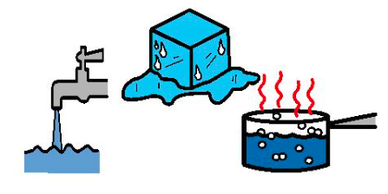
Background: We have just learned that the three states of matter are solid, liquid, and gas.

Challenge: Design a pop-up card that depicts your knowledge of all three states of matter.

Criteria: Your pop-up card should include:
- Information for all three states of matter
- A minimum of two different pop-up mechanisms
- A brief explanation describing the states of matter
- Should be neat and attractive

Materials: Unlimited

- File Folders | - Glue | - Fuzzy Sticks
- Construction paper | - Craft sticks | - Card stock

Tools: Unlimited

- Scissors | - Hole Punch | - Ruler
- Markers, Crayons, Colored Pencils

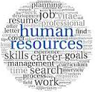
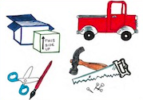
Resources

Background: We have just learned about natural resources, human resources, and capital resources.

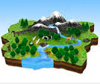
Challenge: Design a pop-up card that depicts your knowledge of all three types of resources.

Criteria: Your pop-up card should include:
- Information for all three types of resources
- A minimum of two different pop-up mechanisms
- A brief explanation describing the three resources
- Should be neat and attractive

Materials: Unlimited

- File Folders | - Glue | - Fuzzy Sticks
- Construction paper | - Craft sticks | - Card stock

Tools: Unlimited

- Scissors | - Hole Punch | - Ruler
- Markers, Crayons, Colored Pencils

