Quick Challenge

What is a quick challenge?
- Introduces students to one learning concept or idea from the standards. This concept is generally used in a larger design challenge.
- They can also be used as a “hook” for the lesson or unit to be presented
  - For example, if I wanted my students to build a spring rocket, I could incorporate quick challenges for the different aspects they would need to know before building the rocket, such as repeatability, accuracy, height, tension, distance, etc.

What does a quick challenge look like?
- Quick challenges should be NO more than 15 minutes from start to finish.
- They should also:
  - Use simple and common materials; however, they should require students to construct something using a curtailed version of the engineering design process.
  - Focus on one piece of information from content standards
  - Fit into a larger design challenge or lesson
______________________________________________________________________________

In Class Quick Challenge - Natures Weavers
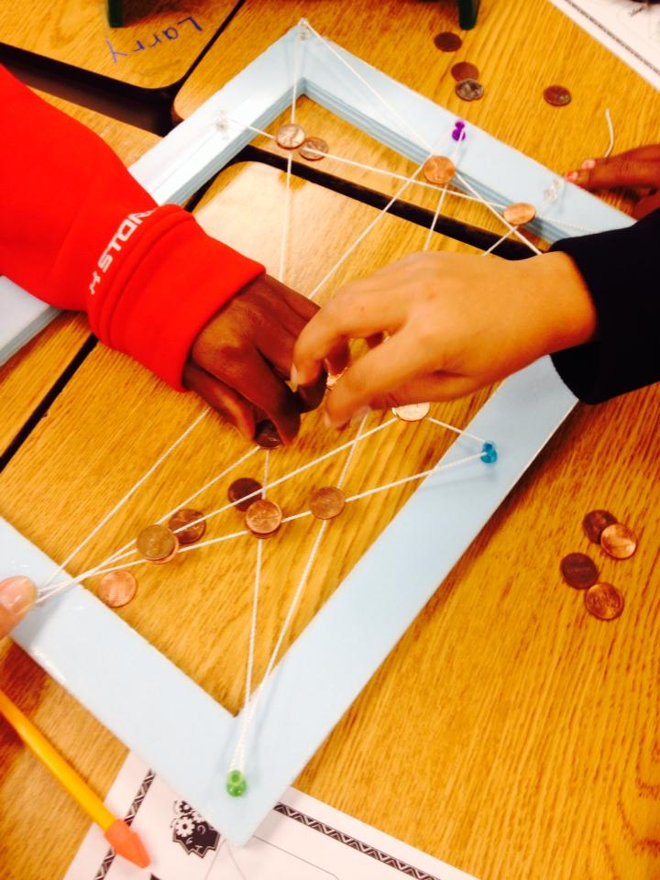
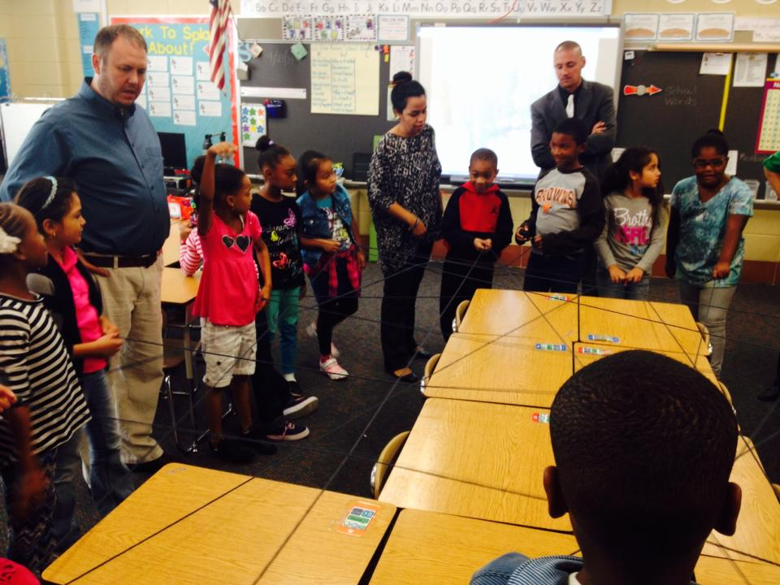
Grade 1

Quick challenge to focus on math standard

Learning Standard: CCSS.Math.Content.2.G.A.1
Recognize and draw shapes having specified attributes, such as a given number of angles or a given number of equal faces.1 Identify triangles, quadrilaterals, pentagons, hexagons, and cubes.

- Students will make a large circle within the classroom
- Students will pass yarn to a friend standing across from them and continue till each student has had a turn
- Each time a new angle or shape can be identified the selected student will describe its attributes and identify it accordingly. Special focus should also look at the different angles of the shapes.

Quick challenge used as a hook

Students will be introduced to a new unit with the narrative text Charlotte’s Web.

- Students will make a large circle within the classroom
- Students will pass yarn to a friend standing across from them and continue till each student has had a turn

The goal of the challenge should be to make the web as strong as possible and will be tested by placing different classroom objects on top of the web to determine its strength.

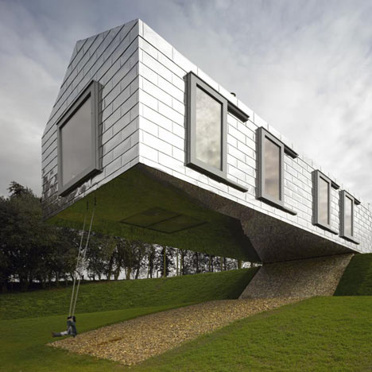
Quick Challenge

Content Information

A cantilever is an architectural component widely used in the building industries. A cantilever is a beam anchored at only one end. The beam carries the load to the support where it is forced against by a moment and shear stress. Cantilever construction allows for overhanging structures without external bracing. Cantilevers can also be constructed with trusses and slabs. This is in contrast to a simply supported beam such as those found in a post and lintel system. A simply supported beam is supported at both ends with loads applied between the supports.

Cantilevers are widely found in construction, notably in cantilever bridges and balconies. In cantilever bridges the cantilevers are usually built as pairs, with each cantilever used to support one end of a central section. A cantilever in a traditionally timber framed building is called a jetty or forebay. In the southern United States a historic barn type is the cantilever barn of log construction.

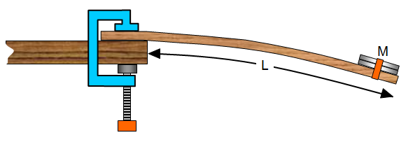

Challenge

Using the materials supplied, build a cantilever that will both protrude at least 10 inches from the edge of the table and hold the most weight as possible without shearing or fracturing when loaded.

Essential Question

How can you build a cantilever that protrudes from the table side that will support the most weight as well as measure at least 10 inches using only the given supplies?

Supplies: | Tools:
2 sheets of paper | Ruler and Pencil
Masking tape | Various Weights (washers, pennies, etc.)

