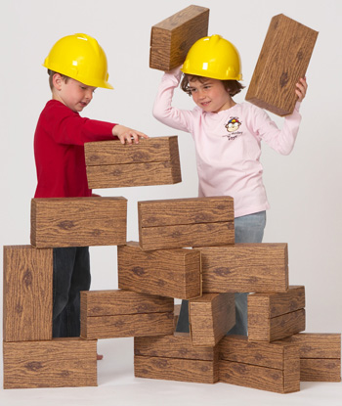
STEM Quick Challenge/Challenge:
Homemade Construction Blocks

A STEM Quick Challenge is an ungraded ice-breaker or bell-ringer designed to capture student’s attention prior to covering new content in a STEM class. They usually take less than 15 minutes and are typically introduced with little fanfare. They are designed to capture the student’s attention and engage them in the next content that will be covered in class.
Directions: Using the homemade construction blocks provided, design a quick challenge that could be used to draw students into an upcoming lesson/design challenge related to human-made structures.

- Guidelines:
- Use the SAMPLE on the next page as a model for your quick challenge
- Decide what you will “challenge” the students to build.
- Develop a title
- Write the challenge.
- Decide whether additional materials should be added and then develop a list of materials (keep it simple).
- Decide what questions students should be able to answer after finishing the challenge and then develop questions for the students.
- Prove that your challenge can be solved by constructing a solution to the challenge.
- Be prepared to discuss the science, technology, engineering, and math concepts that would be introduced through this STEM quick challenge.

Title:

Challenge:

Materials: PVC, ½” wooden dowels, plastic bag, -

Questions:

STEM Concepts:

SAMPLE
Quick Challenge: Leaf Spring Launcher
Tension

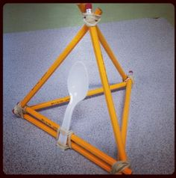
Leaf springs are stacks of curved metal bars that support the wheels of a car or railroad truck and bend up and down to smooth out the bumps. Leaf spring are typically made of high-tensile strength steel so that they can withstand years and years of flexing.
Challenge:
To demonstrate the tension of leaf springs, construct a marshmallow launcher using a plastic spoon as the leaf spring. Design the launcher to project the marshmallow as high as possible then, redesign the launcher to project the marshmallow the greatest distance.

Questions:
- What design differences were necessary when attempting to achieve height versus distance?
- What role does elasticity play in this design challenge?
- How would you change your design if you were given a chance to start over?
- How well did your device launch the marshmallow?
- Did everyone on your team contribute to the design?

Materials: wooden pencils, tongue depressors, rubber bands, plastic spoons, marshmallows, tape measure.

