Simple electricity/electronics worksheet
- Practice making a simple electrical circuit using paper, a pencil, a 9 volt battery, and an LED (take care to not touch the LED directly to the 9 volt battery).
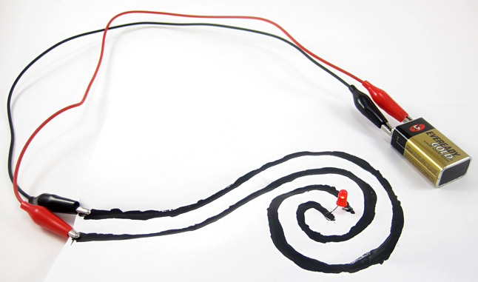
Drawing a Circuit – How can a pencil conduct electricity?

Materials:
Soft drawing pencil (6B is best)
Paper
5mm LED bulb
9 volt battery
9 volt snap connectors
330 ohm resistor
Two insulated wire leads

Create the following circuit.

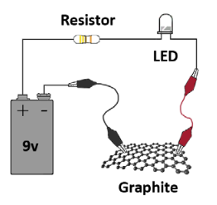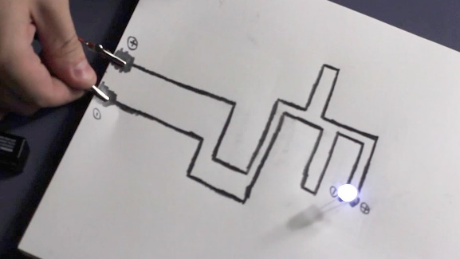

- Build a simple circuit that resembles the one below using coated copper wire, a resistor, an LED, a 9 volt battery, and tape (tape the circuit to a sheet of paper).
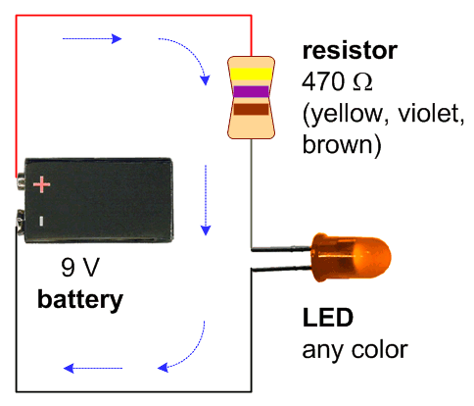

- Now add a switch: Make the switch using construction paper, rubber cement, & aluminum foil; or make the switch using a paperclip, nails, and a block of wood (see diagrams below).
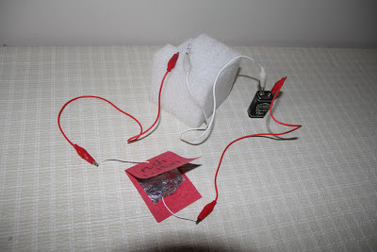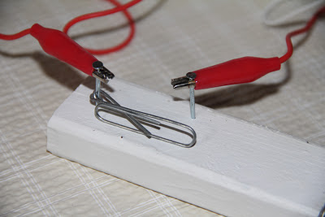

- Now, do some research that will help you develop a very creative solution to the upcoming electricity assignment. Use search terms like, “paper circuit.” Borrow ideas, but use your creativity to make them your own! When you’re finished, you want people to say, “Wow! I’ve never seen anything like that—did you create that?”

