Strategies for Solving Engineering Design Challenges

Engineering design challenges usually include the solution to the problem in the problem statement (e.g. design a vehicle that will travel the greatest distance using only the materials supplied). To efficiently solve engineering design problems, learners should employ the following steps:

- Analyze and Clarify the Problem: Carefully analyze the engineering design problem and break it into its smallest systems and subsystems. Clarify the problem to determine exactly what you have been asked to create.

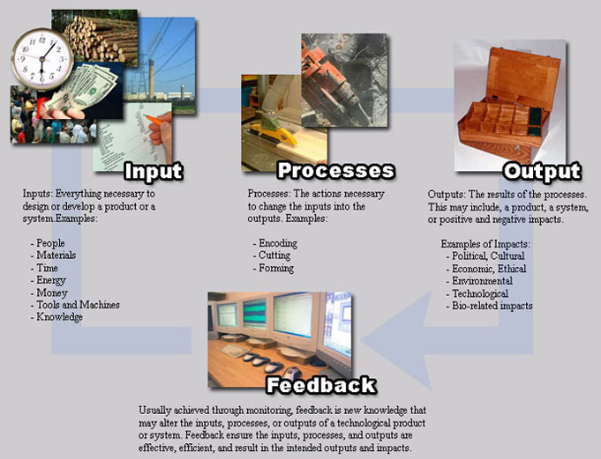

- Gather Resources and Materials: Gather all available resources and materials and analyze these carefully. Sometimes the answer to the engineering design challenge may be found in the available tools and materials.

- Formulate: Create as many possible solutions to the design problem as possible before attempting to implement any of them.

- Question the Solution: The student should ask as many of the spur questions (below) as apply to the problem. By answering these questions, the learner will add clarity to the proposed solution. The spur questions are as follows:
- Is there another way to solve this problem or use these materials?
- Can I borrow or adapt previous solutions or technologies?
- Can I add a new element or twist that might lead to a solution?
- Can I add more to the problem in an effort to find a solution?
- Can I remove parts of the problem in an effort to solve it?
- Can I incorporate substitutes or use other materials/technologies?
- Can I rearrange the elements of the problem to find the solution?
- Can I do the opposite of what I am currently thinking?
- Can I combine elements or technologies to solve the problem?

- Envision the Solution: Students should make sketches and drawings of the proposed solution. By crafting these drawings, learners will add clarity to the final solution prior to implementing the solution.

- Create: Select the most logical solution (often the simplest) and implement it (build it).

- Evaluate the Solution: Test the solution and determine whether it indeed solves the challenge. If it does not solve the challenge, find out why and make changes.

