The Standards and Benchmarks for Technological Literacy

Standard 17 - Students will develop an understanding of and be able to select and use information and communication technologies.

In order to select, use, and understand information and communication technologies, students should learn that:

K-2
- Information is data that has been organized.
- Technology enables people to communicate by sending and receiving information over a distance.
- People use symbols when they communicate by technology.
3-5
- The processing of information through the use of technology can be used to help humans make decisions and solve problems.
- Information can be acquired and sent through a variety of technological sources, including print and electronic media.
- Communication technology is the transfer of messages among people and/or machines over distances through the use of technology.
- Letters, characters, icons, and signs are symbols that represent ideas, quantities, elements, and operations.
6-8
- Information and communication systems allow information to be transferred from human to human, human to machine, and machine to human.
- Communication systems are made up of a source, encoder, transmitter, receiver, decoder, and destination.
- The design of a message is influenced by such factors as intended audience, medium, purpose, and the nature of the message.
- The use of symbols, measurements, and drawings promotes a clear communication by providing a common language to express ideas.

9-12
- Information and communication technologies include the inputs, processes, and outputs associated with sending and receiving information.
- Information and communication systems allow information to be transferred from human to human, human to machine, machine to human, and machine to machine.
- Information and communication systems can be used to inform, persuade, entertain, control, manage, and educate.
- Communication systems are made up of source, encoder, transmitter, receiver, decoder, storage, retrieval, and destination.
- There are many ways to communicate information, such as graphic and electronic means.
- Technological knowledge and processes are communicated using symbols, measurement, conventions, icons, graphic images, and languages that incorporate a variety of visual, auditory, and tactile stimuli.

*This information is adapted from the ITEEA’s Kids Inventing Technology Series.

Introduction
The world is rapidly changing due, in part, to advances in communication and information processing technologies. These technologies started as tools to support speech and personal communication. Today, people have a vast array of communication options including printed media, the telephone, radio, television, cellular telephones, and computer systems.

Information and communication are terms that are often used together but are different phenomena. Information is data (individual facts, statistics, and numerical data) and ideas that have been sorted and arranged. Communication is the act of exchanging ideas, information, and opinions. If people use devices and systems to communicate, communication technology is involved.

Communication technology communicates information using either graphic or wave systems. Graphic communication systems use drawings, pictures, graphs, photographs, or words on flat surfaces to convey information and ideas. These systems include printed media, photographic communication, and technical (engineering and architectural) drawings. Wave communication systems use electromagnetic radiation
(light, sound, or electrical waves) to send information. These systems include broadcast communication and telephony.

Communication Process
The basic communication process uses four major steps to move the information from the sender to the receiver. These are:

- Encoding: Forming the message in a way that it can be communicated.
- Transmitting: Delivering the message to the receiver.
- Receiving: Gathering the message from the transmission medium.
- Decoding: Forming the message in a way that the recipient understands it.

At any point in the communication process, the message may be stored for later retrieval. This can include recording, warehousing, etc.
Producing messages
Messages that are produced for mass audiences are carefully planned and produced.
They are designed, prepared for production, produced, and delivered. Communication messages are planned (designed) to give people information, entertain them, or cause them to take action. A format is selected, information about the audience and the message is gathered, and copy, layouts, or scripts are prepared. The messages are prepared for production by bringing the format, copy, and illustrations together in a pleasing arrangement or manner. The messages are produced using printing or recording techniques. The planned media is made ready for the consumer. Finally, the message is delivered to the audience. Books and magazines are physically delivered while wave messages are sent through the air or over cables. Without communication technologies, we would know little about the world around us. We would live a very sheltered life.

Did you know?

- The first recorded messages were produced about 10,000 years ago when people started to carve shapes on clay tablets.
- Written language using characters started about 5000 years ago.
- Samuel F. B. Morse developed the first operational telegraph system.
- In 1895, Guglielmo Marconi applied these theories for a wireless communication system he called the wireless telegraph (radio).

How to Complete a Task - Design Challenge

Introduction
People communicate in many ways. Often, they use words to communicate their ideas and thoughts. At other times, they use pictures to communicate. In still other instances, they use a combination of words and pictures to transmit information. In this activity, the students will design and produce a "How-to" sheet that uses both words and pictures to highlight the steps needed to complete a simple task.

Teacher Preparation
To prepare to introduce the students to this activity, you should:
- Gather some simple direction sheets that explain how to do something. Guides that come with appliances, electronic equipment, and tools often contain this type of material.
- Gather some simple stories if you elect to use the "illustrate a story" option.
- Make a bulletin board that presents communication technology as using tools and systems to exchange ideas and information.
- Gather the required tools and supplies.

Supplies and Tools Needed
The following tools and supplies are needed to complete this activity:
- Bond paper
- Crayons or colored markers
- Scissors
- Tape
- Rulers

Preparing the Students
Set the stage for this communication activity by doing the following things:
- Discussing communication (exchanging information and ideas with words, symbols, and pictures) and communication technology (using tools and systems to communicate).
- Explaining that communication is judged by the effectiveness in exchanging information and ideas.

Conducting the Activity
- Introduce the challenge: Prepare a simple instruction sheet for completing a task.

- An alternative is to substitute pictures for key words in a story to make it more interesting and challenging.

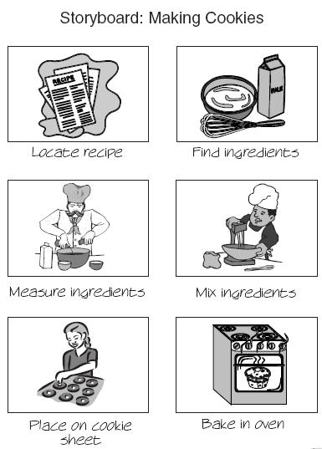
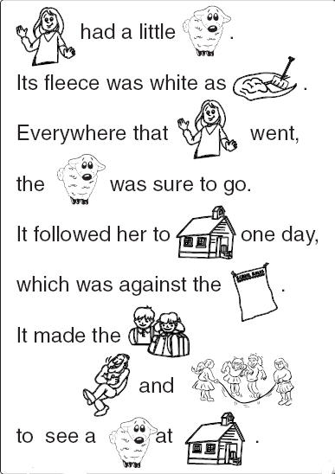

- Divide the class into small groups or have the students work independently.

- Do one of the following things:
✔ Assign the students a simple task to develop a word-and-picture direction
sheet.
✔ Have the students select a simple task to develop a word-and-
Picture direction sheet.
✔ Assign the students a short story or poem to develop a word and-picture
story.
✔ Have the students write a short story or select a nursery rhyme poem to
develop a word-and-picture story.
- Have the students:
- Plan their word-and-picture story or instruction sheet using either the storyboard worksheet (see attached storyboard).
- Make a final copy of the communication product.
- Exchange the product with another student or group.

- Have the students:
- Evaluate the completed communication product they received from other students or groups.
- Suggest ways to improve the product.

Checking for Understanding
Throughout the unit the students should be asked questions about communication and how their products will communicate effectively.
- How would you live without communication technologies?
- Which of these technologies do you use to:
  - communicate with friends and family?
  - be entertained?
  - learn about current events?
  - gather information for school assignments?

Storyboard

______________________ ______________________ ______________________
______________________ ______________________ ______________________
______________________ ______________________ ______________________

______________________ ______________________ ______________________
______________________ ______________________ ______________________
______________________ ______________________ ______________________

______________________ ______________________ ______________________
______________________ ______________________ ______________________
______________________ ______________________ ______________________

Advertising and Communication

Introduction
Advertising is a special type of communication. It is the sponsored offering of goods, services, or ideas through mass communication media. Some of the first advertising was conducted by business people in ancient Egypt who used criers to announce ship and cargo arrivals. The invention of printing opened the modern age of advertising. The major advertising media are newspapers, magazines, television and radio, business publications, billboards, mass mailing circulars, and email and Internet announcements.
In this activity, the students will study communication technology as they design a print advertisement that meets the standards expected from responsible businesses.

Teacher Preparation
To prepare to introduce the students to this communication activity, you should:
- Gather a number of print advertisements.
- Prepare a bulletin board on advertising.
- Review Web sites on advertising.

Supplies and Tools Needed
The following tools and supplies are needed to complete this activity:
- Bond paper
- Colored markers
- Scissors
- Ruler
- Tape

Preparing the Students
Set the stage for this introductory activity in communication technology by:
- Discussing communication and communication technology.
- Explaining the phases of a communication system (encoding, transmitting, receiving, decoding, storing, and retrieving).
- Describing advertising as a communication activity with a sender, message, and audience.
- Discussing truth and advertising.
  - ADVERTISEMENTS must be truthful and non-deceptive
  - ADVERTISEMENTS must have evidence to back up claims
  - ADVERTISEMENTS cannot be unfair

Conducting the Activity
- Introduce the challenge:
- Develop an advertisement for your favorite cereal or snack food that meets the criteria for truth in advertising.
- Divide the class into small groups.
- Have each group use the Initial Proposals worksheet to:
- Select a cereal or snack food for the advertisement.
- Develop a theme for the advertisement.
- Have each student in each group use the Initial Proposals worksheet to:
- Develop two initial advertisements.
- Present the ideas to the group.
- Discuss the proposals with the members of the design team.
- Record the strengths and weaknesses of each proposal.
- Have each student in each group:
- Develop a final advertisement.
- Present the proposal to the group.
- Have each group:
- Select the best proposed advertisement developed by its members.
- Produce a final copy of the advertisement.
- Present the advertisement to the class.

Initial Proposals
Name:_____________________
Product:___________________
Theme:___________________

Advertisement Idea #1 Advertisement Idea #2

Strengths: Strengths:

Weaknesses: Weaknesses:

Checking for Understanding
Throughout the unit, the students should be asked questions about:
a. Communication and communication technology.
b. The communication process.
c. How advertising is a communication activity.

Extending the Activity
Packaging
- Using the same product and theme, develop a new package for the item that would be attractive to a specific age group.
- Research the requirements for nutritional information for food products and include the required information on the new package design.

Evidence of Attainment

Students who have developed an understanding of and are able to select and use information and communication technologies can:

- Describe the difference between communication and communication technology.
- List and describe the six phases of the communication process.
- Develop and analyze communication media.
Key Terms
- Technology - Using tools, materials, and knowledge (knowhow) to extend the human potential.

- Advertising - Sponsored offerings for goods, services, or ideas through mass communication media.

- Communication - Sending a message from one person to another.

- Communication Media - The product or device that is used to transfer information.

- Encoding - Forming the message in a way that it can be communicated.

- Transmitting - Delivering the message to the receiver.

- Receiving - Gathering the message from the transmission medium.

- Decoding - Forming the message in a way that the recipient understands.

Connections to Other Subjects
- Science: Electromagnetic waves and spectrum.
- Mathematics: Measurement systems used in printing.
- Social Studies: The impact of advertising on people and society.
- Language Arts: Writing copy for advertising and technical publications.
- Art: Use of design principles to attract and hold a viewer's attention.
- What about the Common Core Standards?

