The Technology of Communicating Resources Guide

Images

What's the difference between raster and vector?

- A raster image is made of up pixels, each a different color, arranged to display an image.
- A vector image is made up of paths; each with a mathematical formula (vector) that tells the path how it is shaped and what color it is bordered with or filled by.
The major difference is that raster image pixels do not retain their appearance as size increases - when you blow a photograph up, it becomes blurry for this reason. Vector images retain their appearance regardless of size, since the mathematical formulas dictate how the image is rendered (PsPrint, 2012).

Working with images

SnagIt – The Ultimate Screen Capture Tool

- http://www.oldapps.com/SnagIT.php?old_snagit=12?download

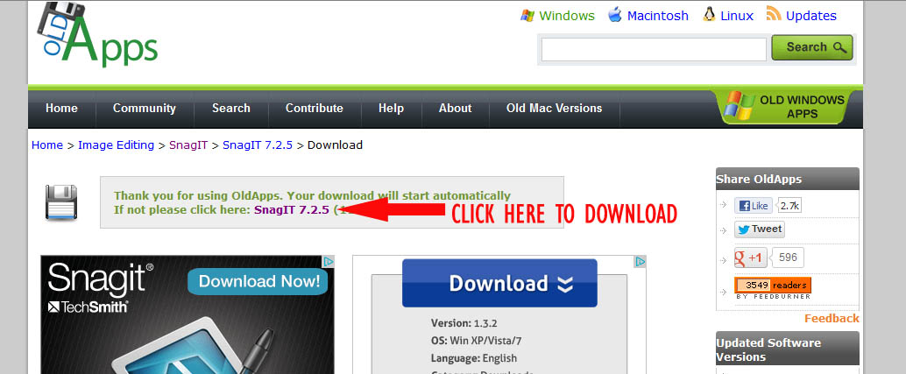

- If you are prompted to enter a key, you may use:
  - Key: YW6RC-4YMK6-SZBBD-C2MCW-Q9D96
- This free screen capture tool is only available on a PC; however, there are many free screen capture tools available for MAC users.

The Macintosh operating system has always made it easy to capture a screen shot (an image of your computer desktop or an active window).

  - To capture the entire desktop, press Command-Shift-3. The screen shot will be automatically saved as a PNG file on your desktop.

  - To copy the entire desktop, press Command-Control-Shift-3. The screen shot will be placed on your clipboard for you to paste into another program.

  - To capture a portion of the desktop, press Command-Shift-4. A cross-hair cursor will appear and you can click and drag to select the area you wish to capture. When you release the mouse button, the screen shot will be automatically saved as a PNG file on your desktop. (The file is saved as PDF in Mac OS 10.3 and earlier.)

  - To capture a specific application window, press Command-Shift-4, then press the Spacebar. The cursor will change to a camera, and you can move it around the screen. As you move the cursor over an application window, the window will be highlighted. The entire window does not need to be visible for you to capture it. When you have the cursor over a window you want to capture, just click the mouse button and the screen shot will be saved as a PNG file on your desktop. (The file is saved as PDF in Mac OS 10.3 and earlier.)

  - Capture Me: http://www.chimoosoft.com/products/captureme/

Paint.net:

http://download.cnet.com/Paint-NET/3000-2192_4-10338146.html

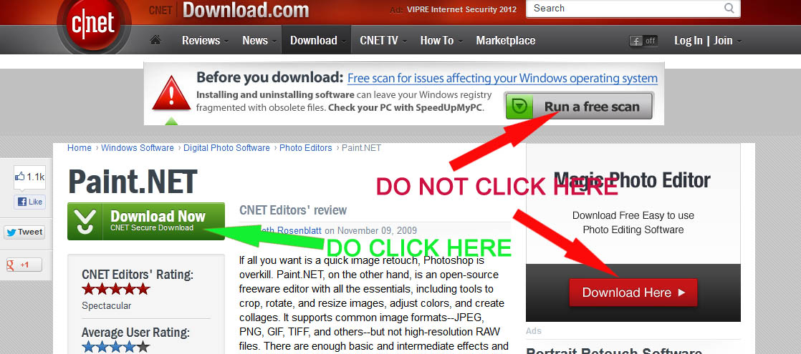

Gimp:

http://www.gimp.org/
- Mac users - http://www.gimp.org/macintosh/

Photostory

- http://download.cnet.com/Photo-Story-3-for-Windows/3000-12511_4-10339154.html

Creating your first Photostory

  - http://windows.microsoft.com/en-US/windows-xp/help/digitalphotography/create-first-photo-story

