STEM Narrative Curriculum

Design Activities

Fall 2012

Table of Contents

Can Your Billy Goats Survive the Troll?

Building a Structured Castle

Can a Hot Air Balloon be like a Tortoise?

Dogzilla: Dog Bone Slinger Design Challenge

Will Humpty Go Splat or Will He Last?

Franklin is Lost

Chain Reaction Activity

The Big Orange Splot Activity

Helping Monkey’s Stay A ‘Float

Structurally Sound Houses: Building Houses that can withstand external elements

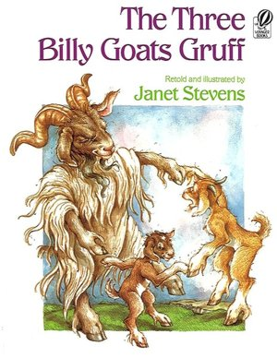

Problem:

Once upon a time there were 3 billy goats. They ate the grass in the valley until it was all gone and they were hungry. The 3 billy goats knew that on the other side of the creek there was another meadow full of grass. There was only one problem, they had to cross a bridge to get to the other side and the evil troll lived under that bridge. The troll was hungry, too. The billy goats really need to get to the other side, but they cannot cross over the troll’s bridge.

Challenge:

You decide to help the billy goats reach the opposite side of the creek so they can eat. You must create a model structure to help the billy goats get from one side to the other, while using the design loop and only the materials provided. Your teacher will also provide you with model billy goats, with specific weights, that your bridge must be able to withstand.

Criteria:

- Your Bride should be able to withstand the weights: 10 pounds, 12 pounds, and 15 pounds
- Your bridge should be at least 11 inches wide and allow the billy goats to cross a ravine of 6 inches deep

Materials Market:

pipe cleaners
craft sticks
hot glue
string
modeling clay
foam wedges
construction paper
Q-tips

*GOAL: A bridge that can withstand the most weight, weighs the least, and has the best physical appearance

Think About It:
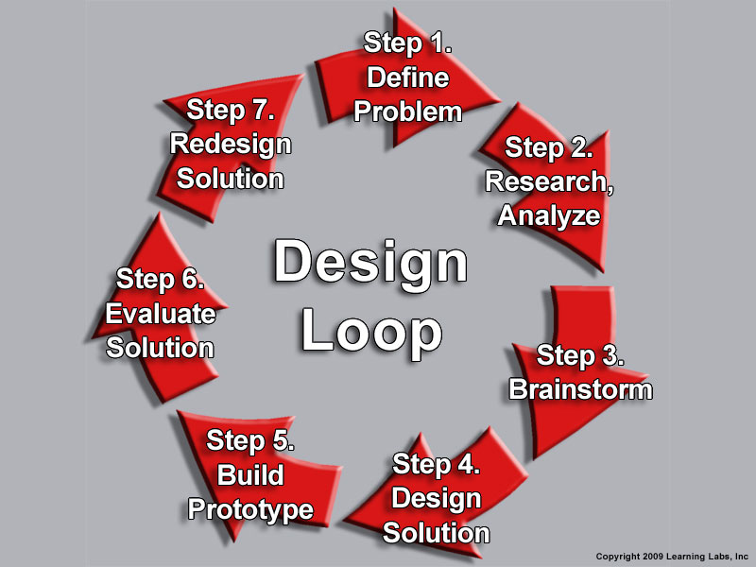
Research strong bridges and think about what makes them strong? Think about which materials would be the best solutions for your bridge design and try to use the least amount of materials as possible because your instructor may put a limit to the amount of items you can use. Use the spaces below to record your ideas and show them to your teacher before going to the market. (Be sure to label the materials you will need for your bridge in each of your ideas

Surviving The Troll
Build the Billy Goats a Bridge

Teachers: This project will teach students that building a sturdy bridge takes more than material. You have to consider your resources, the length, the weight, and the type of bridge needed.

Disciplinary Area: STEM

Unit: Structures, angles, force

Standards
- Common Core Math Standards (Geometry): Solve problems involving scale drawings of geometric figures, including computing actual lengths and areas from a scale drawing and reproducing a scale drawing at a different scale.
- Standards for Technological Literacy: Develop the abilities to apply the design process
- ELA Common Core Standards (writing): Follow precisely a complex multistep procedure when carrying out experiments, taking measurements, or performing technical tasks, attending to special cases or expectations defined in the text

“Big Ideas”
- Learning to use creativity for problem solving
- Learning to use the concepts of the design loop
- Technology is key in constructing the bridge
- Learning that science, technology, engineering, and mathematics all play important rolls in developing the bridge
- Tools and techniques

Essential Question: Can you design a structure to get the 3 Billy goats from one side of the creek to the other (11 inches wide and 6 inches deep), without crossing the troll, and withstanding their body weight (10 pounds, 12 pounds, and 15 pounds)?

Scenario: Once upon a time there were 3 billy goats. They ate the grass in the valley until it was all gone and they were hungry. The 3 billy goats knew that on the other side of the creek there was another meadow with lots of lushes grass. There was only one problem. They had to cross a bridge to get to the other side and the troll lived under that bridge. The troll was hungry, too. The billy goats really need to get to the other side so they can eat, but they cannot cross over the troll’s bridge. You decided to create a model structure to help the billy goats cross the creek so that they can eat. You can only use the materials provided and it will need to be able to withstand the billy goats body weight. The creek is 11 inches wide and the ravine are 6 inches deep.

Materials and Resources (You can allow them to work in teams to introduce cooperative learning or work alone)
- Pipe Cleaners
- Craft Sticks
- Hot Glue
- String
- Modeling Clay
- Foam Wedges
- Construction Paper
- Q- tips

Teachers: You can also change the projects difficulty level by assigning credits to the materials and only allowing them a select amount of credits to spend. By doing this you are making them think about the resources they may need before diving in. They will need to be sure their designs are accurate and precise, or they may not get the right materials with their credits.

Content: A bridge is a structure designed to help us transport from one side of land to another, whether that be over water, mountains, or rough terrain. Bridges are very important in our lives today and have been for many years. Most bridges are made from steel and iron, and use cables for support. Bridges are made to withstand certain amounts of weight at any one time and if they are not used properly, transporting more weight than the bridge can allow, can cause them to break. Angles, structure-to-weight ratio, and design are all very important factors when building a bridge.
The greatest bridge builders were the ancient Romans. The Romans built arch bridges and aqueducts that could stand in conditions that would damage or destroy earlier designs. They were made from heavy wedge shaped rock. Some still stand today. Bridges went from being constructed of limestone, water, wood, sand, and volcanic rock to steel, iron, and cables. Stefan Bryla made the first welded bridge in 1927.

There are many different types of bridges, but each bridge has a specific use. Beam bridges are flat and use piers for support. Arch bridges are very strong and look like half circles. The longest bridges in the world are suspension bridges and use foundations for support. Think about the weight you will be transporting across your bridge to determine which design you should use.
Source: http://library.thinkquest.org/CR0210346/history.html

Teachers: Allow the students to do some research on bridges. There are many different types of bridges and they will need to consider their resources and weight before designing their own. It would be nice to do a short presentation on bridges and how angles and design are very important.

Deliverables:
Using only the materials supplied by you, your student or team of students must build a scale model bridge that can withstand the weight of the billy goats. The smallest billy goat will weigh 10 pounds, the middle will weigh 12 pounds, and the heaviest will be 15 pounds. Your bridge will need to withstand the weight of each individual billy goat and to add a little more competition you can keep adding weight to see which can withstand the most.

Parameters: The completed bridge must:
- Must reach across an 11 inch ravine
- Be designed using the engineering design model
- Support must be at least 6 inches tall (if building a beam or suspension bridge)
- Withstand the weight of the billy goats: 10 pounds, 12 pounds, and 15 pounds
- Be submitted to you with a completed brainstorming sheet and working drawing that illustrates how the structure was designed
- Should be designed in a way that it can be attached to the model river

How to test the bridges: Connect the student bridge to a ravine like structure that you have prepared (11 inches wide and 6 inches tall). Once connected, start with the 10-pound billy goat and place it on the middle of the bridge, continue to do this with the 12-pound and 15-pound billy goat models. Do this with each student’s bridge. To create a bigger challenge: continue to add weight after every bridge has been tested to see which bridge can withstand the most weight.

Assessment

Surviving The Troll

Team Name:_________________________ Group Members________________________

Scoring Criteria:

- The Bridge was submitted with four well thought out brainstorming ideas (0-10 pts.)
- The design loop was used to reach the completed bridge (0-20 pts.)
- The Bridge with stood the weight of the billy goats (0-40 pts.)
- The materials were used affectively (0-10 pts.)
- The bridge met the parameters (0-20 pts.)

Building a Structured Castle
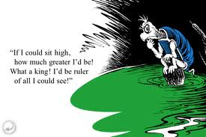

Disciplinary Area: STEM
Unit: Structures and parts of a castle
Standards:
Common Core Standards
- Standards of Literacy: Analyze the author’s purpose in providing an explanation, describing a procedure, or discussing an experiment in a text.
- Standards of Technology: Students will develop an understanding of design
“Big Ideas”:
- Literacy: Yertle the Turtle, by Dr. Seuss
- Using science, technology, engineering and mathematics to create a castle
- Creativity to make castle and bring in new ideas on “how to help the king and the other townspeople”.
- “Tools and Techniques”
- Teamwork

Essential Question: Can you help the other turtles (townspeople) build a castle for the king to see for “miles”?
Scenario: Say to students: Although, your “king” is selfish and impatient, you decide you have solution to build a castle that everyone can live in and use but the king can also see for miles.
Materials and Resources:
- Construction paper
- Scissors
- Markers, paints
- Tooth picks
- Glue
- Things found outside or inside (sticks, rocks, leaves, toilet paper rolls )
- Cardboard or scraps of cardboard, cereal boxes etc
- Stapler
- Pringles cans, coffee cans etc.

Content Information: A castle is a type of structure built in Europe and the Middle East during the middle Ages by nobility.
“After the fall of the Roman Empire in the fifth century, Europe underwent a series of cultural changes that lasted a thousand years. This period of time has become known as "Medieval" or the "Middle Ages." It was time of knights, battles, and castles. The romanticism of the period is manifest in the literature, the history. Castles, and the remains of them, still dot the European landscape and remind us of a time when chivalry, gallantry, and courage were the order of the day.”
I would also talk to students about kings and how the turtle relates to a lot of the kings whom exercised their power. You could go into talking about society and have a discussion there.
Castle Preparation: Students have to build a castle using ideas from blue prints of castles.
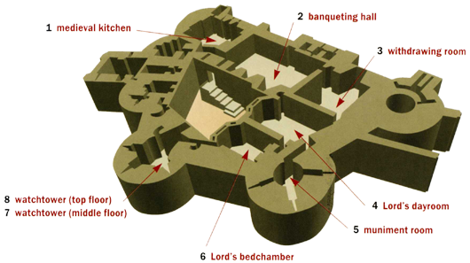

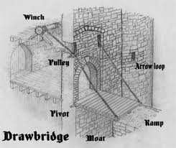

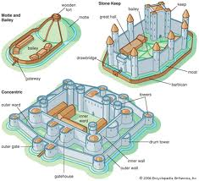

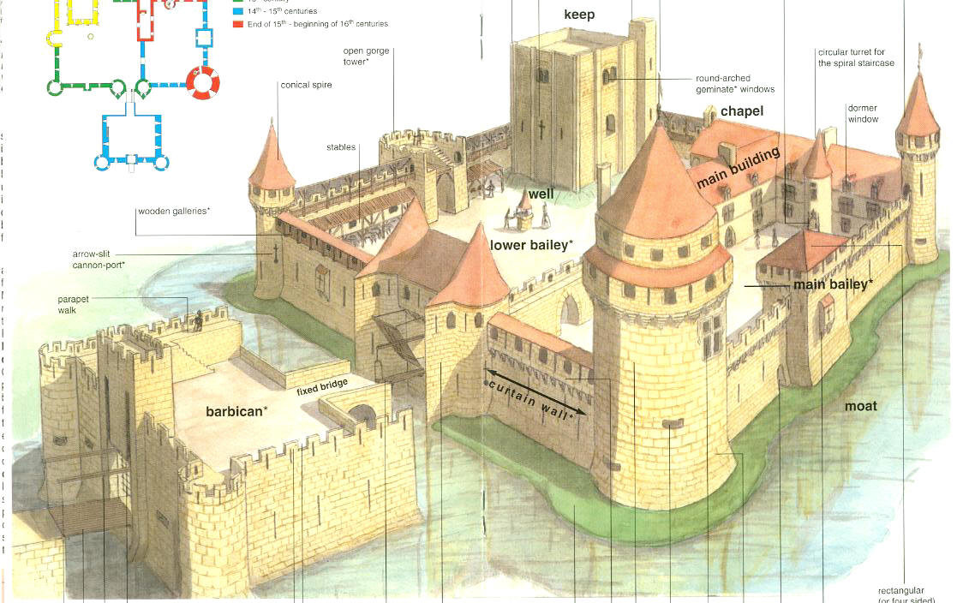
Students will have lots of references to look at. I would have a power point of castles and then after discussion a print out of the blue prints. They can search the web to look for castles they like and print out their own samples. I will also have books talking about castles and parts of the castles.
Deliverables:
Then they build on top of boards their castles. They must build at least three parts used in an actual castle. For example: Chapel, drawbridge, and king’s bedroom. Then answer “Can the king see for miles?” No limitations!

Parameters:
- 3 rooms or structures used in real castles
- Used Design Loop
- Can the king see far away?
- Presents to class each section of their castle and why.
Assessment
Team name:
Group members:

- Where is the king located?
- 3 sections of the castle were presented
- Used the design loop

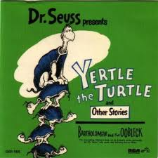
As a Class we will read Yurtle the Turtle by Dr. Suess.
Then we will have a class Discussion. Points we will talk about:
- Yurtle, the King
- The other turtles under his rule
- Better solutions that help everyone! Not just the King.
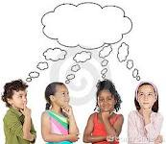
I will divide you up into teams.
Once in groups your will have one king and the rest are the other turtles.
You will use the design loop to:
- Brainstorm
- Look at books or on the internet on castle designs
- Tell your findings and ideas with your partners
- Draw, write down ideas or plans
- Make revisions
- Start building your castle

Rules:

- everyone in the group must have a room and give the “ok” with the castle design
- must include 3 real parts of a castle I showed or you found in book or on the internet
- Be a good team player… Don’t be a Yurtle

Lastly, present to class. Be sure to include in presentation:
- Tell us who everyone was whether a king or turtle.
- Who came up with what
- Your 3 parts of the castle
- Why you built all the parts you have included in your castle.
- What did you learn?
- What was difficult?

“Can a Hot Air Balloon be like a Tortoise?”

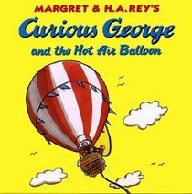

Designing a hot air balloon that will rise into the air slowly.

Grades 1-4

Lisa Ann Baker

“Can a Hot Air Balloon be like a Tortoise?”

Designing a hot air balloon that will rise into the air slowly.

Grades 1-4

Disciplinary Area: STEM (Physical Science)

Unit: Structures, speed & acceleration, gravity, weight

Standards:

Common Core State Standards for Mathematics

Measurement and Data:
- Measure and estimate lengths in standard units
- Relate addition and subtraction to length.
- Represent and interpret data.
Geometry:
- Reason with shapes and their attributes

Standards for Technological Literacy

Students will develop an understanding of Engineering Design:

- The role of troubleshooting
- Research and development
- Invention and innovation
- Experimentation in problem-solving
- Everyone can design solutions to a problem.
- Design is a creative process.
- The design process is a purposeful method of planning a practical solution to a problem.

Arkansas Science Curricular Frameworks (Physical Science):

- Students shall demonstrate and apply knowledge of motion and forces using appropriate safety procedures, equipment, and technology.

Big Ideas:

- The engineering design process includes identifying a problem, looking for ideas, developing solutions, and sharing solutions with others.

- Expressing ideas to others verbally and through sketches and models is an important part of the design process.

Literature Connection: “Curious George and the Hot Air Balloon” By Margret & H.A. Rey

The Problem (scenario): Curious George’s hot air balloon rose so fast that he didn’t have time to get off!

Essential Question: Can you design a hot air balloon that will rise slowly?
Content Information:
A hot air balloon is a lighter-than-air craft in which air or gas heated by a flame is trapped in a large fabric or other materials bag. The hot air balloon is the oldest successful human-carrying flight technology. A hot air balloon consists of a bag called the envelope that is capable of containing heated air. Suspended beneath is the gondola or wicker basket (in some long-distance or high-altitude balloons, a capsule) which carries the passengers and (usually) a source of heat, usually an open flame. The heated air inside the envelope makes it buoyant since it has a lower density than the relatively cold air outside the envelope. Unlike gas balloons, the envelope does not have to be sealed at the bottom since the air near the bottom of the envelope is at the same pressure as the surrounding air. In today's sport balloons the envelope is generally made from nylon fabric and the mouth of the balloon (closest to the burner flame) is made from fire resistant material (Wikipedia).
Design Challenge (Deliverables):
You will work with a team of two to four aeronauts. Your team will design and build a model of a hot air balloon using the materials from the “store”. When the balloons are completed, each team will test its balloon to see how high it will fly in 15 seconds. A hairdryer will be used as the source of hot air.

Parameters:

Your completed Hot Air Balloon must:

- Be designed using the engineering design model
- Be able to “fly” for 15 seconds
- Include a completed Design Loop worksheet
- Use only materials from the Hot Air Balloon store
- Must not use more than 15 Balloon Credits to purchase supplies from the Balloon Store

Materials/Resources (for balloon store):

Ketchup cups (from fast food restaurant)

Berry baskets (grocery store)

Small Dixie cups

Construction paper

Helium Balloons (Small and Medium)

Kite string

Fishing line

Heavy duty thread

Masking tape

Cellophane tape

Scissors

Hole puncher

Paper clips

Straws

Popsicle sticks

Toothpicks

Small dried beans
Balloon Credits

Can a Hot Air Balloon be a Tortoise?

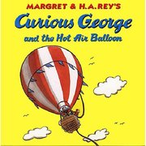

Today you will read a story about Curious George and his adventure in a hot air balloon.

You will learn about hot air balloons, gravity, and weight and force while designing and constructing your own hot air balloon.

Can you design a hot air balloon that moves slowly (rises), like a tortoise, so Curious George can get off before he gets too high?

People who fly hot air balloons are known as aeronauts. You will be on a team with other aeronauts. You and your team will brainstorm different solutions to create a hot air balloon for Curious George.

Your team must follow these rules:

- Your design must follow the Design Loop.
- Your hot air balloon must be able to “fly” for 15 seconds.
- Only materials from the Hot Air Balloon Store can be used
to construct your model.
- The Design Loop worksheets must be included with your
model presentation.

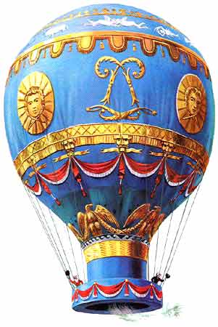

The Design Loop

For

Elementary Grades (K-4)

- Ask the students “What is the problem? What are trying to fix or make better (improve)?

- Have a class discussion on ideas. Have students work in groups to brainstorm ideas. Tell them to use a variety of resources: computer, library. Asking others questions, etc.

- Tell each group to choose what they think is the best solution for the problem. Have student draw a sketch or blueprint of their solution. Ask students to think about these questions:

A. What will you need to build or create your solution?
B. How will you build it?
C. What problems or difficulties might you have?

- Test your solution. Student will test their prototype.

- Review your solution. Have students think about the results of their test.
  - Was it the best solution?
  - What could they do differently?
  - Can they add something or change something to make it better?

- Present the problem and your solution. Have each group do a class presentation of their solution and the results.

Team Name: _______________________________________________

Members:

_________________ __________________ _________________ _________________

- What is the problem? State the problem in your own words. 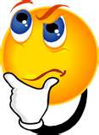
________________________________________________________________________________________________________________________________________________________________________________________________________________________________________________________________________________________________________________________________________________________________________ __________________________________________________________________________________________
- Brainstorm solutions……Draw or describe some possible solutions.

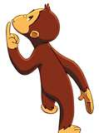 3. Choose the solution you think is best.

__________________________________________________________________________________________________________________________________________________________________________________________________________________________________________________________________________________________________________________________________________________________________________________________________________________________________________________________________________________________________________________________________________________________________________________________________________________________________________________________________________________________________________________________________________________________________
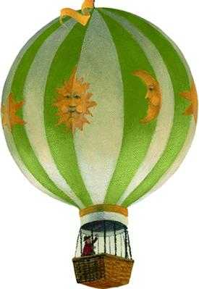4. Test your Solution.

Did you use only the materials provided? YES NO

Did you test your balloon for 15 seconds? YES NO

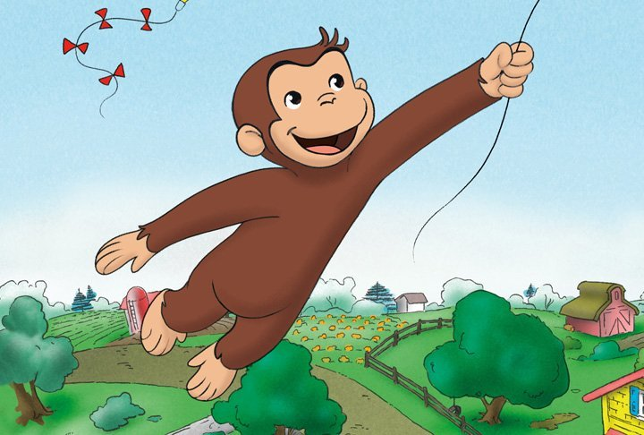

5. Evaluate your solution
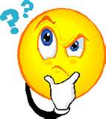

Was it the best solution? _________________________
Would one of your other ideas have been better? Why or why not?
_________________________________________________________________________________________________________________________________________________________________________________________________________________________________________________________________________________________________________________________
What would you have done differently?
_________________________________________________________________________________________________________________________________________________________________________________________________________________________________________________________________________________________________________________________
Could you add to it to or take away from it to make it better? What would you add/take away?
_________________________________________________________________________________________________________________________________________________________________________________________________________________________________________________________________________________________________________________________________

1 Credit Items 2 Credit Items 3 Credit Items

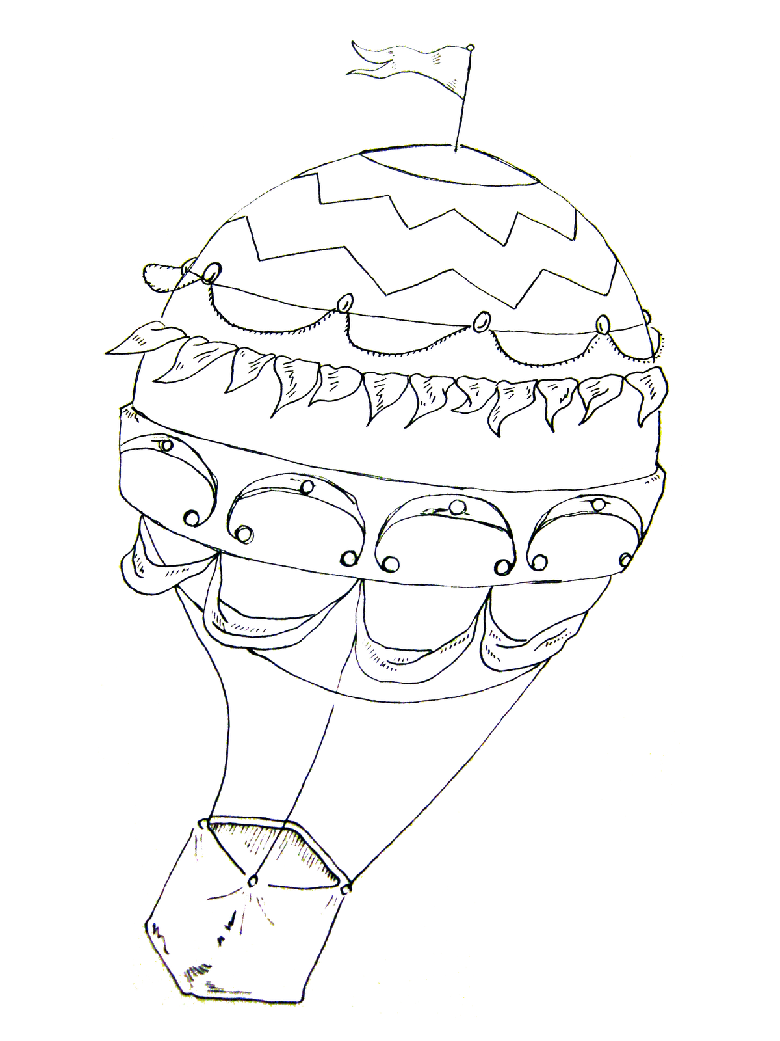

Team Name | Height Reached in 15 seconds | Weight of Hot Air Balloon

Slowest: Heaviest:

Fastest: Lightest:

Difference in time: Difference in Weight:

Slowest Weighed:

Fastest Weighed:

Difference in Weight:

Assessment for “Can a Hot Air Balloon be a Tortoise?”

Name____________________________ Date______________
Criteria for Assignment | No Evidence  0 | Limited Understanding  1 | Some Understanding  2 | Good Understanding  3 | Comprehensive Understanding  4
The problem was restated in his/her own words.
(Design Loop #1)
Brainstorming included more than one idea. (Design Loop #2)
A solution was created with a sketch of the design (a blueprint).
(Design Loop #3)
Model hot air balloon used only materials from the “store’ and was tested for 15seconds.
(Design Loop #4)
Student completed the data sheet for all hot air balloons tested.
Student evaluated how he/she could make it better next time.
(Design Loop #5)


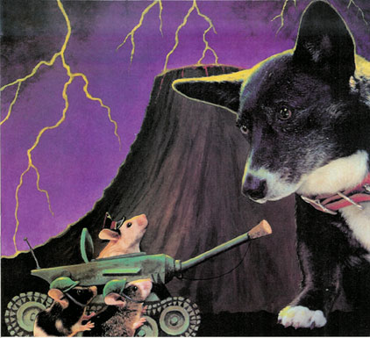

Dog Bone Slinger Design Challenge

Situation:
The city of Mousopolis is in trouble once again now that Dogzilla’s puppies are free! The Big Cheese and all the other mice must find a new way to keep the puppies away from their precious city and of course the Second Annual Barbeque Cook-Off! They decide to create the incredible Dog Bone Slinger to run the pups far, far away from the city. The only problem is that the mice don’t know how to build it!
Challenge:
In your assigned groups, you will help the mice design the most incredible Dog Bone Slinger. Using the design loop and the materials below, create a machine that is easy to operate and will fling dog bones as far away as possible from the city.
Tools:
(3) Rubber bands (4) pencils ruler scissors
Paper towel roll masking tape small cup duct tape
Paper cardboard clothes hanger plastic spoon
Test:
- Test out your solution and make any needed adjustments.
- Once your design is at its very best, your group will present to the class
- Then we will put all the designs to the test and see which group’s Dog Bone Flinger could shoot the bones the farthest away
Idea 1)
Brain Blast!

Idea 2)
Are your ideas thoughtful? Are they creative? Do they accomplish the goal?
Idea 3)
Dogzilla Literacy Challenge
Constructing a Dog Bone Slinger
Disciplinary Area: STEM
Unit: force, motion, direction, and mass
Standards:
Arkansas Science Curricular Frameworks (Physical Science): Students shall demonstrate and apply knowledge of motion and forces using appropriate safety procedures, equipment, and technology.

Standards for Technological Literacy: Students will develop an understanding of the role of troubleshooting, research and development, invention and innovation, and experimentation in problem-solving.

Common Core Math Standards (Measurement and Data) – Students will solve problems involving measurement and conversion of measurements from a larger unit to a smaller unit. (Geometry) – Students will draw and identify lines and angles, and classify shapes by properties of their lines and angles.

Common Core ELA Standards (Writing Standards) – Students will conduct research to build and present knowledge.
“Big Ideas”:
- role of brain storming to problem solve
- applied creative thinking for innovation
- principles of physics
- effective use of resources as technology
- engineering design
Essential Question: Can you design a machine that will shoot a dog bone as far as possible while also remaining easy to operate?
Scenario:
The mice of Mousopolis have realized they need a new plan of attack in order to defeat the dreadful puppies who threaten to ruin their beautiful city and precious second annual barbeque cook-off. They thought up the idea of using a machine that will shoot dog bones as far away as possible so that the pups will chase them and never return. The only problem is that the mice don’t know how to build such an incredible machine. Help the mice by building them a machine that can fling dog bones as far away as possible from the city while still remaining easy enough for a mouse to operate. This should be done in groups of 4 using the resources available below. Be creative in your ideas and use your resources wisely. You must plan out your idea on the Brain Blast sheets before any materials will be passed out.
Materials & Resources: (assigned teams of 4)
rubber bands duct tape paper masking tape
pencils small cups clothes hanger spoon
ruler paper towel roll cardboard scissors
Content Information:
According to Newton’s first law of physics, an object in motion will stay in motion and an object at rest will stay at rest unless acted upon by an outside, unbalanced force. This means that any object will not accelerate on its own or decelerate on its own. An object will actually resist change in its motion. It could be said that an object will keep on doing what it is doing. This tendency is called inertia. However, as stated earlier, an object will change its motion if acted on by an unbalanced force.
To understand an unbalanced force, we must know that there are always two forces acted upon an object at rest, gravity (the force that pulls all objects down towards Earth’s surface) and the force from the base of the object (such as the floor) pushing it up. These two forces are balanced and allow the object to stay at rest. Whenever a new force is introduced though, such as a push from the side, there is no force to compensate for it, or balance it out. Therefore, the force is unbalance and the object will move. This is also true when an object is in motion. This is why a ball that is rolling will eventually stop. The force of friction is acting upon the ball causing it to slow down.

When it comes to measurements, we use numbers to assign specific times, distances, space and weights to objects. There are set, standard units that each measurement can be compared to when measuring an object. These units can describe one dimensional, two dimensional, or three dimensional distances. Some examples include, centimeters, inches, square feet, or even cubic feet.

Source: http://www.physicsclassroom.com/class/newtlaws/u2l1a.cfm
Deliverables:
In your designated groups, design and create a machine using the materials given that effectively shoots a dog bone as far as possible from the machine. Each design will be tested in a competition to see which machine would best be suited for the mice of Mousopolis.
Parameters: The completed machine must:
- be capable of shooting a dog bone as far as possible from the machine
- be easy to operate
- be designed with the engineering design model in mind
- be turned in to instructor along with brain blast activity sheets, showing that the ideas were purposeful, thoughtful, and creative
- demonstrate the knowledge of force and motion through design
Evaluation:
Constructing a Dog Bone Slinger Rubric
Machine Name: _______________________________
Group Members:_____________________________________________________________________________
Assessment Criteria:
1) Machine was submitted along with brain blast activity ideas _________/10
2) Machine demonstrated creative, thoughtful and intentional _________/25
use of materials to carry out design
4) Students in group clearly and effectively presented their _________/15
project to the class
5) Machine shot the dog bone some distance across the room _________/20
6) Machine was easy to operate _________/10
7) Evidence that team followed the design loop to create _________/20
their machine
Total ___________/100
Will Humpty Go Splat or Will He Last?

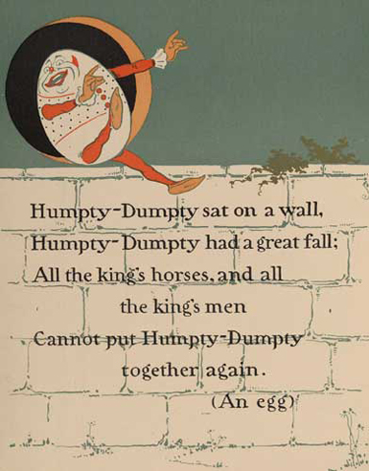
http://www.gutenberg.org/files/25883/25883-h/25883-h.htm
(Online Version of Humpty Dumpty Story)

Disciplinary Area: STEM

Unit: Gravity, Force, Impact and Laws of Motion

Standards:
- Common Core Standards (Writing) – Students will write or draw out the reasoning behind the use of each material and provide the research they found in order to back it up.
- Common Core Math Standards (Geometry) – Students will be able to solve structural problems using concepts of volume and space.
- Standards for Technological Literacy – Students will troubleshoot issues, research and develop a plan, experiment in problem solving by creating their containers, and then test the final product.
- Arkansas Science Curricular Frameworks (Physical Science): Students should demonstrate and apply knowledge of motion and forces using appropriate safety procedures, equipment, and technology.

“Big Ideas”:
- Develop increased ability to observe and discuss the common properties, differences, and comparisons of the objects and materials used and not used.
- Show an increased awareness as well as a basic understanding of the changes in materials and the cause and effect relationships that they have.
- Develop an understanding of scientific principles.
- Show creativity in their problem solving methods.
- Develop the skills necessary to describe their methods, predictions, explanations, and generalizations as they experience trial and error.

Essential Question: Can your students design a structure that would be able to help Old Humpty make it through his fall off of the wall?

Scenario: It was a beautiful day, just like many others before it, but today was a bit different in that an egg by the name of Humpty Dumpty faced a near death experience as he walked along one of the city walls. After regaining his balance he was reminded of the story of his own father’s (Old Humpty’s) tragic death. Shortly after the tragedy a hen in the town tells him of the simple procedure of becoming a hard-boiled egg that would help him avoid a death like his fathers.
In the case of this project it will be best if we focus on Humpty Dumpty’s father and what could have been done to protect him as he fell. This activity will be best accomplished in groups and once everyone has been given their student guides they can begin their research, make a few sketches, then of course gather their chosen supplies, and begin to build their containers. Below is a list of some of the possible resources that can be used in the construction of the structures.

Materials and Resources:

- Eggs
- Straws
- Shredded Paper
- Computer Paper/Newspaper
- Paper Towel Rolls
- Ziploc bags
- Foam
- Packing Peanuts
- Tape
- Glue
- Popcorn
- Cardboard
- Cartons and other containers
- Bags
- Popsicle Sticks
- Cotton

Content Information:
As we all know eggs are very vulnerable to breakage in their normal form, but with some extra protection any egg can be given a second chance at life. Although the outer case of the egg is meant for protection it is very fragile and not meant to withstand the impact of being dropped. If an egg is dropped the probability of being able to survive is slim to none. Once the egg begins to fall gravity takes hold and it has no other way to brace for impact other than shattering the shell that was meant to keep it safe in the first place. We see this same concept when we look at what happens to a car that ends up in a car accident. In most cases the shell of the car protects what is inside while in other cases it leaves quite a mess behind. In both cases the shell is being used to absorb the impact in hopes of keeping its contents safe.

Note to Teachers:
As you get ready to group your students and send them off to begin their work make sure and require that the students research and provide sketches of potential container ideas before allowing them to dive into the materials. As they brainstorm about their plans and work on their sketches you should make sure to remind them of the concepts behind the Laws of Motion and how they might play a role in the end results of the impact. Since an object stays in motion once it is set in motion they will need to make sure that they take the last bit of energy produced from the impact, and still needing to be displaced, into consideration. As the students approach you with questions about the many different materials you should have resources for them to dive into to find answers instead of just telling them why you would choose any given material while also allowing them to touch and test their structures with other objects before introducing the eggs into the equation.

Deliverables: Using only the materials you provide the students will be expected to make a “basket” or a container that would help Old Dumpty withstand a fall. Once the containers are built you will have your students do a drop test to see just how effective their final products really are while also requiring them to do some critical thinking. Critical thinking can be encouraged by requiring your students to jot down what they would have done differently, what aspects they would take away from other containers, what materials they wouldn’t use again, etc.

Parameters: The completed protective container must:
- Be as lightweight as possible.
- No bigger than 8in by 8in by 8in.
- Show creativity in the ways that the resources are used.
- Look pleasing to the eye. (Not just thrown together)
- Be able to withstand being dropped from a list of different heights.

Assessment: The assessment will be based upon the overall quality and originality of each students design. A small portion of the student's grade should be based upon the overall quality of the tested device and only slightly upon the fact of the egg making it through the fall or not. So when it comes down to it a rigid, well-made, and well-thought-out container should earn more points than an egg that is just placed in a box with cushioning materials. This is to ensure that the students who invest more brainpower time into the project and overall design itself receive a grade that fully reflects their efforts.

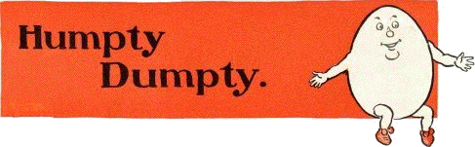
Will He Go Splat or Will He Last?

Be creative and ALWAYS remember to think outside of the box.

- Research- materials and the benefits they may have to your structure.
- Sketch- out your ideas, thoughts, findings, and what you would like your structure to look like.
- Build- a structure using the provided materials only.
- Test- your structure
- Rethink- the issues and fix what you can.
- Repeat- until you are happy with the end result.

Challenge: Using the resources listed below design a container that would help an egg make it through a fall.

Resources

- Eggs
- Straws
- Popsicle Sticks
- Shredded Paper
- Sheet Paper
- Newspaper
- Paper Towel Rolls
- Foam
- Pacing Peanuts
- Popcorn
- Cotton
- Cardboard
- Cartoons and other containers
- Paper Bags
- Plastic bags
- Tape
- Glue

Parameters: The completed protective container must:
- Be as lightweight as possible.
- No bigger than 8in by 8in by 8in.
- Show creativity in the ways that the resources are used.
- Look pleasing to the eye. (Not just thrown together)
- Be able to withstand being dropped from a list of different heights.

After the drop:
- Write down your observations.
- What did you learn after all of the containers were tested?
- Why do you think some devices didn’t protect the eggs?
- Were there any techniques that you wish you would have taken from other group containers and added to your own container?

Explain Yourself:
What interesting facts did you find while researching?

Why did you choose some materials over others?

Sketch it out

Nicole Choate
STEM Tuesday Thursday 2:15
Making a Map Activity
“Franklin is Lost” By: Paulette Bourgeois

Situation Challenge:
Franklin is out playing hide and goes to play hide and seek with his friends. He was told by his parents to be home by six o’clock, and when he does not show up they become worried about him. Franklin got lost in the woods looking for fox, who had decided to hide at bear’s home. Franklin’s parents finally find him, and take him back on the path in which he got lost on.

Challenge:
Franklin and his parents do not like it when he gets lost. Design a map that will help Franklin find his way home, and also design a map of your surrounding area that you could use to find your way home. Be sure to include landmarks and a compass so that you know which direction to go.
Resources:

Paper
Markers
Ruler
Tape/ Glue
Yarn
String
Aluminum Foil
Pipe Cleaners
Card Stock
Construction Paper
Scissors
Egg Cartons
Paper Plates
Popsicle Sticks
Beads

Limitations:
- Each map should have 5 to 10 geological or industrial land marks to help you identify Franklin’s way home.
- The map of your own house and surroundings should also contain 5 to 10 geological or industrial land marks to help you identify your own home.
- Each map should contain a compass, or grid to help you know the directions (north, south, east, and west).
- Design your map with clear titles.
- Each map should be colorful.
- Each map should be no bigger than 20”x20”, and no smaller than 10”by 10”.
- Each map must contain at least three 3D images (Standing on the map)
Evaluation:
- Make a checklist for your map, realistically relating it to your surroundings’ and Franklin’s.
- Develop a design loop for your map.
- Present and demonstrate your map to the class.
Curriculum Standards:
Reading Literature Standards K-8: Concentration Grade 2

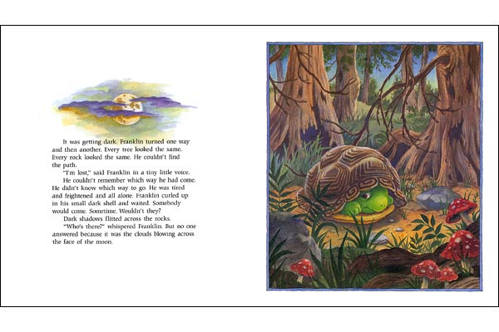

Assessment:
Name: _____________________________
Date: ____________
Rating: 10 Excellent/ 1 Needs Improvement
Technology Log:
- Design Sketch 10 9 8 7 6 5 4 3 2 1
- Documentation of Problem Solving 10 9 8 7 6 5 4 3 2 1
- Meeting Requirements 10 9 8 7 6 5 4 3 2 1
Franklin’s Map/ Your Map Design:
- Creativity (Use of Materials) 10 9 8 7 6 5 4 3 2 1
- Size of Maps 10 9 8 7 6 5 4 3 2 1
- 3D Structures 10 9 8 7 6 5 4 3 2 1
- 5 to 10 geological or industrial structures 10 9 8 7 6 5 4 3 2 1
- Compass or Grid (For directions) 10 9 8 7 6 5 4 3 2 1
- Title 10 9 8 7 6 5 4 3 2 1
Overall Challenge Assessment
- Design Loop 10 9 8 7 6 5 4 3 2 1
- Sketches (Ideas) 10 9 8 7 6 5 4 3 2 1
- Presentation 10 9 8 7 6 5 4 3 2 1
Comments/ Observations:

Interdisciplinary Connections:
Health
- The importance of knowing where you are
- The importance of staying safe and not getting lost
Language Arts
- Read the book aloud “Franklin is Lost”
- Watch Episode of “Franklin is Lost”
Music
- Learn a song about Maps
- Listen to relaxing music while constructing the maps
Science
- The study of the directions
- Geological and Industrial landmarks (Understanding the difference)
- Learn about gridlines on a map
Technology
- Constructing the map
- Incorporating the use of a compass
Math
- Measurements for the map size
- Measurements for the grid lines
Art
- The construction of the maps
- 3D landmarks on the map
- Title for the maps
Social Studies
- The importance of a map in order to know your surroundings
- Learn about the different uses of maps in our world today

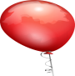
Chain Reaction Activity

Situation:
In the book, Because the Little Bug Went Ka-Choo, the bug sneezed and caused a huge chain reaction of events. This silly story is similar to the idea of Rube Goldberg’s machines.

A Rube Goldberg machine is a contraption that performs a simple task in indirect and complex ways.

Challenge:
Create a “Rube Goldberg” contraption to pop a balloon. Use your imagination and have fun!

Instructions:
- Work with a partner or group to brainstorm and create a set of machines to pop a balloon.
- Use a minimum of 6 steps to complete the task.
- Use at least 2 simple machines (lever, pulley, wedge, wheel and axel, screw, inclined plane)
- Use at least 3 recycled items
- Write a description that explains each step of your contraption. Use lots of detail!

Materials:
Use any materials you would like.
Here are some ideas of possible materials you can use:

String/yarn, cups, balls, Lego’s, wheels, toys , magnets, pens and pencils, tape, milk cartons, cans, pipe cleaners, utensils, paperclips, paper towel tubes, rubber band, ect…

Evaluation:
1. You will have time to set up your contraption.
2. You will then present your contraption to the class.
3. You will also turn in any brainstorming sheets and your narrative.

Assessment Rubric

Project Name_________________________________________________________
Group Members___________________________________________________________

Rating: 5 = Excellent/ 1 = Needs Improvement

Narrative

A. Detail 5 4 3 2 1
B. Creativity 5 4 3 2 1
C. Fluency 5 4 3 2 1

Contraption

D. Creative Use of Materials 5 4 3 2 1
E. Uses at least 5 steps 5 4 3 2 1
F. At Least 2 Recycled Materials 5 4 3 2 1
G. At least 2 Simple Machines 5 4 3 2 1
H. Contraption is successful 5 4 3 2 1

Team

I. Organization 5 4 3 2 1
J. Cooperation 5 4 3 2 1
K. Presentation 5 4 3 2 1

_________________________________________________________________________

Overall Assessment 5 4 3 2 1

Comments/Observations:
___________________________________________________________________________________________________________________________________________________________________________________________________________________________
__________________________________________________________________________________________________________________________________________________
Chain Reaction Activity (Teacher Version)
Grade level: 4-6
Curriculum Standards:
Science
- Communicate the designs, procedures, and results of scientific investigations
- Collect and interpret measurable empirical evidence in teams and as individuals
- Use simple equipment, age appropriate tools, technology, and mathematics in scientific investigations
- Investigate the relationship between force and direction
- Investigate the relationship between force and mass
- Conduct investigations using
  - levers (e.g., toothbrush)
  - pulleys
  - inclined planes-ramps, wedges, and screws
  - wheels and axles

- Relate simple machines to inventions and discoveries
- Compare and contrast potential energy and kinetic energy as applied to motion
- Conduct investigations using potential energy and kinetic energy

Language Arts

- Use subject-related information and vocabulary
- Communicate ideas and information with clarity
- Give precise directions and instructions for more complex activities and tasks
- Organize writing to convey a central idea
- Use available technology to collect information for writing
- Revise writing to utilize elements of style, including word choice and sentence variation
- Write to define, clarify, develop ideas, and express creativity
- Write complex narrative, descriptive, expository, and persuasive compositions that have topic sentences, concrete sensory supporting details, a context to allow the reader to imagine the event, and a logical conclusion
- Use logical sequence
- Use such descriptive language as action verbs, specific nouns, vivid adjectives, and adverbs to add interest to writing
- Use purposeful Vocabulary
- Deliver oral presentations using appropriate vocabulary

Students should be able to:
- List the general steps of the engineering design process.
- Think critically about the importance of the machines they encounter in life.
- Use their knowledge of simple and compound machines to design and build a small Rube Goldberg machine.
- Understand Cause and Effect and the significance of step-by-step.
Procedure
Part 1: Design the Rube Goldberg Machine (25 minutes)
- In groups of three, have student engineering teams decide on what materials they are going to use and how they are going to utilize them
- With every group member contributing ideas, have students brainstorm ideas about how they will accomplish the simple task.
  - Remind them that they must use at least two simple machines in their final design.
- Teams should include a list of all the materials they think they will need. Be sure to include any extra materials they would like.
- Teams will show their design to the teacher for approval.
- Have students make design alterations if not immediately approved.
Part 2: Build the Rube Goldberg (50-60 minutes)
- Have students spend a few minutes reviewing their drawings from Part 1 before starting to build.
- Have student teams gather their materials and begin to build their design.
- Emphasize that each group member participates.
- Student engineering teams should follow the design as closely as possible.
- Once teams, have completed their design, have them test their machine.
- Allow student teams to return to their seats and make adjustments if necessary.
- Allow each engineering team to display their Rube Goldberg machine to the class during the last 10 minutes or so of class.

(http://www.teachengineering.org/view_activity.php?url=collection/cub_/activities/cub_simp_machines/cub_simp_machines_lesson05_activity1.xml#objectives)

The Big Orange Splot Activity
Student Handout

Essential Question: Can you construct a model home using the design loop out of purchased materials that meets all of the given parameters, and that is unique and reflects your individual personality?

The Scenario:
Mr. Plumbean gets a can of bright orange paint dropped on his roof by a seagull, which makes his house stand out apart from the other homes. His neighbors want him to paint over the splot, but he likes the splot and decides to completely repaint his home with other bright colors. The neighbors are unhappy at the sight of his house, but soon people become inspired and begin to redesign there homes to reflect their personalities as well.

Resources and Prices:

-Cardboard base as foundation will be provided.
-1 cereal box brought from home (will be provided if student can not
obtain one)=Free
-various other boxes collected from Recycling= 3 credits per box
-paper towel rolls= 2 credits per roll
-glue= 1 credit
-masking tape= 10 inches for 1 credit
-popsicle sticks= 4 credits for 6 sticks
-cardstock= 2 credits per sheet
-paint= 1 credit
-construction paper= 3 credits for 3 sheets
- materials found on nature walk= FREE but a maximum of 7 things

Limitations:
- Students will work independently or with 1 to 2 partners to design a house.
- The model house must reflect each students’ personality, and be able to stand on its own.
- The completed model house must be at least 10 inches taller and 10 wider than the original box, without exceeding 2.5 ft in width, length or height.
- The model should be designed as light as possible.
- Each student is given 20 credits if working individually, if working as a group they will be allotted 25 credits.
Evaluation:
- Test stability and weight, refine your design.
- Evaluate and record your solution.
- Present and demonstrate your solution to the class.
Assessment Rubric
Name:__________________ Date:________
Rating Scale: 5=Excellent!....1=Needs Improvement
Recorded Data:
A. Design Sketch 5 4 3 2 1
B. Documentation of Problem Solving 5 4 3 2 1
C. Self-Evaluation 5 4 3 2 1

Student-Designed House:
D. Creative use of materials 5 4 3 2 1
E. Size and weight of model home 5 4 3 2 1
F. Use of credits 5 4 3 2 1
G. Presentation relating personality to the design 5 4 3 2 1

The Big Orange Splot Activity
Disciplinary Area: STEM

Unit: Structures, Design, Language Arts

Curriculum Standards:
- Common Core Math Standards (Standard 5): Use appropriate tools strategically
- Standards for Technological Literacy (Standard 10): Students will develop an understanding of the role of troubleshooting, research and development, invention and innovation, and experimentation in problem solving.
- ELA Common Core Standards (Standard 3): Students will read, write, listen, and speak for critical analysis and evaluation.

“Big Ideas”
- Role of brainstorming and creativity to solve a problem
- Engineering is the application of science and technology
- Effective use of resources as technology
- Conservation of materials
- Design under constraint

Essential Question: Can you construct a model home using the design loop out of purchased materials that meets all of the given parameters, and that is unique and reflects your individual personality?

The Scenario:
Mr. Plumbean gets a can of bright orange paint dropped on his roof by a seagull, which makes his house stand out apart from the other homes on his street that all look the exact same. His neighbors want him to paint over the splot but he decides he likes the big orange splot, and in fact would like many more bright colors and designs added to the exterior of his home. The neighbors are initially aghast at the sight of his house, but soon people become inspired and begin to redesign there homes to reflect their unique personalities.

Resources and Prices:

-Cardboard base as foundation will be provided.
-1 cereal box brought from home (will be provided if student can not
obtain one)=Free
-various other boxes collected from Recycling= 3 credits per box
-paper towel rolls= 2 credits per roll
-glue= 1 credit
-masking tape= 10 inches for 1 credit
-popsicle sticks= 4 credits for 6 sticks
-cardstock= 2 credits per sheet
-paint= 1 credit
-construction paper= 3 credits for 3 sheets
- materials found on nature walk= FREE but a maximum of 7 things

Deliverables: Students must construct a model home using only the materials supplied by the instructor that shows individual personality and meets all designated parameters.

Parameters:
- Students will work independently or with 1 to 2 partners to design a house.
- The model house must reflect each students’ personality, and be able to stand on its own.
- The completed model house must be at least 10 inches taller and 10 wider than the original box, without exceeding 2.5 ft in width, length or height.
- The model should be designed as light as possible.
- Each student is given 20 credits if working individually, if working as a group they will be allotted 25 credits.
Evaluation:
- Test stability and weight, refine your design.
- Evaluate and record your solution.
- Present and demonstrate your solution to the class.

Assessment Rubric
Name:__________________ Date:________
Rating Scale: 5=Excellent!....1=Needs Improvement
Recorded Data:
A. Design Sketch 5 4 3 2 1
B. Documentation of Problem Solving 5 4 3 2 1
C. Self-Evaluation 5 4 3 2 1

Student-Designed House:
D. Creative use of materials 5 4 3 2 1
E. Size and weight of model home 5 4 3 2 1
F. Use of credits 5 4 3 2 1
G. Presentation relating personality to the design 5 4 3 2 1

Sarah Bart Intro to STEM
Helping Monkey’s Stay A ‘Float
Building a Functional Model Boat and Adding Weight
Disciplinary Area: STEM
Unit: Shapes, mass, density, buoyancy
Standards:
- Common Core Math Standards (Measurement and Data): Solve problems involving measurement and estimation of intervals of time, liquid volumes, and masses of objects.
- Standards for Technological Literacy: Develop the abilities to apply the design process
- Standards for Science: Evidence, Models, and Explanations
- Standards for English/Language Arts (Writing): Write and/or draw to communicate ideas
“Big Ideas”
- The role of creativity and problem solving
- Design under constraint
- Engineering Design
- Fundamental concepts of engineering and mathematics
- Fundamental concepts of science
- Turning something known into something understood
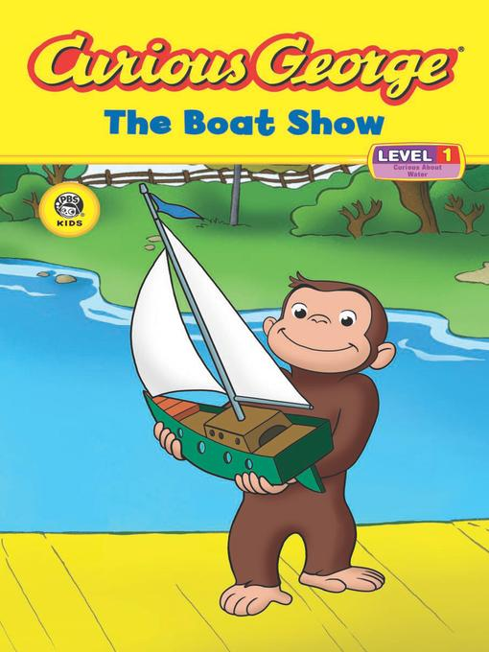
Essential Questions: Can you design a boat that, when placed in water, can stay a ‘float while monkeys are being added for weight?
Scenario: You have just read aloud the Curious George short story, The Boat Show, to your first grade class. Now it is time to explain what it takes for a boat to be able to float in the water. Topics such as shapes, weight, force, buoyancy, density and mass should be discussed with your students. Discuss these topics with them before you read the story so you can explain those terms to them while you’re reading the story and show them examples along the way. You decide to give the children an opportunity to make a boat of their own that they can test in a small body of water you are providing for the classroom. Let the children work individually for this assignment so everyone is able to construct a boat they will be proud of just like Curious George did. Have the students test their boats one at a time once their work is completed.

Materials and Resources:
- 6 inches Masking Tape | - Cardboard
- 6 inches Duct Tape | - ½ pound of Clay
- 12 inches Yarn | - 2 sheets of Paper
- Hot glue (with teachers help!) | - 5 Craft Sticks
- 6” by 12” Aluminum foil | - A ruler

Content Information: Boats are able to float for many reasons. When teaching a first grade classroom why boats are able to float, use real terms and vocabulary to spark their thinking. A good way to start the lesson would be to have a series of objects in front of the room and hold them up individually. Ask the class if they think they will float or sink and why. Once they answer the question, place it in a tub of water for them to see if it will float or sink. Describe to them that the shapes of many objects plays a part too. For example, clay will float if it is shaped properly however if it were made into a ball it would sink down to the bottom. Describe to the class that a boat will float because of a word called buoyancy. Buoyancy is a force that liquid has to make objects of less density rise to the surface. Essentially, buoyancy forces objects that are lighter than the water to stay at the surface of the water. Explain to the children that when an object sinks, gravity is pulling it down. Buoyancy works against gravity to keep lighter objects at the surface of the water. Density is another subject area that should be discussed. Density is how much material is in a given space. Density relates to mass because it tells us that objects with the same mass could have a different density. For example, if you 2 boxes of the same sitting next to each other. You filled one box with rice and the other box with feathers. The box with rice is more dense because there isn’t a lot of space for air to take place unlike the box filled with feathers. The best shape for a boat would be rounded but in the shape of a traditional canoe. The deeper the boat is made, the longer is needs to be made as well. This will prevent the boat from tipping over in the water. Give the children a background on boats as well. The front is called the bow, the back is called the stern and the hollow part that allows the boat the float is called the hull. Boats have a surface covering the hull where the people stand called the deck. Explain to the children that this is where they would stand if they were on a boat. Let them know what boats are able to float no matter how large they are because of the amount of air that is inside the hull.

Deliverables:
Give the children access to the materials provided above. Don’t limit them to a certain number because that can be frustrating to young students. Their boats should be able to float in a tub of water that you will be providing. Have the students count to 10 which will be the length of time they want their boat to at least float for with the most amount of monkeys their boat can hold.
Parameters:
- Have the students draw a few brainstorming ideas for their boat design and show you to get their materials
- The boat should be able to float for at least 10 seconds (the students counting)
- The floating device should appear as a boat (hollow center, front and back)
- The boat should be at least 6 inches long
- Be designed using the design loop presented in class
- Only using the materials the teacher has provided in class

Assessment:
Helping the Monkey’s Stay A ‘Float Grading Sheet
Name: _______________________________ Date:_____________________
______ Boat was able to float for 10 second with the maximum amount of monkeys it could hold
______ Floating device appeared to be a boat
______ Only used the materials provided in class
______ Completed a brainstorming sheet and used the design loop
______ Boat was at least 6 inches long and appropriately measured
_______ Total stars:
5 stars= EXCELLENT
4 stars=GOOD
3 stars= SATISFACTORY
2 stars= NICE EFFORT
1 star=BACK TO BRAINSTORMING
Brainstorming Sheet
Name__________________
Draw the materials you will use. | How will you piece together your materials to form a boat?
What will your boat look like when putting the pieces together? | Finished product!

Name:__________________
Date:___________________
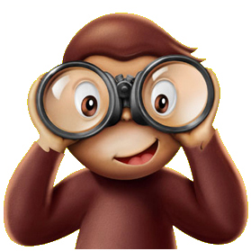
Helping the Monkey’s Stay A ‘Float!
We just read about Curious George and his time at the boat show. George was able to build a boat out of toys he had. His boat was able to float in the water. Now it is your turn! You get to build a boat that floats in water too! You are allowed to choose from the following materials:
- 6 inches Masking Tape | - Cardboard
- 6 inches Duct Tape | - ½ pound of Clay
- 12 inches Yarn | - 2 sheets of Paper
- Hot glue (with the teacher’s help!) | - 5 Craft Sticks
- 6” by 12” Aluminum foil | - A ruler

Make sure your boat is AT LEAST 6 inches long. That means use your ruler to measure it!
Before you get started BRAINSTORM your ideas on the next page!
Show George and I the best boats you can build and how many monkeys it can hold!
Use our class design loop to get started!
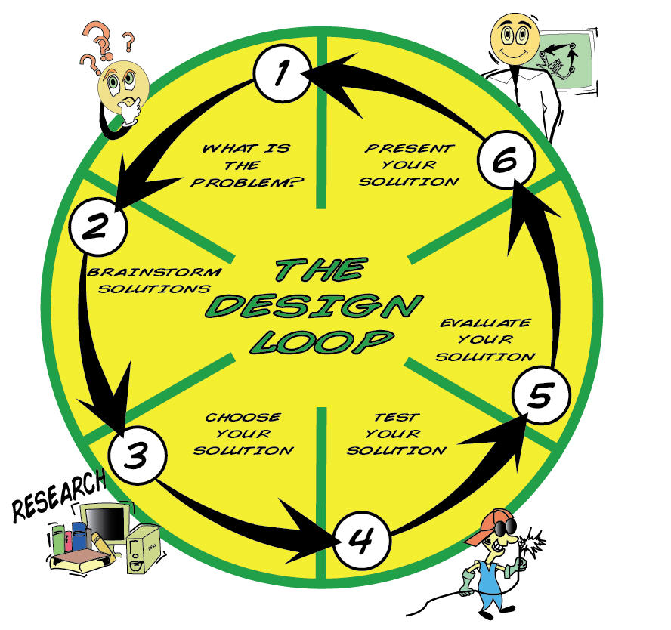
Helping the Monkey’s Stay A ‘Float Grading Sheet
Name: _______________________________ Date:_____________________
______ Boat was able to float for 10 second with the maximum amount of monkeys it could hold
______ Floating device appeared to be a boat
______ Only used the materials provided in class
______ Completed a brainstorming sheet and used the design loop
______ Boat was at least 6 inches long and appropriately measured

_______ Total stars:
5 stars= EXCELLENT
4 stars=GOOD
3 stars= SATISFACTORY
2 stars= NICE EFFORT
1 star=BACK TO BRAINSTORMING

Structurally Sound Houses
Building houses that can withstand external elements

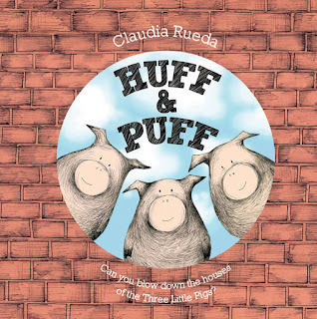

Disciplinary Area: STEM

Unit: Structures, Force, Motion, Weather (Tornado)

Literacy: Huff and Puff written by: Claudia Rueda

Standards:
- Common Core Math Standards (Geometry): Reason with shapes and their attributes.
- National Science Education Standards (Physical Science): Properties of objects and materials.
- Standards for Technology Literacy (Engineering Design): The engineering design process, involves defining a problem, generating ideas, selecting a solution, testing the solution, making the item, evaluating it, and presenting the results.
- Arkansas Department Education Frameworks (Oral and Visual Communications – Speaking): Students shall demonstrate effective oral communication skills to express ideas and to present information.
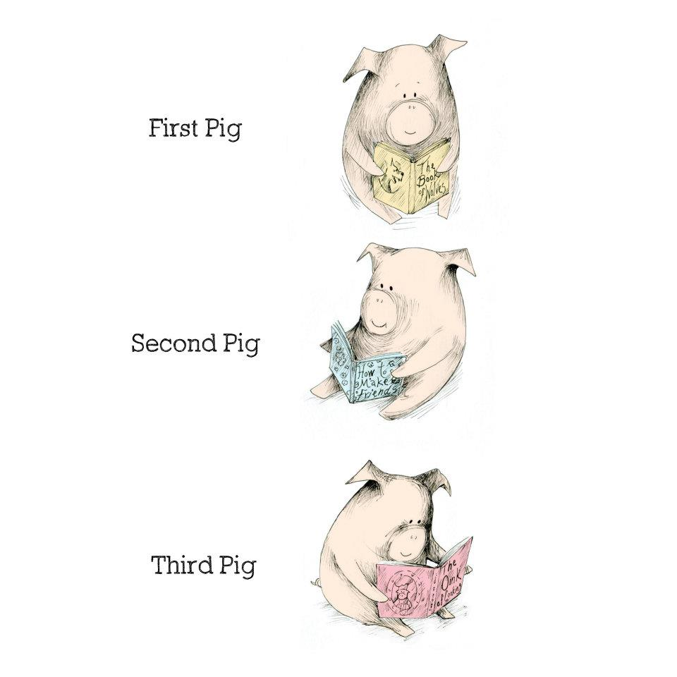

Big Ideas:
- Attributes of shapes and their effect on sustainability
- Properties of materials and their ability to survive the storm
- Proper use of design loop
- Ability to demonstrate and present final project to group

Essential Question: Can you design a shelter that will withstand the winds of a tornado?

Scenario: After reading Huff and Puff, a tale of the three little pigs and their attempts and successes of building a shelter to remain safe from the “huff and puff” of the big, bad, wolf, you will now create a model shelter that can withstand the winds of a F2-F3 tornado (a very strong “huff and puff”).

Directions: Students will develop a plan by following the design loop. The students should not be given resources until they complete numbers 1-3 on the design loop handout. Students are only allowed to use materials from the materials/resource list. Students will choose one item from each of the categories, they are not allowed to use more than the initial given resources. The shelter must be at least 6 inches tall, have a base of 7X7 inches, and must adhere to a cardboard base.
After your students create a model, it will be tested to determine its ability to withstand the high winds created from a simulation tornado.

New Vocabulary Terms:
Instability – The sense of being uncertain.
Cylinder – Circular shape
Classifications – Grouping items together based upon their similarities
Simulation – A product that is created to represent a separate event or circumstance
Fujita Scale – A classification system that determines the strength of tornadoes

Materials/Resources: Choose one resource from each of the following categories to build your shelter:

Straws | Craft sticks | Spaghetti Noodles

Construction Paper | Cellophane

Heavy Tape | Wood Glue

Content Information:
Tornadoes are a forceful rotating wind storm that occurs when warm wet air mixes with cold dry air. When these two different types of air meet they create instability. This instability can then cause the air to spin and blow in different directions causing an updraft. When the tornado forms it will continue to spin and looks like a cylinder reaching from the sky to the ground. Tornadoes can come in different sizes and strengths depending upon the air type, temperature, rain, and wind. A tornadoes severity is measured on a Fujita scale. The following table explains the different strengths of tornadoes and their classifications.

SCALE | WIND SPEED | POSSIBLE DAMAGE
F0 | 40-72 mph | Light damage: Branches broken off trees; minor roof damage
F1 | 73-112 mph | Moderate damage: Trees snapped; mobile home pushed off foundations; roofs damaged
F2 | 113-157 mph | Considerable damage: Mobile homes demolished; trees uprooted; strong built homes unroofed
F3 | 158-206 mph | Severe damage: Trains overturned; cars lifted off the ground; strong built homes have outside walls blown away
F4 | 207-260 mph | Devastating damage: Houses leveled leaving piles of debris; cars thrown 300 yards or more in the air
F5 | 261-318 mph | Incredible damage: Strongly built homes completely blown away; automobile-sized missiles generated
Shelter and Weather
Building a shelter that can withstand a tornado

Situation:
We just finished reading Huff and Puff, the story of the three little pigs and their attempts at building a house to stay safe from the big, bad, wolf. Now you will create a model shelter that can stay standing when challenged by the winds of a F2-F3 tornado (a very strong “huff and puff”).

Challenge: Can you design and build a shelter that will stay standing during the strong winds of a tornado?
Directions:
- You must complete numbers 1-3 on the design loop before you get your materials.
- You are only allowed to use materials from the material/resource list.
- You are not allowed to use more resources then given.
- Your shelter must be at least 6 inches tall, 7 inches wide, and 7 inches long
- You must attach your shelter to a cardboard base
- After you create your shelter, it will be tested to determine its ability to withstand the high winds created from a simulation tornado.

Materials/Resources: Please choose one resource from each of the following categories to build your shelter:

Straws | Craft sticks | Spaghetti Noodles

Construction Paper | Cellophane

Heavy Tape | Wood Glue

Information to Know:
Tornadoes are a forceful rotating windstorm that occurs when warm wet air mixes together with cold dry air. When these two different types of air meet they create instability. This instability can then cause the air to spin and blow in different directions. When the tornado forms it will keep spinning and begins to look like a cylinder reaching from the sky to the ground. Tornadoes can come in different sizes and strengths depending upon the air, temperature, rain, and wind. Tornadoes strength is measured on a Fujita scale. The following table tells you the differences between tornados according to their classifications.

SCALE | WIND SPEED | POSSIBLE DAMAGE
F0 | 40-72 mph | Light damage: Branches broken off trees; minor roof damage
F1 | 73-112 mph | Moderate damage: Trees snapped; mobile home pushed off foundations; roofs damaged
F2 | 113-157 mph | Considerable damage: Mobile homes demolished; trees uprooted; strong built homes unroofed
F3 | 158-206 mph | Severe damage: Trains overturned; cars lifted off the ground; strong built homes have outside walls blown away
F4 | 207-260 mph | Devastating damage: Houses leveled leaving piles of debris; cars thrown 300 yards or more in the air
F5 | 261-318 mph | Incredible damage: Strongly built homes completely blown away; automobile-sized missiles generated

New Vocabulary Terms:
Instability – The sense of being uncertain.
Cylinder – Circular shape
Classifications – Grouping items together based upon their similarities
Simulation – A product that is created to represent a separate event or circumstance
Fujita Scale – A classification system that determines the strength of tornadoes

The Design Loop:


1) Identify the problem: ______________________________________________________________________
2) Consider the Facts and develop a solution:

______________________________________________________________________
3) Choose your solution and draw your idea:

4) Build your model and Test

5) Evaluate your model and make changes ___________________________________

______________________________________________________________________
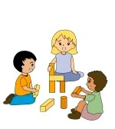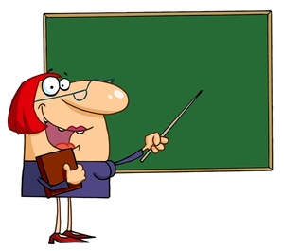
6) Present your ideas to others

