STEM Through Kinetic Folk Art
Michael Daugherty and Vinson Carter
University of Arkansas
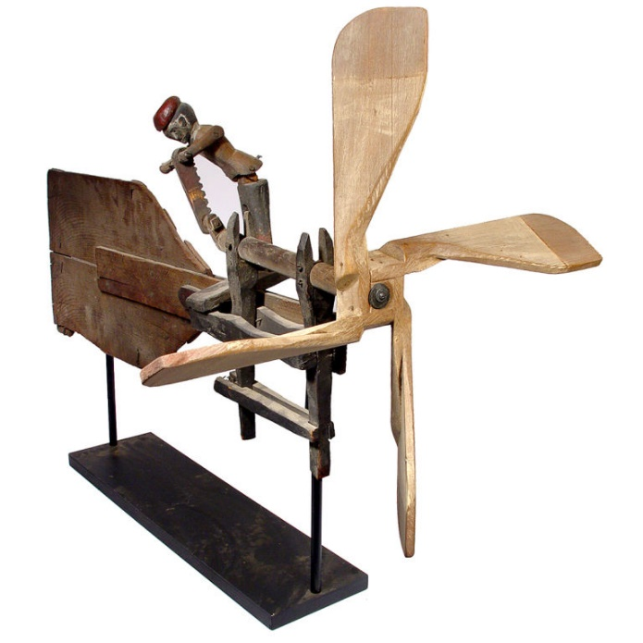
From simple paper pinwheels on sticks to intricate kinetic wind sculptures, the history of the whirligig dates back to a twirling propeller made of bamboo, which originated in China in 400 B.C., and the later wind-propelled toys that imitated the world's first windmills. A crucial part of whirligigs is the weathervane, which was invented in Sumeria between 1600 and 1800 B.C. and in 644 B.C., the Persians first used the horizontal windmill for irrigation. However, no whirling toys of this period appear to have survived apart from one Egyptian string-propelled doll from 100 B.C. As you travel throughout the countryside and towns of America, you can’t help but take notice of the various weathervanes and whirligigs that grace rooftops and gardens as well as those that have made their way into homes and museums as folk art objects for display. What you may not have considered are the numerous science, technology, engineering, and math (STEM) concepts that make the whirligigs function. All basic whirligigs transition straight-line (linear) wind motion into rotary motion, and then reciprocal motion (up and down). This folk art themed STEM activity will allow you to experiment with some basic concepts from all of the STEM disciplines while examining some themes from the art world.
STEM Content Standards
- Next Generation Science Standards: 3.PSA.A
  - Definitions of Energy: Moving objects contain energy. The faster the objects move, the more energy it has. Energy can be moved from place to place by moving objects, or through sound, light, or electrical currents. Energy can be converted from one form to another form.
- Technology for All Americans Standards: #16 Energy and Power Technologies
  - Students will develop an understanding of and be able to select and use energy and power technologies.
    - Energy is the capacity to do work. Power is the rate at which energy is converted from one form to another or transferred from one place to another.
- Common Core Mathematics: Measurement & Data: CCSS.Math.Content.4.MD.A.1
  - Solve problems involving measurement and conversion of measurements. Know relative sizes of measurement units within one system of units including km, m, cm; kg, g; lb, oz.; l, ml; hr, min, sec. Within a single system of measurement, express measurements in a larger unit in terms of a smaller unit. Record measurement equivalents in a two-column table. For example, know that 1 ft is 12 times as long as 1 in. Express the length of a 4 ft snake as 48 in. Generate a conversion table for feet and inches listing the number pairs (1, 12), (2, 24), (3, 36), …
Big Ideas
- Understand the types of energy and energy conversion.
- Mathematics can be used to measure time, distance, intervals, speed, etc.
- Major STEM concepts can be used to create works of art
- Art can be kinetic
- Art is often an expression of surroundings
Content Information (in brief)
- What is energy? The ability to do work.
- What is potential energy? The amount of energy something has stored for later use.
- What is kinetic energy? The energy of an object in motion.
- What is propulsion? The force that propels or moves something forward.
- How does mass relate to speed? The more mass an object has, the more energy it will require to move. The less mass, the less energy required.
- How is the wind energy, provided by nature, transferred into vehicular or object motion? Samples: Sailboat, kite, windmill, etc.
- Energy conversions: How is one type of energy changed into another? Wind (linear) to rotary to reciprocal to rotary to etc.
- What mathematical instruments are used to make sure four identical items are of the same size?
- How can machine rotations be calculated and represented in revolutions per minute (RPM)?
- What is the mathematical relationship between wind (linear) speed and rotary speed in RPM’s?
- Conservation of Energy: The total energy of an isolated systems remains constant—conserved.
- Newton’s Three Laws of Motion
  - 1st Law: Every object in a state of uniform motion tends to remain in that state of motion unless an external force is applied to it
  - 2nd Law: The relationship between an object's mass m, its acceleration a, and the applied force F is F = ma. Acceleration and force are vectors; in this law the direction of the force vector is the same as the direction of the acceleration vector.
  - 3rd Law: For every action there is an equal and opposite reaction
- Kinetic art: Dadaist and Constructivist movements of the 1910’s.
- Art embracing technology and the improvement of life
- Art as a satirical attitude toward machines and movement—the machine as the master.
- The relationship between the machine and the human.
Scenario
- You have a very important point that you would like to make, but every time you open your mouth, you seem to get in trouble. Life does not seem fair, adults get to say whatever they want without getting in trouble. During a recent visit to Crystal Bridges Museum, you discovered that many great artists were able to say a great deal without uttering a word and you decided to make your point through kinetic art. You’re going to work with some other students to design a whirligig that makes a point!

Essential Question
- How can a kinetic machine be designed to convert rotary motion into reciprocal motion while representing an idea or a concept?
Challenge
Using a whirligig and simple recycled materials, your team will design a whirligig that turns rotary motion into reciprocating motions and powers a piece of kinetic art.
Parameters
Teams completing this whirligig must strictly adhere to the following design constraints:
- Use only materials provided by your teacher.
- The completed whirligig must utilize a given whirligig base and not extend beyond the ends of the base or more than 8 inches above the base.
- The message portrayed through the kinetic art must be in good taste and something that your grandmother would approve.
- Teams must complete the engineering journal and submit it with the completed whirligig.
- Teams must calculate force, RPMS, and describe the energy conversions taking place on the whirligig (include in the engineering journal).
Tools, Materials, and Resources
Whirligig base | Card stock or cardboard | Digital stop watch/I-phone
Dowel rods | rulers | Masking tape
Hot glue/glue gun | Paperclips | Colored markers
Coat hanger wire | Wire cutters | Needle nose pliers
Wood saw | Sandpaper | Brass brads
Paper hole punch | Scissors | Engineering journal

Assessment
The design team constructed a working whirligig that delivered a message while converting motion from linear to rotary to reciprocal motion | (0-20 pts)
The design team utilized the design loop to arrive at a solution and recorded this activity in the engineering journal | (0-20 pts)
The design team accurately calculated the force and RPM’s of the whirligig and recorded this information in the engineering journal as well as correct information related to energy conversions | (0-10 pts)
The design team accurately used the materials and tools necessary to complete this design problem | (0-10 pts)
The design team demonstrated knowledge of the STEM content associated with this lesson during informal discussions with the teacher | (0-20 pts)
The design team worked as a cohesive unit during the completion of the STEM problem—with all members contributing equally | (0-10 pts)
The design team used appropriate STEM vocabulary and technical terms during the team presentation of the whirligig | (0-10 pts)
TOTAL | (0-100 pts)
Teacher Notes
Students should be provided with an exploration of the content associated with this activity prior to being placed in design teams of three to four students. Each design team should be provided with a whirligig base, an engineering journal, and the materials identified in the table above prior to beginning this STEM activity. Some teachers prefer to simply assign a price for each resource and a budget for each team—thereby encouraging the teams to efficiently “purchase” the materials necessary to complete the activity. The teacher should also review the scenario, the challenge, the parameters, and the assessment prior to allowing the teams to begin work. The teacher may also want to review the engineering design loop (below) if the teams do not have previous experiences using this essential design tool. After the design teams have completed their respective whirligigs, each team should complete the required calculations, finalize the engineering journals, and complete a short presentation on their team whirligig. This presentation should include discussions on the idea, how the idea was refined, changes made during the design work, the function of the whirligig, changes that would be made if the team could start again, and a technical discussion of motion.

The Engineering Design Loop
