TEED 1103 Anthropological Assignments

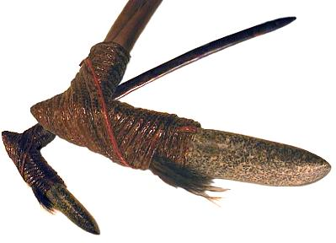
This assignment allows you to look at the connections between nature, technology, society and culture by exploring two anthropological artifacts. It takes an historical and anthropological perspective, going back to the earliest stone tools and tracking their genealogical connection with contemporary high-tech design in order to think outside the box. Tracking the design of these technologies takes us through an interdisciplinary mix that includes archaeology, cultural anthropology, science studies, the history and sociology of technology, cognitive science and even evolutionary psychology.

Aims and objectives
The overall aim is to address some abstract and theoretical questions concerning the process of design, and in particular the interrelation of nature and technology in making and consuming goods. We need a big picture and long term view to understand the relationship between nature and technology and concepts for tackling questions and problems raised by contemporary science and technological development. This accounts for the anthropological and archaeological component of the course - the only basis for such a broad big picture.

Requirements
During the remainder of this course, you will be required to submit two anthropological case studies that include a design challenge for students. You may select from the list of below (or choose another appropriate artifact – please get this approved) when picking the two artifacts that you will examine. The assignment is to prepare a case study/challenge on a selected artifact. The objective is to unpack the working of the artifact, track it through conception, design and consumption, to make manifest the stories and scenarios held within the association of material, technology, use.

The submitted case study may take any digital form - a dossier of discrete items, visual and/or textual, one or more narratives, an analytical model, or whatever is considered appropriate means of manifesting the connections between nature, technology and culture.
- After selecting an appropriate artifact, you should complete the following exercises to develop an appropriate submission:
- Gather research—lots of research
- Develop an outline for the case study
  - Abstract (in one paragraph, tell us the whole story)
  - Introduction (what is the artifact? Why was it developed? What did it replace?)
  - Design (how as the artifact designed? What tools were used to make the artifact? What was the inspiration?)
  - Historical introduction and adaptation (How did this artifact advance civilization? –if it did, What changes did it cause? What unintended consequences resulted?)
  - Photos and/or sketches
  - Social and cultural impacts
  - Conclusions
  - Create a design challenge for students
  - References
- Prepare a case study of your artifact that sets the background for your design challenge.
- After developing your case study, you should create a teaching model of your artifact.
You will receive a score on:
  - The digital and printed submission (50%) - case study /challenge
  - The model (50%)
For the first case study, select from the following artifacts:
- A Palaeolithic or Neolithic handaxe
- Atlatl
- An American Indian spear point
- Or choose another appropriate artifact – please get this approved

