Innovation and Invention Project (15 points)
Due Thursday, May 7 – 8:00am

The Problem: Using your critical thinking skills, create a product using simple materials, other found materials, and simple tools and fabrication techniques.

- How could I create a product using the provided materials, other found materials, and simple tools and fabrication techniques?
  - Appropriate technological solution or original invention
    - Reuse a product container/packaging
    - Relate it to something in your own life
- What features from other familiar tools could be added to improve the product?
- How could I create more “curb appeal” for the product?
- What is the most people would pay for an improved product?

The Challenge: Work individually to create an improved product that incorporates the provided materials.

Resources: Found or other appropriate materials, tools in the STEM lab

Limitations: Individuals will be required to remain within the following design parameters while completing the design challenge:

- Individuals must complete the four steps included in the Design Log (next page) prior to beginning construction.
- Individuals must provide typed responses to all of the questions outlined above and submit them with the completed design log and prototype.
- The prototype should be constructed in a neat fashion.
- You will complete the Design Log, construct the prototype, conduct a trial of the device, and record the data in the Invention Assessment Rubric before the due date.

Objectives: After completing the lesson, students will illustrate a greater understanding of the role of creativity in the development of new technologies.

Curriculum Standards: Standards for Technological Literacy (Standards #2, #6, #8)

Initial Questions

How could I create a product using the provided materials, found materials, simple tools, and fabrication techniques?

What features from other familiar tools could be added to improve the product?

How could I create more “curb appeal” for the product?

What is the most people would pay for an improved product?

Name: ________________________________ Date: __________________

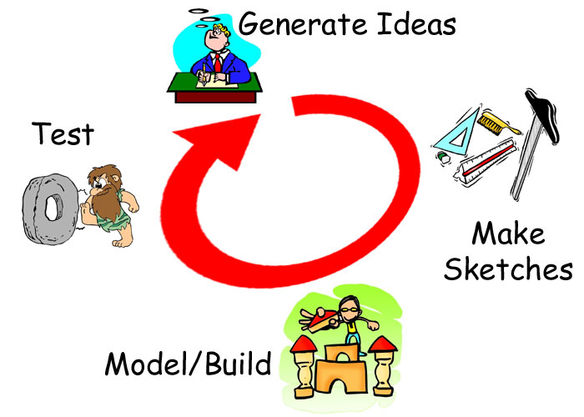
The Design Log:
Complete each of the steps outlined below as you
work to create a prototype.

Generate Ideas:
Carefully consider the challenge that you have
been given. Generate and record as many ideas as
possible (minimum of 50) during the limited time
you have been provided. Record your initial ideas in
the space below:

Develop 4 sketches and descriptions from your initial ideas in the boxes below.

Create a final drawing and description that includes the best ideas from all of your refined ideas.

Modeling/Testing: Use your final drawing and description to construct the prototype. Test your product. After testing your prototype complete the Invention Assessment Rubric and Reflection.

Name: ________________________________ Date: __________________

Invention Assessment Self-Assessment Rubric

Rating: 5 = Excellent/1 = Needs Improvement

1. Completion of Design Log 5 4 3 2 1
2. Neatness of Final Product 5 4 3 2 1
3. Functionality of Final Product 5 4 3 2 1
4. Written Discussion Questions 5 4 3 2 1

Total Points: ________/20

Reflection: How could you improve your product?

__________________________________________________________________________________________

__________________________________________________________________________________________

__________________________________________________________________________________________

__________________________________________________________________________________________

__________________________________________________________________________________________

__________________________________________________________________________________________

__________________________________________________________________________________________

__________________________________________________________________________________________

__________________________________________________________________________________________

__________________________________________________________________________________________

__________________________________________________________________________________________

__________________________________________________________________________________________

__________________________________________________________________________________________

__________________________________________________________________________________________

__________________________________________________________________________________________

__________________________________________________________________________________________
Invention and Innovation Project Design Rubric

Name: ________________________

Project Title: ________________________

Category | 0 pts. | Up to 1 pt. | Up to 2 pts. | Up to 3 pts. | Score
Timeline | No (or limited) attempt made | Did not finish product schedule on time | Finished product schedule on due date | Finished product schedule before due
Quality of Product | No (or limited) attempt made | Product design is below quality standards | Product design meets quality standards | Product design exceeds quality standards
Design Loop/ Drawings, Sketches, Descriptions | No (or limited) attempt made to use the design loop or provide drawings/sketches. | Used one or two stages of the design loop successfully  Drawn items are below standards or incomplete | Used some stages of the design loop effectively. Drawn items are at the standard | Provided evidence of using the design loop extensively.  Drawn items exceed or are very detailed and include an accurate description of the design
Product Assessment | No (or limited) attempt made | Documentation of testing was below standard | Documentation of testing met the standard | Documentation of testing exceeded requirements
Model/  Prototype | No (or limited) attempt made | Model or prototype meets some, but not all requirements | Model or prototype met all necessary requirements | Model or prototype exceeds requirements
Comments: Total Points: /15

Final Exam/Project (10 points)
- Students will have 5 minutes to sell your invention to the class and demonstrate your prototype/teaching model. This can be in the form of a video/commercial, brochure/advertisement, or other appropriate demonstration of your invention

Name: ________________________

Project Title: ________________________

Category | 0 pts. | Up to .5 pts. | Up to 1.5 pts. | Up to 2.5 pts. | Score
Product | Student does not have grasp of product; student cannot answer questions about subject. | Student is uncomfortable with product and is able to answer only rudimentary questions. | Student is at ease with product and content, but fails to elaborate. | Student demonstrates full knowledge (more than required) with explanations and elaboration.
Organization | Audience cannot understand presentation because there is no sequence of information. | Audience has difficulty following presentation because student jumps around. | Student presents information in logical sequence which audience can follow. | Student presents information in logical, interesting sequence which audience can follow.
Presentation | Presentation appears incomplete.  Multimedia is over or underused.  Format does not enhance content. | Student occasional used visuals that rarely support text and presentation.  Presentation is loosely organized. | Multimedia is used to illustrate the main points.  Format is appropriate for the content.  Presentation is organized. | Multimedia is used to clarify and illustrate the main points.  Format is well organized.  Presentation is well organized.
Mechanics | Student's presentation had four or more spelling errors and/or grammatical errors. | Presentation had three misspellings and/or grammatical errors. | Presentation has no more than two misspellings and/or grammatical errors. | Presentation has no misspellings or grammatical errors.
Comments: Total Points:

