A Bridge to Nowhere
Introduction:
Cantilevers are widely found in construction, notably in cantilevered bridges and balconies. In an architectural application, Frank Lloyd Wright's Fallingwater used cantilevers to project large balconies.
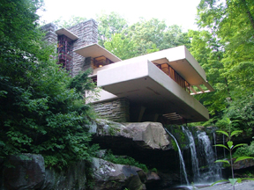
Another use of the cantilever is in fixed-wing aircraft design.
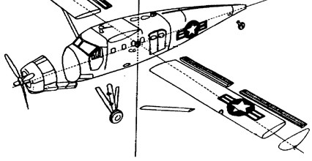

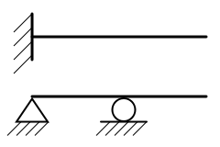
Most cantilevers are created by an extension of a simply supported beam.

Design Challenge:
Working as a member of an engineering design team, design a cantilevered structure that will extend the furthest distance possible from a vertical surface that can support the weight of a golf ball.
Design Requirements:
Your cantilever must have a full moment connection (like the diagram below).

Materials:
1 ft. - Masking Tape
2 - 8 ½ x 11 Sheets of Paper
1 ft. - Masonry Line (braided-string)
Additionally, students may use a pair of scissors and a writing instrument.
(*Materials can only be applied to the surface of the wall and extended outward. The total horizontal distance of the structure away from the wall will be measured.)

