ArtBot Lesson Plan
Basic Electricity

Overview:
ArtBots can be made from found objects and recycled materials. They work using a simple circuit that demonstrates motion created by an offset motor. You can use new motors or motors and switches from discarded toys and electronics. There are a variety of skills and concepts one can explore including playing with variables (weight of materials, drawing implements) as well as energy, circuits, kinetic motion, balance, design, pattern, repetition, color, etc.
Objectives:
- Apply knowledge of electric circuits to design and construct a simple circuit with motor.
- Identify the pathway the energy travels from the battery through the motor and back.
- Use the principles of art and design thinking to help me plan and construct my ArtBot.
- Revise projects in response to testing my machine and feedback from my peers.
Materials:
- 1 - 1.5 to 3 volt DC hobby motor
- 2 - AA batteries
- Battery holder (or homemade battery holder)
- Plastic or paper cup
- Rubber eraser or cork
- Electrical wire
- Masking tape
- Scissors
- Misc. materials including: Recycled containers, cardboard, pipe cleaners, popsicle sticks, colored tape, markers, construction paper, etc.
- White butcher paper for students to test their machines. It can be helpful to set up a barrier around the paper!

1 - Small 1.5-3V Motor – .98 - https://teachergeek.com/collections/bulk-components/products/1-5-3v-mini-motor-bug-motor-20-pack?variant=3993392068
1 - AA Double Battery Holder with Switch and Wire Leads - .84 - https://teachergeek.com/collections/bulk-components/products/2-aa-battery-holder-w-switch-10-pack
2 - AA Batteries - .24 X 2 - https://www.amazon.com/dp/B00LH3DMUO/ref=sxr_rr_xsim_1_s_it?pf_rd_m=ATVPDKIKX0DER&pf_rd_p=3008523062&pd_rd_wg=qNhUh&pf_rd_r=ESFH716TNM2QXGDG5051&pf_rd_s=desktop-rhs-carousels&pf_rd_t=301&pd_rd_i=B00LH3DMUO&pd_rd_w=X22Jk&pf_rd_i=aa%2Bbatteries&pd_rd_r=ffb47c1e-efba-433a-b80e-44142479d79b&ie=UTF8&qid=1511285693&sr=1&th=1
Additional supplies -

24” - Masking Tape/Duct Tape
2 – Pencils
2 – Paper Clips
1 - Party Cups
2 – Straws
2 – Popsicle Sticks
1 – Small piece of aluminum foil

Tools – *We can supply the tools
Wire Strippers
Scissors
Quick Cutters
Rulers

Artist Connections:
- Cameron Robbins: http://www.abc.net.au/arts/stories/s3636858.htm
- Bruce Shapiro: http://egg-bot.com
- Maillardet's automaton: https://www.youtube.com/watch?v=jfeNC28vpYo
- Juan Fontanive: https://vimeo.com/102453528
Major STEM Concepts:
- Students make observations to provide evidence that energy can be transferred from place to place by sound, light, heat, and electric currents.
- Students apply scientific ideas to design, test, and refine a device that converts energy from one form to another.
- Students conceive of original artistic goals for media artworks using a variety of creative methods, such as brainstorming and modeling.
- Students practice foundational innovative abilities, such as design thinking, in addressing problems within and through media arts productions.
- Students demonstrate the use of tools and techniques

Procedure:
- Introduce the lesson by asking students what they know about electricity and what life would be like without electricity.
- Provide students with a battery, wires, and motor and ask them to connect the materials to make the motor run. Once all circuits are running, ask students what is making the motor run. Record student ideas and discuss until the class reaches a unified model of how electricity drives the motor (electrons generated by the battery which then travel through the wires to the motor and back to the battery).
- Show artists examples. Using Visual Thinking Strategies, ask the students to respond to the images/videos.
- Let students know that they will be designing their own ArtBots in teams using the materials provided. Do a quick demonstration on how one can construct simple forms and attach materials including the pens.
- Have students do a sketch of their ideal machine.
- Making the motor run! Connect the battery to the motor using wires from the battery holder.
- Offset the motor by attaching an off-centered weight (the rubber eraser) to the rotor pin. This will create the motion needed for the machine to move across paper.
- Create the basic form or base of your ArtBot to attach the offset motor using the cup and tape. Students can modify the form once the motor is attached and tested.
- Attach the offset motor to the base. Make sure there is enough clearance for the offset motor to spin and that the ArtBot, with motor, can stand.
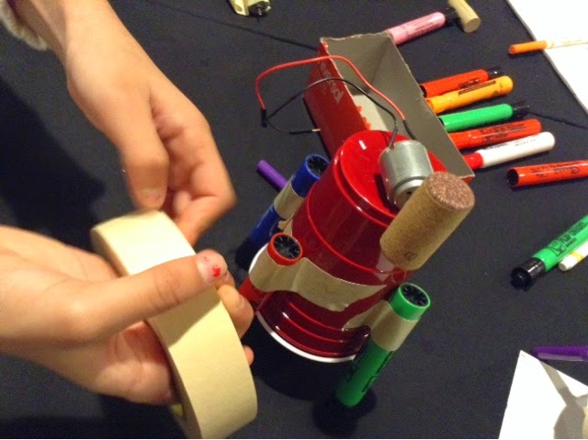
- Attach drawing materials using three markers, charcoal, pencils, chalk, etc.
- Test your ArtBot to make sure it moves. Revise as needed.
- Finish designing, decorating, and personalizing your ArtBot.
- Start drawing!

Assessment:
Assessing these design-based products can be accomplished through teacher or self-review. The teacher assessment should start with a student or team presentation—allowing the students to defend their team decisions. Students should gather around one group and their project. The teacher should facilitate the process: “Look at the ArtBot designed by this team. What aspect of their work shows an interesting solution to the design challenge?” Provide students a sentence frame such as “this is successful because…the evidence is…” Students can then document their responses in writing.

Management Considerations:
Connecting the motor to the battery and adding it to a base that can move without falling down, can be challenging for the students. When students begin to test their machines on paper they will see the results of their work and the excitement and motivation will increase. At this point, the teacher can encourage the students to make adjustments or challenge them to modify their designs to change the behavior of the ArtBot. Testing the ArtBots also reveals other challenges students might encounter such as attaching drawing implements to the base so that they don’t fall off, creating an ArtBot that can move without falling over, etc. Often the students themselves will step in to assist a peer when these problems arise.

