Propulsion Machine Design Journal

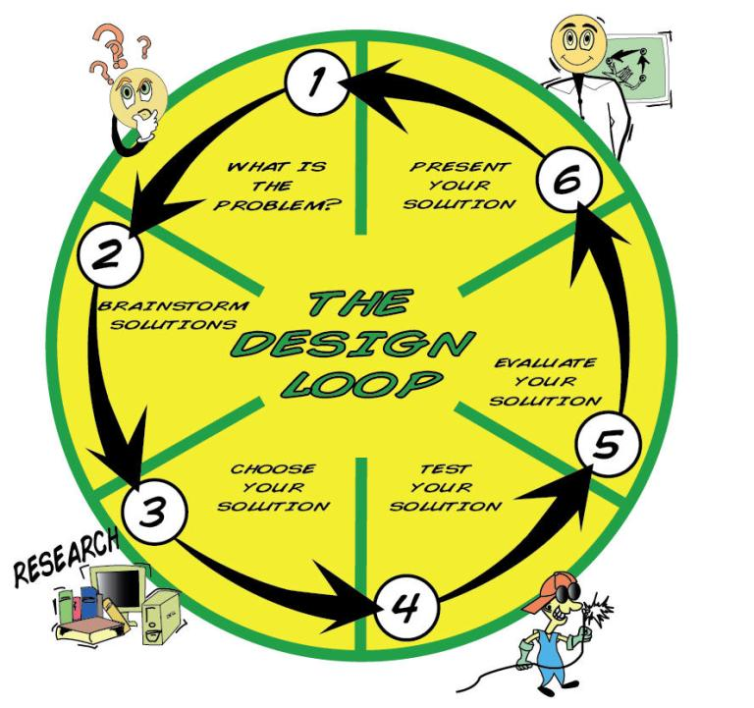

Design Team Members:

_________________________________________

Date Started: Tuesday, February 3

Date Completed: Tuesday, February 10

- What is the problem?

What do I need to do?

- Brainstorm solutions –

What do I already know?

What do I need to find out?

What did I find out?

My First Ideas:

- Choose your solution:
My best idea is ……

The steps I will use:

The tools and materials I will use:

ADDITIONAL NOTES:

- Test your solution

How did you test your solution?

How do you know if your idea works?

5. Evaluate your solution

How would you change your idea?

What did you learn?

What did you like about this project?

What did you not like about this project?

6. Prepare to present your solution to the class.

