Lego Mindstorms NXT Robotics Technology (Design Challenge – 10 pts.)

Day 1
- You will work in teams to construct a Lego Mindstorms NXT robot.
  - Using the Lego Mindstorms Education Building Guide (9797), you will complete the construction of the Driving Base robot (pgs. 8-22)

*Remember to bring a laptop for your group to use on days 2 and 3. You will need to install the LEGO Mindstorms NXT 2.1 software.
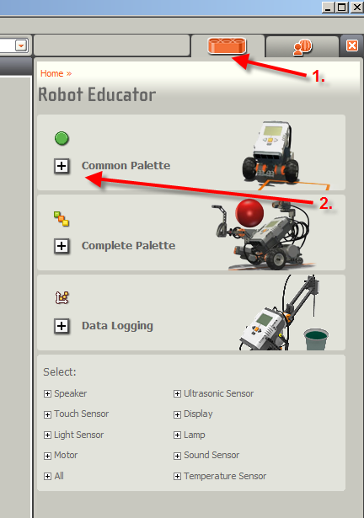
Day 2
- Using the LEGO Mindstorms NXT 2.1 program on your computer.
  - Click on orange block to enter the Robot Educator
  - Click on the Common Palette and complete Challenge Briefs 1 – 17.

- Next, you will begin to develop programing to complete two of the four design challenges that we will be presenting to students at the Springdale Public Library
  - 360 Degree Maze
  - Line Follower Maze
  - Spelling Challenge
  - The Labyrinth

Day 3

- Complete design challenge programming and demonstrate completed challenges
Evaluation (10 points)
- Successfully built the Driving Base and used accessory sensors as needed
- Completed Challenge Briefs 1-17
- Conducted simple programing and building experiments needed to successfully complete two of the four design challenges
    - 360 Degree Maze
    - Line Follower Maze
    - Spelling Challenge
    - The Labyrinth

2:00 Class Robotics Teams

Team 1 – Caitlin G., Demi Team 2 - Caitlin A., Avery
Team 3 – Danette, Kourtnie Team 4 – Ryan, Ashton
Team 5 – Anna, Hanna Team 6 – Alyssa, Lauren
Team 7 – Mackenzie, Sarah Team 8 – Ashlyn, Amanda

