Lego Mindstorms NXT Robotics Technology (Design Challenges – 50 pts.)

Day 1 – April 6
- You will work in teams to conduct experiments using a Lego Mindstorms NXT robot.
- Using the LEGO Mindstorms NXT 2.1 program on your computer.
  - Click on orange block to enter the Robot Educator
  - Click on the Common Palette and complete Challenge Briefs 1 – 20.

*Remember to bring a laptop for your group to use. You will need to install the LEGO Mindstorms NXT 2.1 software.
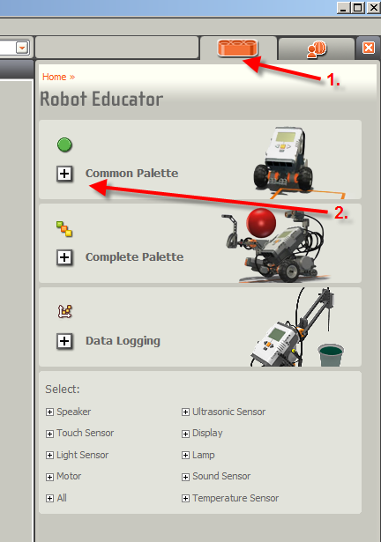
Day 2 – April 11
- Next, you will begin to develop programing and modifications to complete each of the following challenges.
  - 360 Degree Maze
  - Line Follower Maze
  - Spelling Challenge
  - The Labyrinth

Day 3 – April 13
- Complete design challenge programming and demonstrate completed challenges
- Successfully modified the Driving Base and used accessory sensors and motors as needed
to completed Challenge Briefs 1-20
- Conducted simple programing and building experiments needed to successfully complete each of the following design challenges:
    - 360 Degree Maze
    - Line Follower Maze
    - Spelling Challenge
    - The Labyrinth
  - Broke down project for storage (please keep driving base intact).
Bonus:
- Visit the website: http://www.nxtprograms.com/index1.html.
- Try completing one of the additional projects listed on this website.

