Lego Mindstorms NXT Robotics Technology (Design Challenge – 10 pts.)

Day 1 – February 18

*Remember to bring a laptop for your group to use on days 2 and 3. You will need to install the LEGO Mindstorms NXT 2.1 software.
- Using the LEGO Mindstorms NXT 2.1 program on your computer.
  - Click on orange block to enter the Robot Educator
  - Click on the Common Palette and complete Challenge Briefs 1 – 17.
Day 2 – February 23
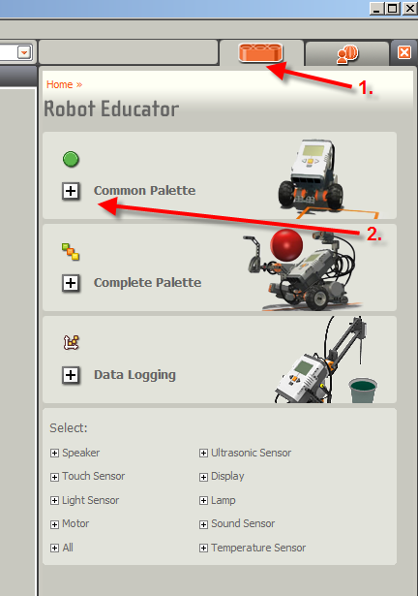
- Next, you will begin to develop programing to complete two of the four design challenges that we will be presenting to students at the Springdale Public Library
  - 360 Degree Maze
  - Line Follower Maze
  - Spelling Challenge
  - The Labyrinth

Days 3 & 4 – February 25 and March 8

- Complete design challenge programming and demonstrate completed challenges
Evaluation (10 points)
- Successfully built the Driving Base and used accessory sensors as needed
- Completed Challenge Briefs 1-17
- Conducted simple programing and building experiments needed to successfully complete two of the four design challenges
    - 360 Degree Maze
    - Line Follower Maze
    - Spelling Challenge
    - The Labyrinth

4:00 Class Robotics Teams

Team 1 – T.A., Madison Team 2 – Ashley, Paige
Team 3 – Emmalee, Dani Team 4 – Makenzie, Savannah
Team 5 – Cortney, Krystine Team 6 – Michael, Kelsey
Team 7 – Anna, Elise Team 8 – Tyler, Carley

