Marionette Resources
Constructing a Simple Marionette
- https://www.youtube.com/watch?v=eLa2-zOr-Fg
- http://www.stormthecastle.com/how-to-make-a/how-to-make-a-marionette.htm
Materials Needed – newspaper, wire, masking tape, string or fishing line, popsicle or craft sticks, eye hooks
Tools – wire cutters, scissors, drill
Stringing the Puppet for Manipulation
http://www.puppetsinprague.eu/instructions/stringing_puppet.html
https://www.youtube.com/watch?v=rqsjfIVFIdg
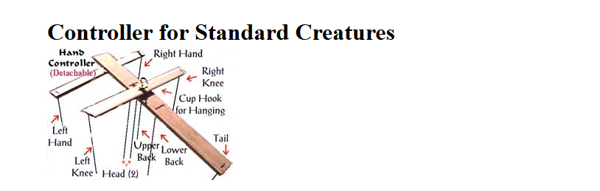
Additional Resources
https://www.youtube.com/watch?v=9p5wxccxtU0
http://www.sp.uconn.edu/~wwwsfa/library_howto_rodpuppets.htm

