TEED 1103 Midterm Review

Technology

The engineering design process/loop – what is happening at each stage of the design process

Terms associated with the technology and engineering education profession - AIAA – ITEEA

Invention

Innovation

Model

Prototype

Con straints

The history of rope

The history of the stirrup

The Standards for Technological Literacy

The difference between science and technology

Assessing technology – intended, unintended, positive, negative, immediate, and delayed effects

technological literacy
Historical and current terminology associated with the study of technology
manual technology
training & engineering
1870’s Present

Arkansas TEED curriculum – ETE

National TEED curriculums - PLTW, EbD

4 main areas of emphasis in technology and engineering education

- _____________________________ 2. __________________________________

3. _____________________________ 4. __________________________________

Food Security

Biotechnology

Urbanization

Food Miles

Technologies from student anthropological assignment I presentations – atlatl, basketry, boleadoras, paleo sling, paleolithic handaxe, Neolithic handaxe, mortar and pestle

TEED 1103 Midterm
- In 1939, the American Industrial Arts Association (AIAA) was founded. Today, it is known as the ITEEA or the ____________ ______________ ____ _____________ __________.
- Released in the spring of 2000 by the ITEA and its Technology for All Americans Project, the Standards for ______________ ______________: Content for the Study of Technology (STL) were developed to assist curriculum developers as they develop K-12 technology education curricula.
- Designers and engineers use the _______________ _____________ to guide their thinking while developing solutions to problems.
- Technology and engineering education is generally referred to as ETE (Engineering and Technology Education) in grades 7-9. Arkansas has adopted PLTW or _____________________ ___________ ______ _____ ‘s curriculum at the high school level.
- The processes used in technology to alter or change the natural world are ____________, innovation, problem-solving, and design.
- There is evidence that humans were making _________ as far back as 17,000 BC, and is viewed as one of the earliest examples of humans improving on nature (making technology).
List 3 names associated with the i of Technology & Engineering Education in the past:
7. _____________________________ 8. ________________________________
- ____________________________
- A throwing device usually consisting of a stick fitted with a thong or socket to steady the butt of a spear or dart and extend the length it travels is called an _________________.
- The parameters placed on the development of a product or system, are referred to as _________________.
- The term STEM is sometimes used synonymously for technology and engineering education stands for the integrated study of ___________ ___________ ____________ and _____________.
- ____________ is the modification or adaptation of the natural world to suit their own purposes of humanity.
- ____________ seeks to understand a world that already exists, and provides the knowledge about the natural world that underlies most technical products today.
What are the 4 main areas of emphasis of study within technology and engineering education
- _____________________________ 16. _____________________________
- _____________________________ 18. _____________________________
- A ___________ is a full size or working model of a device or process. Sometimes the term is used to mean the first complete item of what subsequently becomes a production series.
- The term _______________ ______________ is used to describe a person who is comfortable with and objective about the use of technology, and neither scared nor infatuated with it. This term is used also used to describe one's ability to use, manage, evaluate, and understand technology.

TEED 1103 The Nature of Technology Name: ________________________

- ________________________
- ________________________
- ________________________
- ________________________
- ________________________
- ________________________
- ________________________
- ________________________
- ________________________
- ________________________
- ________________________

- ________________________
- ________________________
- ________________________
- ________________________
- ________________________
- ________________________
- ________________________
- ________________________
- ________________________
- ________________________

PLEASE LETTER ALL RESPONSES NEATLY
Why is important to understand technology? (10points)

________________________________________________________________________________________________________________________________________________________________________________________________________________________________________________________________________________________________________________________________________________________________________________________________________________________________________________________________________________________________________________________________________________________________________________________________________________________________________________________________________________________________________________________________________________________________________________________________________________
______________________________________________________________________________________________________________________________________________________________________________________________________________________________________________________________________________________________________
Technology is often referred to as a double-edged sword. What does this mean? (10points)
________________________________________________________________________________________________________________________________________________________________________________________________________________________________________________________________________________________________________________________________________________________________________________________________________________________________________________________________________________________________________________________________________________________________________________________________________________________________________________________________________________________________________________________________________________________________________________________________________________
______________________________________________________________________________________________________________________________________________________________________________________________________________________________________________________________________________________________________
Use the chart below to assess the use of cell phone technology. (10points)

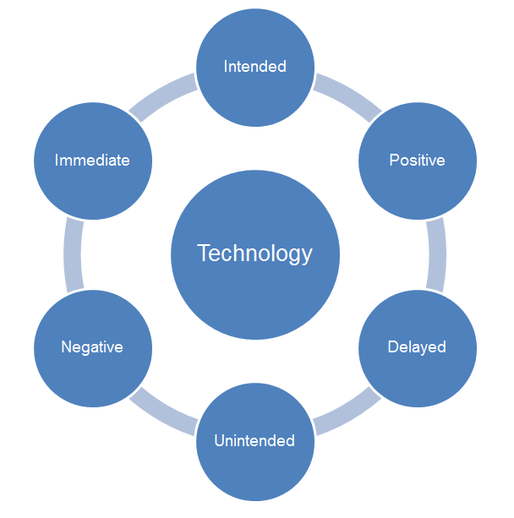
Cell Phone

