SCTC 2018 PROBLEM SOLVING – VibroBOT Design Challenge

CHALLENGE
Working as a member of an engineering design team (2-3) members from your school), design and construct a working VibroBOT that can travel the greatest distance from a specified starting location during a one-minute time period.

OVERVIEW
A VibroBOT can be made from simple materials and work using a simple circuit that demonstrates motion created by an offset motor. There are a variety of skills and concepts one can explore including altering variables (weight of materials, friction implements/points) as well as energy, circuits, kinetic motion, balance, design, pattern, repetition, etc. For this design challenge you will need to apply your knowledge of electric circuits to design and construct a simple circuit with motor, identify the pathway the energy travels from the battery through the motor and back, and use the principles of design thinking to plan, construct, and improve your VibroBOT to travel the great distance in a limited period of time.

ELIGIBILITY
Teams are limited to three members.

LIMITATIONS
To complete this engineering design activity successfully, your team must adhere to the design parameters outlined below. Failure to observe these parameters may cause your team to be disqualified.
- Schools may have multiple engineering design teams entered in this contest, but each team should not include more than three members from the school;
- The completed VibroBOT device must:
  - Initiate from the designated starting location.
  - The device must be constructed from the following materials:

1 - Small 1.5-3V Motor
1 - AA Double Battery Holder with Switch and Wire Leads
2 - AA Batteries
24” - Masking Tape/Duct Tape
2 – Pencils
2 – Paper Clips
1 - Party Cup
2 – Straws
2 – Popsicle Sticks
1 – Small piece of aluminum foil
1 – Piece of a glue stick
Additionally, teams may use the following tools as needed: Wire Strippers, Scissors, Quick Cutters, and Rulers
- Teams must submit a testing sheet and design journal that outlines the process used to design, construct, and test the device.
- One member of the engineering team should be prepared to briefly discuss the design of the team entry prior to testing;
- All rulings of the contest judges during the event will be final.

TIME LIMITS
The device must be completed during the contest time.

EVALUATION
The team with the VibroBOT that can travel the furthest distance from a specified starting location during a one-minute time period will be determined the winner. Solution designs and the design journal will be used to break ties. Only as a last resort does the event coordinator use subjective measurement, such as originality or aesthetics, to evaluate solutions. Please complete following information and submit with your final design to the testing site.

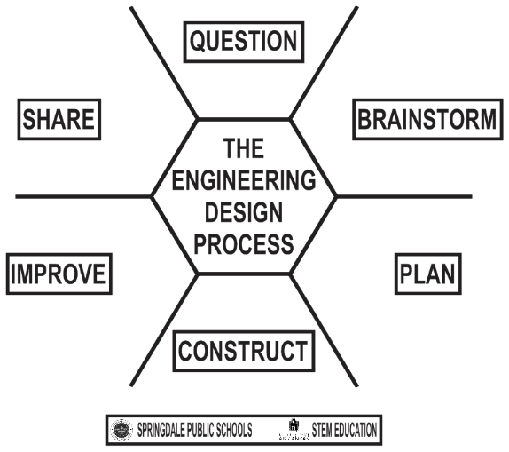
2018 SCTC Problem Solving

☐ LEVEL I ☐ LEVEL II

School Name: ________________________________
Team Members
1. ________________________ Test 1 Distance : ________________________
2. ________________________ Test 2 Distance : ________________________
3. ________________________ Test 3 Distance : ________________________

Question: Identify the problem that your team has been asked to solve?
____________________________________________________________________________________
____________________________________________________________________________________
____________________________________________________________________________________
____________________________________________________________________________________

Brainstorm: Imagine what is possible. Generate (draw) as many ideas as possible

Plan: Choose the best solution. Sketch what your team will build using ideas from above.

Construct: Create your model.

Improve: How can you improve or modify our design? What variables can you change?
____________________________________________________________________________________
____________________________________________________________________________________
____________________________________________________________________________________
____________________________________________________________________________________

Share: Prepare to defend your team solution.

