Depth of Knowledge (DOK) Levels

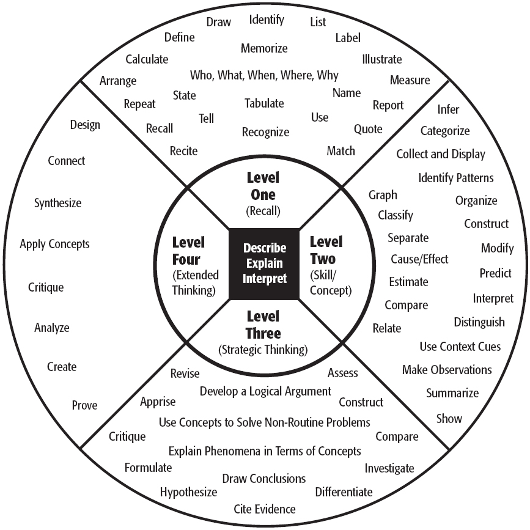

Level One Activities | Level Two Activities | Level Three Activities | Level Four Activities
Recall elements and details of story structure, such as sequence of events, character, plot and setting.  Conduct basic mathematical calculations.  Label locations on a map.  Represent in words or diagrams a scientific concept or relationship.  Perform routine procedures like measuring length or using punctuation marks correctly.  Describe the features of a place or people. | Identify and summarize the major events in a narrative.  Use context cues to identify the meaning of unfamiliar words.  Solve routine multiple-step problems.  Describe the cause/effect of a particular event.  Identify patterns in events or behavior.  Formulate a routine problem given data and conditions.  Organize, represent and interpret data. | Support ideas with details and examples.  Use voice appropriate to the purpose and audience.  Identify research questions and design investigations for a scientific problem.  Develop a scientific model for a complex situation.  Determine the author’s purpose and describe how it affects the interpretation of a reading selection.  Apply a concept in other contexts. | Conduct a project that requires specifying a problem, designing and conducting an experiment, analyzing its data, and reporting results/solutions.  Apply mathematical model to illuminate a problem or situation.  Analyze and synthesize information from multiple sources.  Describe and illustrate how common themes are found across texts from different cultures.  Design a mathematical model to  inform and solve a practical or abstract situation.

