How Batteries Work

A battery is an electrochemical device. It stores chemical energy which can be released as electrical energy when it is needed.
Positive (+)
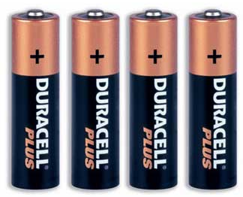

If you look at any battery, you'll notice that it has two terminals. One terminal is marked positive (+), while the other is marked negative (-). In an AA, C or D cell, the ends of the battery are the terminals.

Negative (-)

In a large car battery, there are two heavy lead posts that act as the terminals.
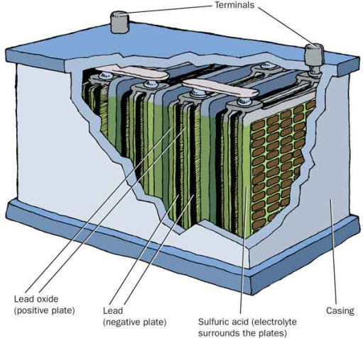

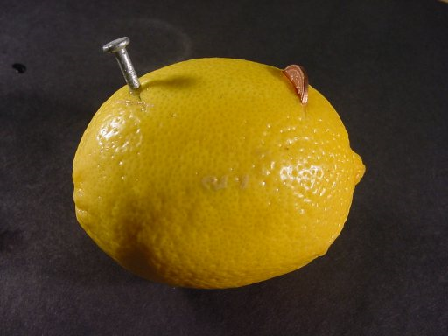
The homemade batteries such as the lemon or film canister, the copper wire and nail act as the terminals.

Positive (+)
Negative (-)
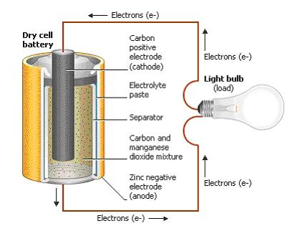
Inside the battery itself, a chemical reaction produces the electrons. The speed of electron production by this chemical reaction controls how many electrons can flow between the terminals. Electrons flow from the battery into a wire, and must travel from the negative to the positive terminal for the chemical reaction to take place.

How to use/read Multi-Meter

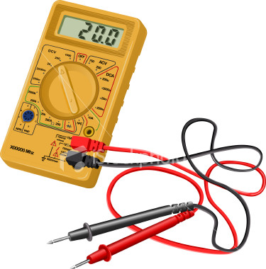
-The dial has the arc shaped scale. The pointer on the dial indicates the values read from the scale.

-The value measured is shown in the digital display.

-The selector switch or knob, allows for the changing of function (volts, ohms, amps) and scale (x1, x10, etc.) of the meter.

-Jacks or openings in the case to insert test leads.

-There are two test leads or probes. Generally, one is black and the other red. The red lead represents positive, while the black represents negative

How to build Alternative Batteries
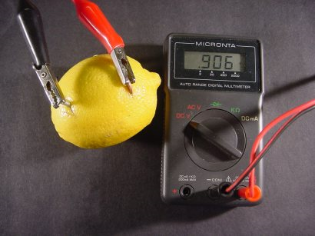
Lemon Battery Materials:

Lemon
Copper Penny
Galvanized Nail
Multi-Meter

- Roll the lemon on the table until the membranes inside have been broken. (Battery runs on the lemon juices acting as the electrolyte)
- Insert the copper penny on one side of the lemon
- Insert the Nail on the opposite side of the lemon
- Put the Multi-Meter on the correct settings (DCV 20v)
- Use the leads and attach the red lead to the penny and the black to the Nail.
- Record the results

Film Canister Battery Materials:

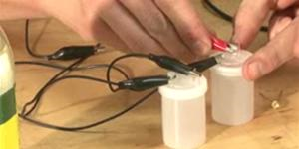
Film Canister
6 inches of Copper Wire
Wire Stripper
Pencil
Galvanized Nail
Vinegar
Water
Multi-Meter

- Take the lid off the film canister and use the nail to poke two holes in the top. The holes should be on opposite sides of the canister lid.
- Shove the Nail halfway through one of the two holes just created.
- Take the six inches of copper wire and strip off the insulation.
- Carefully wrap the copper around the pencil until a coil is formed. Leave about an inch of wire uncoiled and straight
- Take the straight part of the copper coil and stick that through the bottom of the second film canister hole.
- Fill half the canister with water
- Fill the other half with vinegar.
- Put the lid on the canister being careful to keep the copper and nail separate.
- Lightly shake the canister
- Put the Multi-Meter on the correct settings (DCV 20v)
- Use the leads and attach the red lead to the copper and the black to the Nail.
- Record the results.

Additional Resources

Video instructions for Film Canister Battery: http://www.youtube.com/watch?v=FTEfZETJykM

Video instruction for a Lemon Battery:
http://www.youtube.com/watch?v=DXir_ORHOGA

Battery Clinic
http://www.tasbatteryclinic.com/batteryInfo.php

How Stuff works (Batteries)
http://www.howstuffworks.com/battery.htm

How to use a Multi-Meter
http://www.wikihow.com/Use-a-Multimeter

