A Bridge to Nowhere

Introduction:

Cantilevers are widely found in construction, notably in cantilevered bridges and balconies. In an architectural application, Frank Lloyd Wright's Fallingwater uses cantilevers to project large balconies over a stream.
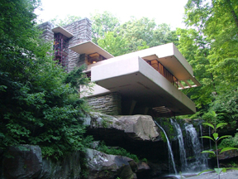
Another use of the cantilever is in fixed-wing aircraft design.
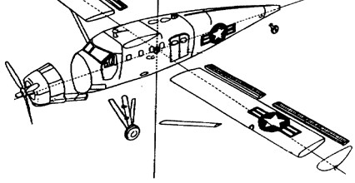

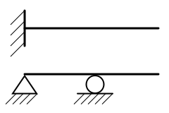
Most cantilevers are created by an extension of a simply supported beam.

Design Challenge:

Working as a member of an engineering design team, design a cantilevered structure that will extend the furthest distance possible from your table that can support the weight of a golf ball.

Design Requirements:

Your cantilever must have a full moment connection (like the diagram below).

Materials:

1 ft. - Masking Tape
2 - 8 ½ x 11 Sheets of Paper
1 ft. - Masonry Line (braided-string)

Additionally, you may use a pair of scissors and a writing instrument.

(*Materials can only be applied to the surface of your table and extend outward. The total horizontal distance of the structure away from the table will be measured.)

*What content and learning standards could you connect to this activity?

