Team Fort Enclosure:
A Cooperative Learning and Problem-based Learning Challenge

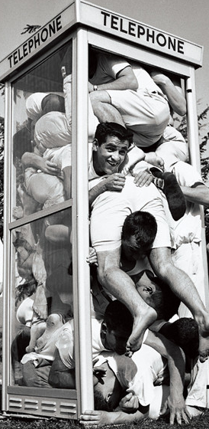
Colleges and universities have long been recognized as institutions that launch crazy fads. I the 1950’s and 1960’s, stuffing as many people as possible into a phone booth was very popular on college campuses. While it was an absurd trend, it did require a great deal of creativity, cooperation, and problem solving ability.
Directions:
In the spirit of phone booth stuffing—and, to test your levels of creativity, cooperative spirit, and problem solving ability, use the Crazy Fort® building materials to build a fort that will enclose your entire problem-solving team.
Limitations:
- The completed fort must have walls and a roof.
- Make sure that the arrows are always pointing upward on the connector balls
- Don’t cut or bend and materials
- Twist the green sticks to insert and remove from the connector balls
- The structure must enclose your entire problem-solving team
- If you can fit more than your team, and you have volunteers; go for it!

Questions: Answer on back of page
- What type of structure did you create?
- Did you find any loopholes that you could exploit? (thinking outside the box)
- What strategies and techniques did you use to design your structure?
- Did your initial design solve the problem, or did you have to move on to Plan B?
- How did your team define the term “enclose?”

