Team Fort Enclosure:
A Cooperative Learning and Problem-based Learning Design Brief

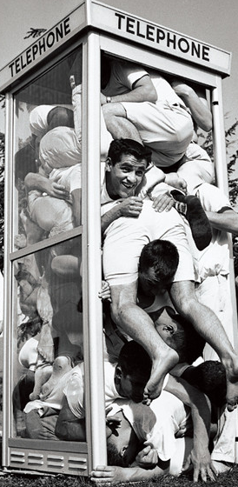
Colleges and universities have long been recognized as institutions that launch crazy fads. I the 1950’s and 1960’s, stuffing as many people as possible into a phone booth was very popular on college campuses. While it was an absurd trend, it did require a great deal of creativity, cooperation, and problem solving ability.
Standards (Grade 2):
STL #8: Students will develop an understanding of the attributes of design
AR.Math.3.MD.C.7: Relate area to the operations of multiplication and addition

Scenario:
In the spirit of phone booth stuffing—and, to test your levels of creativity, cooperative spirit, understanding of area, and problem solving ability, use the Crazy Fort® building materials to build a fort that will enclose your entire problem-solving team.
Challenge:
Work as a member of a design team to build a fort that will enclose your entire team. Then calculate the area of the fort. Use your creative abilities to make the largest fort possible.

Big Ideas:
- The area of a space can be determined by multiplying the side lengths of a volume.
- Area models can represent the inner size of an object
- The perimeter of an object can be calculated using the side lengths

Essential Question: How can we determine the area of a space enclosed in a scale model structure?

Limitations:
- The completed fort must have walls and a roof.
- The connector ball arrows must always point upwards
- Materials must not be cut or bend
- Twist the green sticks to insert and remove from the connector balls
- The structure must enclose your entire problem-solving team
- If you can fit more than your team, and you have volunteers; build the biggest fort in class!

Questions: Answer on back of page
- What type of structure did you create?
- Did you find any loopholes that you could exploit? (thinking outside the box)
- What strategies and techniques did you use to design your structure?
- Did your initial design solve the problem, or did you have to move on to Plan B?
- How did your team define the term “enclose?”
- Calculate the area of your fort. Is it larger or smaller than the other teams in your class?
Teacher’s Guide:
Team Fort Enclosure is designed to introduce your students to the concept of area and provide them with a change to build a scale model, of their own design, and then calculate area. Assign the students to small teams and ask them to create an enclosure that will encapsulate their entire team. Encourage them to make the largest enclosure in class—they can get volunteers from other teams if their enclosure will accommodate more people than they have on their team. After the enclosures are complete, spend some time illustrating the procedures used to calculate area. After all teams have calculated area, ask each team to present their fort enclosure and then test all enclosures to determine whether the team fort can contain all members of the team. Encourage them to keep testing by adding additional students until no more can fit inside the enclosure. Discuss the relationship between area and the number of students who can fit inside the enclosure. Discuss large and small rooms in the school in the context of area. You may wish to reward the team that designs the fort that encloses the most students, our use this activity as an introduction to a larger unit on area.

