Geometric Creatures

We have been studying various geometric shapes. Think about the shapes you see in people and animals.

Design Challenge:
Create a two-dimensional creature that has two moving parts.

Limitations/Constraints/Criteria: Your creature must have -
- At least 5 different shapes
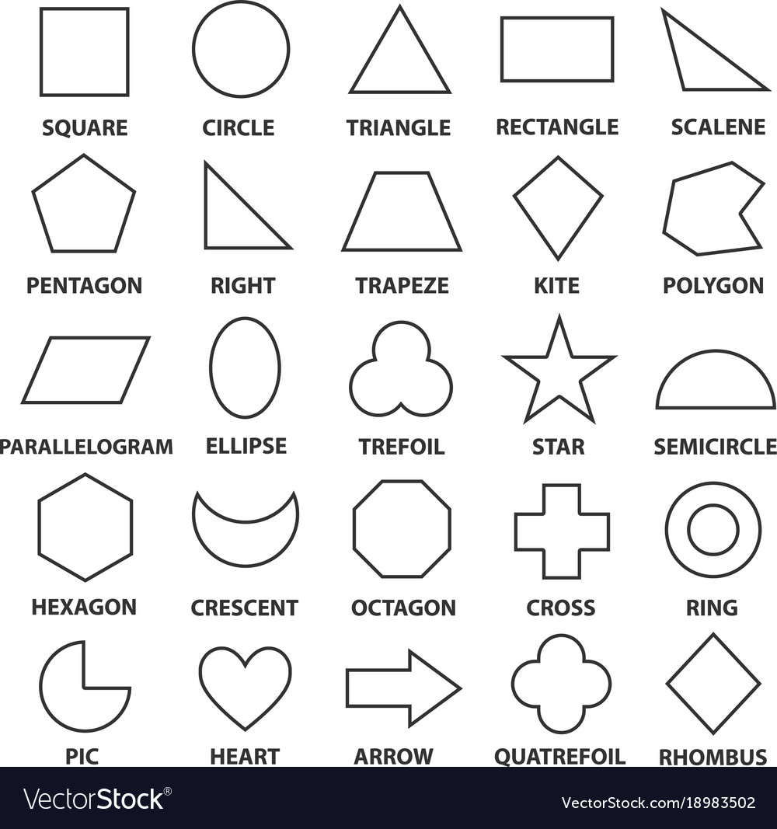
- No more than 20 shapes in all
- Two moving parts (levers)

Materials:
- Paper
- Glue stick
- 4 paper fasteners

Tools:
- Hole punch
- Scissors
- Ruler

What’s Next:
Make up a story about your creature to share with the class!

