Rocket Launch Design Challenge
Materials: Straws (2 different sizes), tape, construction paper, cap eraser, Play-Do Tools: scissors, rulers
Challenge: Design a model rocket using the materials provided and your lungs to launch the rocket. You will have three attempts to get your rocket to go the greatest distance possible.
- What can you use to launch your rocket?
- Can you add fins to your rocket?
- If you add weight to the rocket, will it go further?
- How will you make sure that your rocket flies straight?



Rocket Launch Design Challenge
Materials: Straws (2 different sizes), tape, construction paper, cap eraser, Play-Do Tools: scissors, rulers
Challenge: Design a model rocket using the materials provided and your lungs to launch the rocket. You will have three attempts to get your rocket to go the greatest distance possible.
- What can you use to launch your rocket?
- Can you add fins to your rocket?
- If you add weight to the rocket, will it go further?
- How will you make sure that your rocket flies straight?

Make Some Noise Design Challenge
Materials: Straws, cardboard tubes, wax paper, rubber bands, craft sticks, plastic sheet. Tools: scissors, rulers
Challenge: Your teacher lost her whistle and the students won’t know when recess is over. Design a whistle or some type of noisemaker to alert the students that recess is over. You will have three attempts to make the loudest noise in class.
- Can you make something vibrate when wind is blown across?
- Can you make a horn or a drum?
- Can you fold something over and blow across it to create noise?
- What other techniques could be used to make noise?

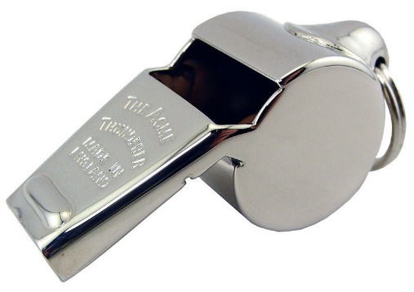

Make Some Noise Design Challenge
Materials: Straws, cardboard tubes, wax paper, rubber bands, craft sticks, plastic sheet. Tools: scissors, rulers
Challenge: Your teacher lost her whistle and the students won’t know when recess is over. Design a whistle or some type of noisemaker to alert the students that recess is over. You will have three attempts to make the loudest noise in class.
- Can you make something vibrate when wind is blown across?
- Can you make a horn or a drum?
- Can you fold something over and blow across it to create noise?
- What other techniques could be used to make noise?

Through the Mountain Design Challenge
Materials: 100 Keva planks, wind-up toy, one sheet of paper Tools: scissors, rulers
Challenge: You have to get from one side of the mountain to the other, and it would take too long to go around the mountain. Design a 11” long tunnel to go through the mountain and get to the other side. You will have three attempts to get a wind-up toy all the way through your tunnel to the other side. The wind-up toy must make it through the tunnel without knocking the tunnel over.
You will have three attempts to get a wind-up toy all the way through your tunnel.
- How large should you make the tunnel?
- How large is the wind-up toy?
- Which wind-up toy would be best for your tunnel?
- How can you make sides and a top for your tunnel?
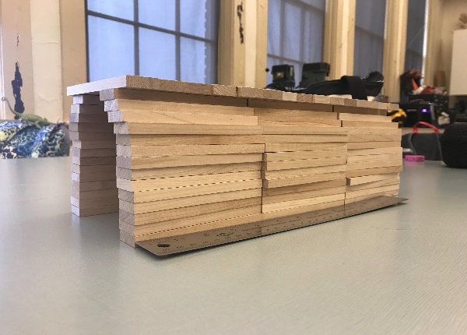

Through the Mountain Design Challenge
Materials: 100 Keva planks, wind-up toy, one sheet of paper Tools: scissors, rulers
Challenge: You have to get from one side of the mountain to the other, and it would take too long to go around the mountain. Design a 11” long tunnel to go through the mountain and get to the other side. You will have three attempts to get a wind-up toy all the way through your tunnel to the other side. The wind-up toy must make it through the tunnel without knocking the tunnel over.
You will have three attempts to get a wind-up toy all the way through your tunnel.
- How large should you make the tunnel?
- How large is the wind-up toy?
- Which wind-up toy would be best for your tunnel?
- How can you make sides and a top for your tunnel?

Skyscraper Design Challenge
Materials: 15 craft sticks, 4 sheets of paper, one can of Play-Do, 1 golf ball. Tools: scissors, rulers
Challenge: Design the tallest tower that will support the weight of a golf ball.
You will have three attempts to get a wind-up toy all the way through your tunnel.
- How tall can you make the tower and still hold the ball?
- How wide should your tower be so that it does not fall over?
- How can you connect the materials to make the tower tall?
- How can you attach the golf ball?

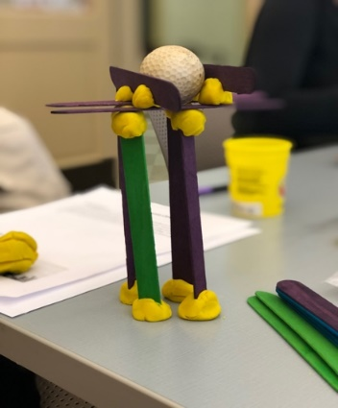

Skyscraper Design Challenge
Materials: 15 craft sticks, 4 sheets of paper, one can of Play-Do, 1 golf ball. Tools: scissors, rulers
Challenge: Design the tallest tower that will support the weight of a golf ball.
You will have three attempts to get a wind-up toy all the way through your tunnel.
- How tall can you make the tower and still hold the ball?
- How wide should your tower be so that it does not fall over?
- How can you connect the materials to make the tower tall?
- How can you attach the golf ball?

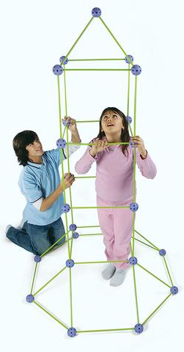

Work with your team and use the Crazy Forts blocks to build the tallest tower possible in the time available.
Make sure that the arrows on the purple blocks are always pointing upward.
Twist the green sticks to lock them into place in the purple fasteners.
Don’t bend the green sticks.
Have fun!
When you’re finished, have one of the teachers measure your tower to see how tall you’ve built.

Work with your team and use the Crazy Forts blocks to build the tallest tower possible in the time available.
Make sure that the arrows on the purple blocks are always pointing upward.
Twist the green sticks to lock them into place in the purple fasteners.
Don’t bend the green sticks.
Have fun!
When you’re finished, have one of the teachers measure your tower to see how tall you’ve built.

Through the Mountain Design Challenge
Materials: 100 Keva planks, wind-up toy, one sheet of paper
Challenge: You have to get from one side of the mountain to the other, and it would take too long to go around the mountain. Design an 11” long tunnel to go through the mountain and get to the other side. You will have three attempts to get a wind-up toy all the way through your tunnel to the other side. The wind-up toy must make it through the tunnel without knocking the tunnel over during the time available.
You will have three attempts to get a wind-up toy all the way through your tunnel.
- How large should you make the tunnel?
- How large is the wind-up toy?
- How can you make sides and a top for your tunnel?

Through the Mountain Design Challenge
Materials: 100 Keva planks, wind-up toy, one sheet of paper
Challenge: You have to get from one side of the mountain to the other, and it would take too long to go around the mountain. Design an 11” long tunnel to go through the mountain and get to the other side. You will have three attempts to get a wind-up toy all the way through your tunnel to the other side. The wind-up toy must make it through the tunnel without knocking the tunnel over during the time available.
You will have three attempts to get a wind-up toy all the way through your tunnel.
- How large should you make the tunnel?
- How large is the wind-up toy?
- How can you make sides and a top for your tunnel?

Paper Chain Quick Challenge
Materials: one piece of construction paper, glue stick Tools: scissors, yardsticks
Quick Challenge:
Create a paper chain using a single sheet of construction paper. Your goal is to make the longest chain possible using a limited amount of materials. You are only allowed to use one sheet of paper.
How can we make the paper chain as long as possible?

When you’re finished, have one of the teachers measure your tower to see how tall you’ve built.

Paper Chain Quick Challenge
Materials: one piece of construction paper, glue stick Tools: scissors, yardsticks
Quick Challenge:
Create a paper chain using a single sheet of construction paper. Your goal is to make the longest chain possible using a limited amount of materials. You are only allowed to use one sheet of paper.
How can we make the paper chain as long as possible?

When you’re finished, have one of the teachers measure your tower to see how tall you’ve built.

The Learn Lever
Materials: 66 golf balls, large lever
Challenge: This lever is balanced in the middle on a fixed support, or fulcrum. The lever can become quickly unbalanced by having varying weights of golf balls in the baskets or by moving the fulcrum away from the center. Your challenge to discover how many golf balls are required to balance the lever when the fulcrum is placed at varying distances from the center.
You will make predictions on how many golf balls are required to balance the lever.
- How many golf balls do we need to add to the other basket to balance the lever?
- Was your prediction accurate?
- How do you know that the lever is balanced?
- What happens when you move the fulcrum in relation to the center?

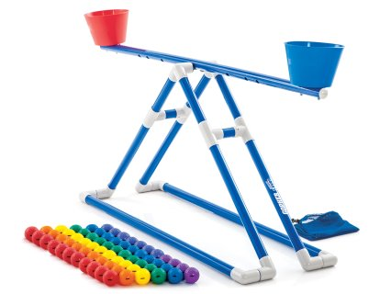
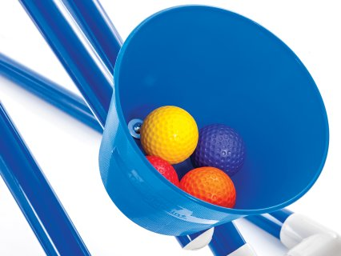

The Learn Lever

Materials: 66 golf balls, large lever
Challenge: This lever is balanced in the middle on a fixed support, or fulcrum. The lever can become quickly unbalanced by having varying weights of golf balls in the baskets or by moving the fulcrum away from the center. Your challenge to discover how many golf balls are required to balance the lever when the fulcrum is placed at varying distances from the center.
You will make predictions on how many golf balls are required to balance the lever.
- How many golf balls do we need to add to the other basket to balance the lever?
- Was your prediction accurate?
- How do you know that the lever is balanced?
- What happens when you move the fulcrum in relation to the center?

KEVA DESIGN CHALLENGE
QUICK CHALLENGE: An engineering firm has asked you and your teammates to construct the widest tower possible. One of the limitations for your design is the size of the foundation. Design and construct a model for your tower using KEVA blocks.

LIMITATIONS: You may only use one block for the base or foundation of your tower.

MATERIALS: KEVA Blocks (120 per group), measuring tape

KEVA DESIGN CHALLENGE
QUICK CHALLENGE: An engineering firm has asked you and your teammates to construct the widest tower possible. One of the limitations for your design is the size of the foundation. Design and construct a model for your tower using KEVA blocks.

LIMITATIONS: You may only use one block for the base or foundation of your tower.

MATERIALS: KEVA Blocks (120 per group), measuring tape

Marble Run
Goal: Work as a team to roll a marble across a given course without touching the marble or letting it touch the floor. Each team member will receive a differing length of track. Your Group will decide the best way to move the marble from start to finish without touching it. The team that moves the marble the fastest wins.
Rules:
- Team members cannot move their feet while the marble is in their individual piece of track.
- The marble must stay on the panels-no throwing, tossing, etc.
- If the marble drops to the floor, or a team member touches the marble in any way, the team must start over.
What you Need:
- Four pieces of guttering of differing lengths
- One marble for each team
- A stop watch or a mobile phone for keeping time
- A course with a start-point and an end-point—described by the teacher

Questions:
- What was the most effective way you saw the marble travel?
- Would you change your design or idea in any way for next time?
- Sketch your design of the gutters and the path of the marble

Marble Run
Goal: Work as a team to roll a marble across a given course without touching the marble or letting it touch the floor. Each team member will receive a differing length of track. Your Group will decide the best way to move the marble from start to finish without touching it. The team that moves the marble the fastest wins.

Rules:
- Team members cannot move their feet while the marble is in their individual piece of track.
- The marble must stay on the panels-no throwing, tossing, etc.
- If the marble drops to the floor, or a team member touches the marble in any way, the team must start over.
What you Need:
- Four pieces of guttering of differing lengths
- One marble for each team
- A stop watch or a mobile phone for keeping time
- A course with a start-point and an end-point—described by the teacher

Questions:
- What was the most effective way you saw the marble travel?
- Would you change your design or idea in any way for next time?
- Sketch your design of the gutters and the path of the marble

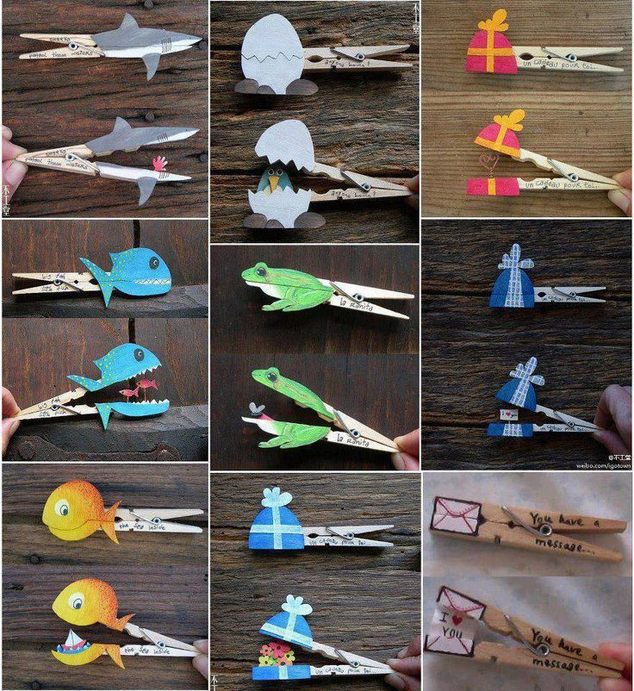
Clothes Pin Creatures (Automata)

QUICK CHALLENGE: Design a creature using simple materials and a clothes pin. How can you bring your creature to life using the clothespin?
MATERIALS: Clothes pin, construction paper, fuzzy sticks, glue sticks, markers

Creatures (Automata)

QUICK CHALLENGE: Design a creature using simple materials and a clothes pin. How can you bring your creature to life using the clothespin?
MATERIALS: Clothes pin, construction paper, fuzzy sticks, glue sticks, markers

