Drawing a Circuit Quick Challenge

Big Ideas:
- Electrical circuits
- Transferring energy

Quick Challenge:
How can a pencil conduct electricity?

Create the following circuit using only a sheet of paper, a pencil, and LED, and a battery.

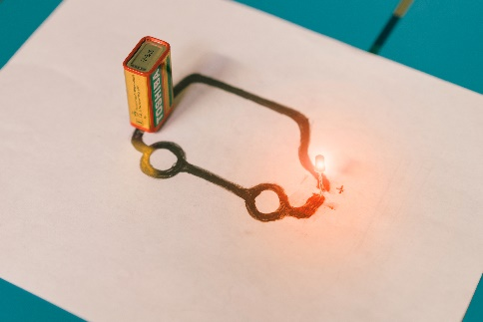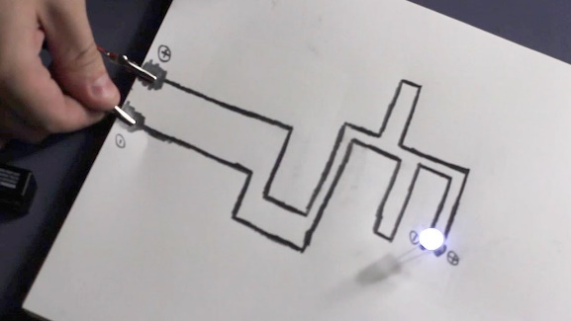

Methodology:

The teacher will demonstrate how you can create a simple electrical circuit using paper, a pencil, a 9 volt battery, and an LED.
Working with a partner, students will create their own paper circuit. What shapes can you create that will light up an LED?

*Be sure not to touch the LED directly to the 9 volt battery

Materials:
- Soft drawing pencil (6B is best)
- Paper or a note card
- LED (light emitting diode)
- 9-volt battery

Optional Materials (if needed)
- 9 volt snap connectors
- 330 ohm resistor
- Two insulated wire leads

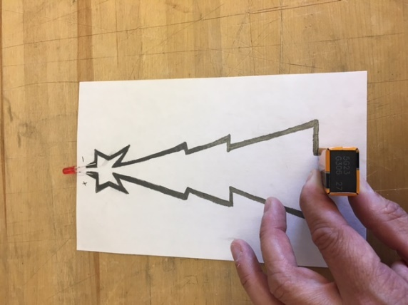
Student Feedback:
What other type of circuit can you create with these materials?

What are the essential components of an electrical circuit?

What, exactly, is a short circuit? What does it mean if a circuit becomes shorted? How does this differ from an open circuit?

What type of material is a good insulator?

What type of material is a good conductor?

Content Outline:

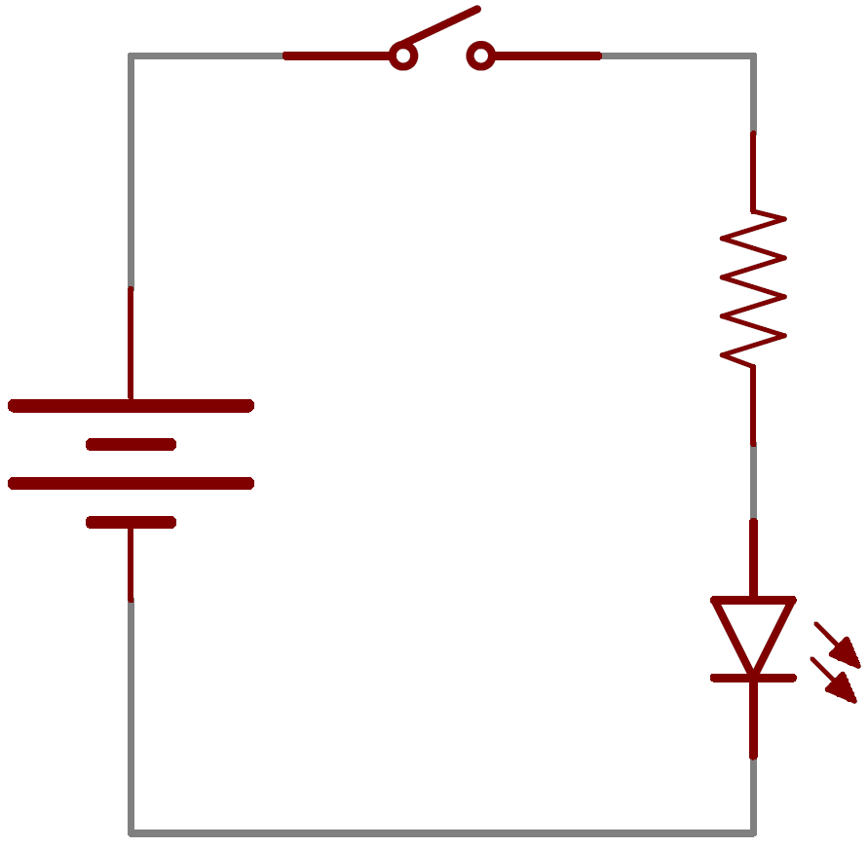
Electrical current is the flow of charge. A switch interrupts the flow of electrons in an electrical circuit. When the switch is connected, electrons flow from the anode (positive/top of battery) to the cathode (negative) at the bottom of the battery and return to the positive pole.

The illustration is a diagrammatic form (i.e. circuit diagram or schematic) used to illustrate an electrical circuit. The two parallel lines of different lengths marked battery actually represent a single cell. Single cells supply 1.5 volts and are what we generally mean when we say a battery (e.g. "I must change the batteries in my flashlight"). Technically, a battery is a series of single cells joined together to provide a greater voltage in, for example, a car battery.

The battery provides the electromotive force (or e.m.f.) that "pushes" the electrons through the wires of the circuit. Electromotive force is measured in volts. In some ways it is similar to the potential energy stored in an object at the top of a hill. The object might roll down the hill and lose its potential energy and, in an analogous way, the electrons flow down the voltage drop (or potential difference) as they move around the circuit.

As the switch is turned on, the light bulb ignites (lights up). When the circuit is closed, by throwing the switch, the battery forces those electrons to flow around the wire, thereby creating the current.

Extension Activities:

Build a simple circuit that resembles the one below using coated copper wire, a resistor, an LED, a 9 volt battery, and tape (tape the circuit to a sheet of paper, cardboard, or foam core).

Now add a switch: Make the switch using construction paper or cardstock, tape, and aluminum foil. You can also make the switch using a paperclip or safety pin, nails, and a block of wood (see pictures below).

Larger STEM Challenge - We will actually complete this larger STEM challenge later in the semester.

Now, do some research that will help you develop a very creative solution to the upcoming electricity assignment. Borrow ideas -but use your creativity to make them your own! When you’re finished, you want people to say, “Wow! I’ve never seen anything like that—did you create that?”

Teacher candidates will work in assigned teams to develop a holiday-themed classroom activity that delivers basic electricity content. The activity should be suitable for 4th grade students and help them develop an understanding that energy can be transferred from place to place by electrical currents.

The best teachers are always looking for a way to tie classroom learning to upcoming events/holidays that students are anticipating—i.e., Thanksgiving, Christmas, etc. This provides a natural hook for the students and typically provides the student with something that can be taken home and placed prominently on the refrigerator door! Remember making a Thanksgiving turkey from a trace of your hand during elementary school? In this case, you are being asked to develop a holiday-themed activity that both represents an upcoming holiday or community event and an introduction to basic electricity. You are welcome to utilize a traditional holiday craft item, but you must also find a way to electrify the activity. As we have learned in this class, it is not enough to simply a purchase a clever craft item at the flea market and then have your students replicate that item in class. ALL ACTIVITIES MUST DELIVER A BIG IDEA and in this case, they must deliver integrated STEM education!

