Geometric Creatures

We have been studying various geometric shapes. Think about the shapes you see in people and animals.

Design Challenge:
Create a two-dimensional creature that has a minimum of two moving parts.

Limitations/Constraints/Criteria: Your creature must have -
- At least 5 different shapes
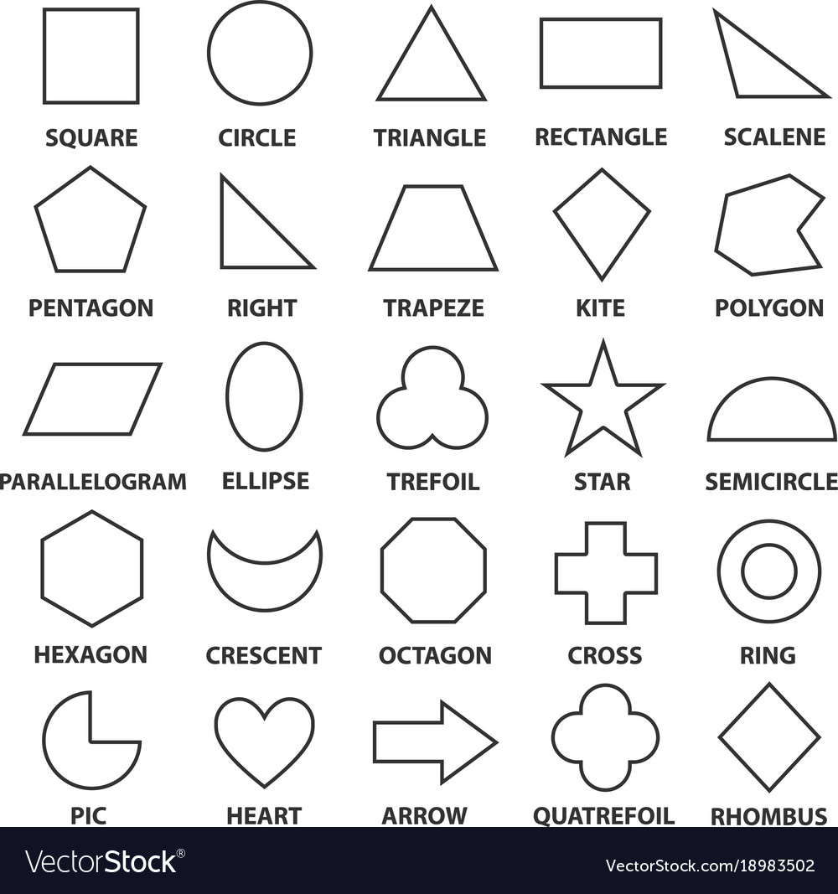
- No more than 20 shapes in total
- Two moving parts (levers)

Materials:
- Paper
- Glue stick/white glue
- 4 paper fasteners
- Crayons, markers, colored pencils

Tools:
- Crop-a-Dile or Hole punch
- Scissors
- Ruler

What’s Next:

Make up a story about your creature to share with the class!

Due February 2 –

- Completed Geometric Creature
- Story describing your creature and presentation sharing the story and showing the function of your creature’s moving parts.

