Remaking a Common Object -
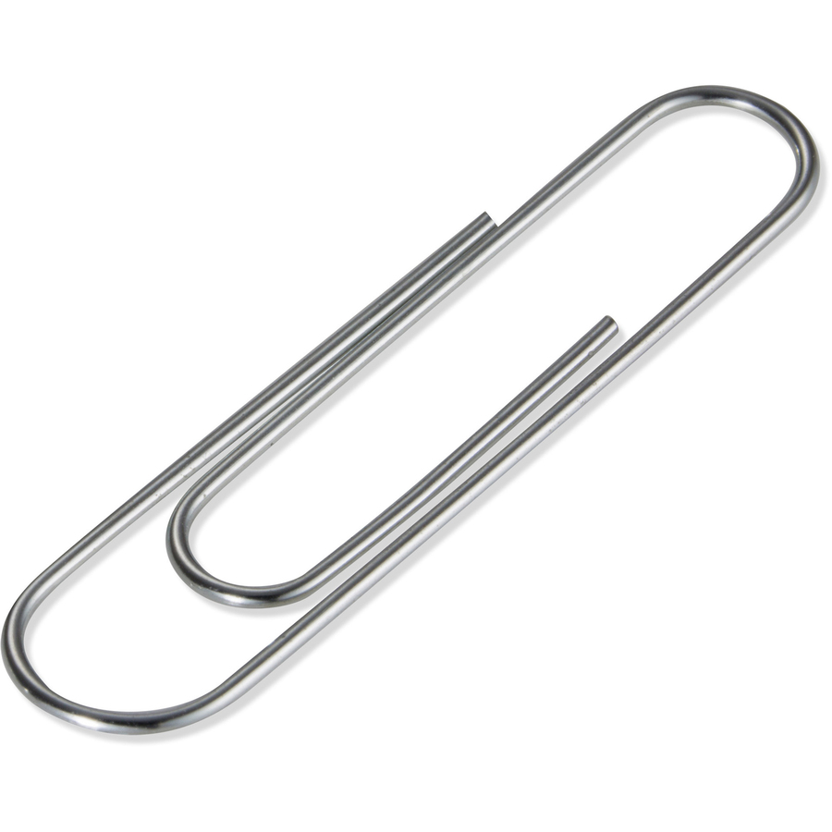

The Paper Clip

How would the paper clip be different if it were made with different materials?

What would change if multiple paper clips were connected (together)?

What other uses might we have for this tool?

Inventing a New Kind of Pencil
So you want to do some inventing? Well then, take a look at the average pencil you find on the floor of the classroom and consider how it could be improved.
Figure 1. Sad looking pencil

What’s wrong with this pencil (some typical replies): Small, ugly, no eraser, needs sharpening, made out of wood—which breaks, can't see inside and how it works, can't write on chalkboard, not made of steel—strong, wears away too fast, lead always breaks, can't eat it, easy to lose, not interesting, not decorated, too skinny, too fat.

How can we improve this pencil? (What new features can we add to make it more useful?) Here are some typical ideas: Put an eraser on both ends, make the eraser bigger, change the color, make it longer, get a new one, make it fatter, make it skinnier

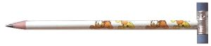
Figure 2. Hammer headed pencil

What might be some advantages and disadvantages of the pencil depicted in Figure 2?

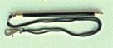
Figure 3. Pencil with String

What might be some advantages and disadvantages of the pencil depicted in Figure 3?

Figure 4. Magnifier Pencil.
What might be some advantages and disadvantages of the pencil depicted in Figure 4?

. 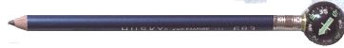
Figure 5. Compass Pencil

What might be some advantages and disadvantages of the pencil depicted in Figure 5?

The Problem: Pencils have not evolved much since they were invented hundreds of years ago. Surely, someone as brilliant as you could improve on this tired old invention! Using your critical thinking skills, create a better pencil by answering the design questions below and questions of your own creation:

- How could the pencil be improved using only simple tools and fabrication techniques?
- What features from other familiar tools could be added to improve the pencil?
- How could I create more “curb appeal” for the pencil?
- What is the most people would pay for an improved pencil?

The Challenge: Working individually, create an improved pencil that incorporates more than one feature beyond writing and erasing.

Resources: A pencil and any other materials or devices you can locate.

Limitations: Individuals will be required to remain within the following design parameters while completing the design challenge:
- Individuals must complete the four steps included in the Design Log (next page) prior to beginning construction.
- Individuals must provide responses to all of the questions outlined above and submit them with the completed design log and prototype.
- The prototype should be constructed in a neat fashion (no one wants to purchase untidy pencils).
- Teams will have a total of fifty minutes to complete the Design Log, construct the prototype, conduct a trial of the device, and record the data in the Assessment Rubric.

Objectives: After completing the lesson, students will illustrate a greater understanding of the role of creativity in the development of new technologies.

Curriculum Standards: Standards for Technological and Engineering Literacy (#2, 5, 7)

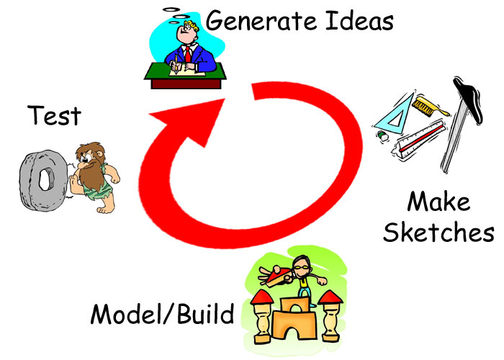
The Design Log: Complete each of the steps outlined
below as you work to create a prototype.

Generate Ideas: Carefully consider
the challenge that you have been given.
Generate and record as many ideas as
possible during the limited time you
have been provided. Record your
initial ideas in the spaces below:

Sketches: Using the initial, create a final drawing that includes the best ideas from all of the initial ideas.

Modeling/Testing: Use the sketch (above) to construct the prototype. Test your product.
Pencil Assessment Rubric

Team Names: ________________________________ Date: __________________

Rating: 5 = Excellent/1 = Needs Improvement

1. Completion of Design Log 5 4 3 2 1
2. Neatness of final Product 5 4 3 2 1
3. Functionality of final product 5 4 3 2 1
4. Written Discussion Questions 5 4 3 2 1

Total Points: ____________________

