Keen on STEM
Yay for STEM! We will be zooming Friday, March 5th at 4:00. In that zoom, Cypress will be building the junk bot step by step and Mrs. Keen will be answering questions in the chat. NOTE: You will follow the engineering design process to design, build, and test your robots. Your objective is to build a robot that can travel in a straight line for at least 5 feet. See introduction video here. There is no single "correct" design for the robot, and their robot will probably not work on the first try. You will need to iteratively modify and retest your robot to get it working.
Join Zoom Meeting
https://fayar.zoom.us/j/91891798872?pwd=TXN1Q2JFbjBYYTVyQlRDcnJ0TVg4dz09
Zoom Meeting ID: 918 9179 8872
Zoom Passcode: 089219298938

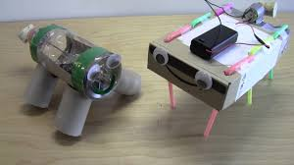
Materials included in this kit:
- 1 small motor
- 1 motor mount (optional)
- 1 on-off switch (optional)
- 1 battery pack
- 1 roll electrical tape
- 2 AA batteries
- 4 straws
- 3 pipe cleaners
- 2 googly eyes
You will need:
- Junk/Recyclables to build your Junk Bot. Junk Bots will need to be made before the zoom if you want to participate in the race.
- An open space where you have marked a start line and a spot 5 feet from that line.

Today’s activity will require you to make both a junk bot and a circuit with a motor and battery pack to power the junk bot. A circuit is a complete path around which electricity can flow. It must include a source of electricity, such as your two AA batteries. Materials that allow electric current to pass through them easily, called conductors (for us, that will be the red and black wires), can be used to link the positive and negative ends of a battery, creating a circuit. The power just flows out of the battery and through the wire to power the small motor.
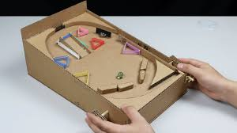
We will be focusing on building the circuit in the zoom. I would suggest making your junk bot ahead of time so that you can attach the motor to it once it is completed. You will use your own materials for the Junk Bot, but there will be googly eyes, pipe cleaners, and straws in the kit for you as well.
Be on the lookout! We will be bringing more STEM fun your way:
- Friday, April 9th- Cardboard Games
- Friday, May 7th- Robot Hands
See you soon! - The Keen’s

Keen on Stem: Junk Bots
Introduction
Today, we are going to build junk bots and then race them. We will see who's junk bot can get to the 5 foot line the fastest! You will need to build your junk bot BEFORE the zoom in order to participate in the race. Remember, you may have to modify and adjust your design today. That is something that engineers do every day. Watch intro video here.

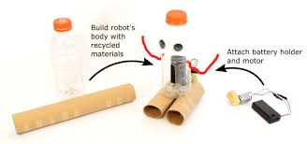
In the zoom, we will:

Step 1: Build Your Junk Bot’s Body Before the Zoom
1. Collect trash and recyclable materials which you think could make a good junk bot. Here are some examples:
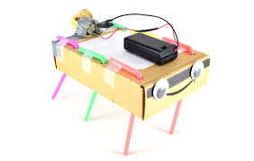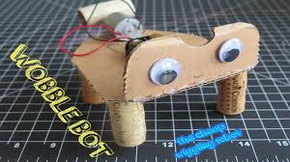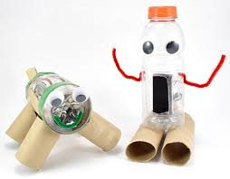
2. Think about your design before you start building. Your goal will be to get your junk bot to move forward in a straight line 5 feet.You may want to sketch your design out first.
3. Gather materials and build the body of the robot. THERE IS NO SET DESIGN FOR YOU TO USE. YOU ARE PUTTING TRASH TOGETHER TO MAKE YOUR OWN DESIGN.

Step 2: Assemble the Circuit
1. Make sure the battery pack's switch is in the OFF position.
2. Insert two AA batteries into the battery pack, as shown in Figure 3. Make sure the "+" signs on the batteries line up with the "+" signs in the battery pack. Note that our battery packs have no covers even though the ones in the pictures do!
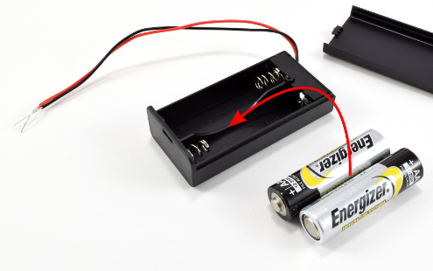
3. Tightly twist together the exposed metal parts of the red wires from the battery pack and motor, as shown in Figure. You should be able to gently tug on the wires without them coming apart.
4. Repeat step 5 for the black wires, as shown in Figure.
5. Firmly press a cork onto the motor's shaft, as shown in Figure 4 Make sure the cork is off-center so it will vibrate.
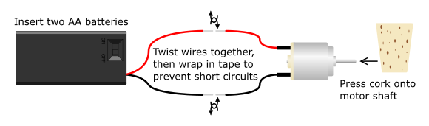
6. Make sure the exposed metal parts of the red and black wires are not touching each other. Hold the motor with one hand and as you connect the wires to make sure that everything is working properly. The cork should spin and make the motor vibrate. This is because you have formed a closed circuit, allowing electrical current to flow in a loop from the battery pack through the motor.
7. Briefly touch the exposed metal parts of the red and black wires together. This creates a short circuit and the motor should stop spinning. Short circuits can cause the battery pack to get hot, and should always be avoided.
8. Disconnect one set of the wires. This creates an open circuit and the motor stops spinning because there is no longer a complete path for electricity to flow. (Optional- You may choose to add the on/off switch here).
9. In order for your robot to function properly, you need to make sure you have a closed circuit. Take one of the batteries out of the battery pack. Now, make sure the wires are tightly twisted together, to avoid open circuits from the wires coming loose. Then, wrap the exposed metal parts of the wires in electrical tape, to avoid short circuits if the wires bump into each other.

Step 3: Attach the Motor to the Junk Bot
1. Attach the motor and battery pack to the robot's body. You may want to use the electric tape and you can even use the motor mount included in the kit if needed.
2. Make sure you do not glue or tape the battery pack all the way shut, since eventually you may need to replace the batteries.
3. Make sure the cork can spin freely without getting stuck against the robot's body.
4. Make sure the wires will not get tangled with the cork when it spins.

Step 4: Test Your Junk Bot
1. Take the robot to an area where it may freely move forward at least 5 feet. Put it on the floor, and place your batteries back in or turn the switch on. Observe how the robot moves.
Is it fast or slow?
Does the robot spin in circles, move randomly, or go straight?
Does the robot fall over or stay upright?
Does the robot's body stay together or do any pieces fall off?
2. Based on your observations, you may want to work on modifying and improving your designs. In general, robots with light, stiff bodies and legs that are all slanted in one direction will work the best. Robots that are very heavy or very flexible will generally be slow because the body will absorb all the vibrations from the motor. Robots that have a flat surface contacting the ground or legs that point straight down (or in different directions) will tend to move randomly or spin in circles. Remember that it is OK if your robot does not work on the first try. The engineering design process is iterative. They will need to test, modify, and retest your designs in order to improve them and meet the objective of building a robot that can go straight for 5 feet. Ask yourself: What have you observed about your robot so far? How does the robot move? Do certain designs or materials seem to work better than others? What changes can we make to the robot so it goes straight?

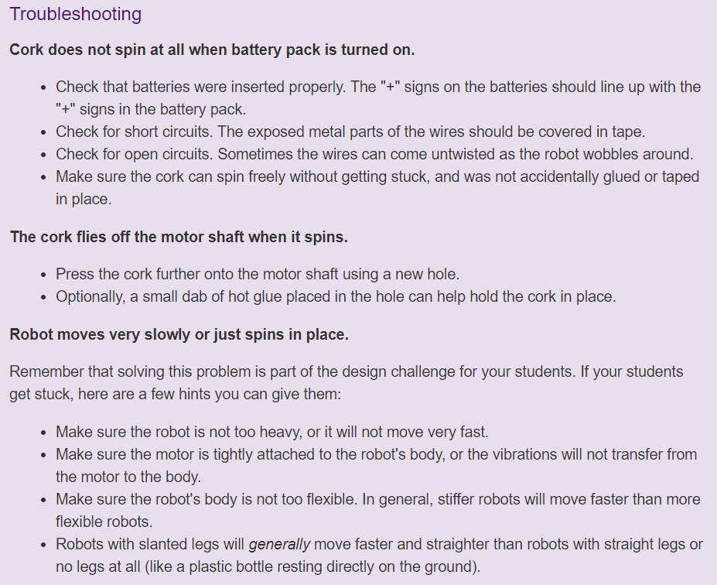

Step 5: Race Your Junk Bot
1. Take the robot back to the area on the floor and mark a spot which is 5 feet away from the starting point of your robot. We will all start our robots at the same time and see whose can get to the 5 foot mark the fastest!



