Converting an Image to Vector in CorelDRAW

- Import the Image in a New File by going to the File Menu, choose Import, select Image and click Import button.

- Now place the image on the page by clicking.

- In the Property bar click on Trace Bitmap and choose Quick Trace (or try one of many of the tracing options). The image has now been converted to Vector. At this point you can Ungroup the vectors and select Create Boundary to use the outline of a shape or image.
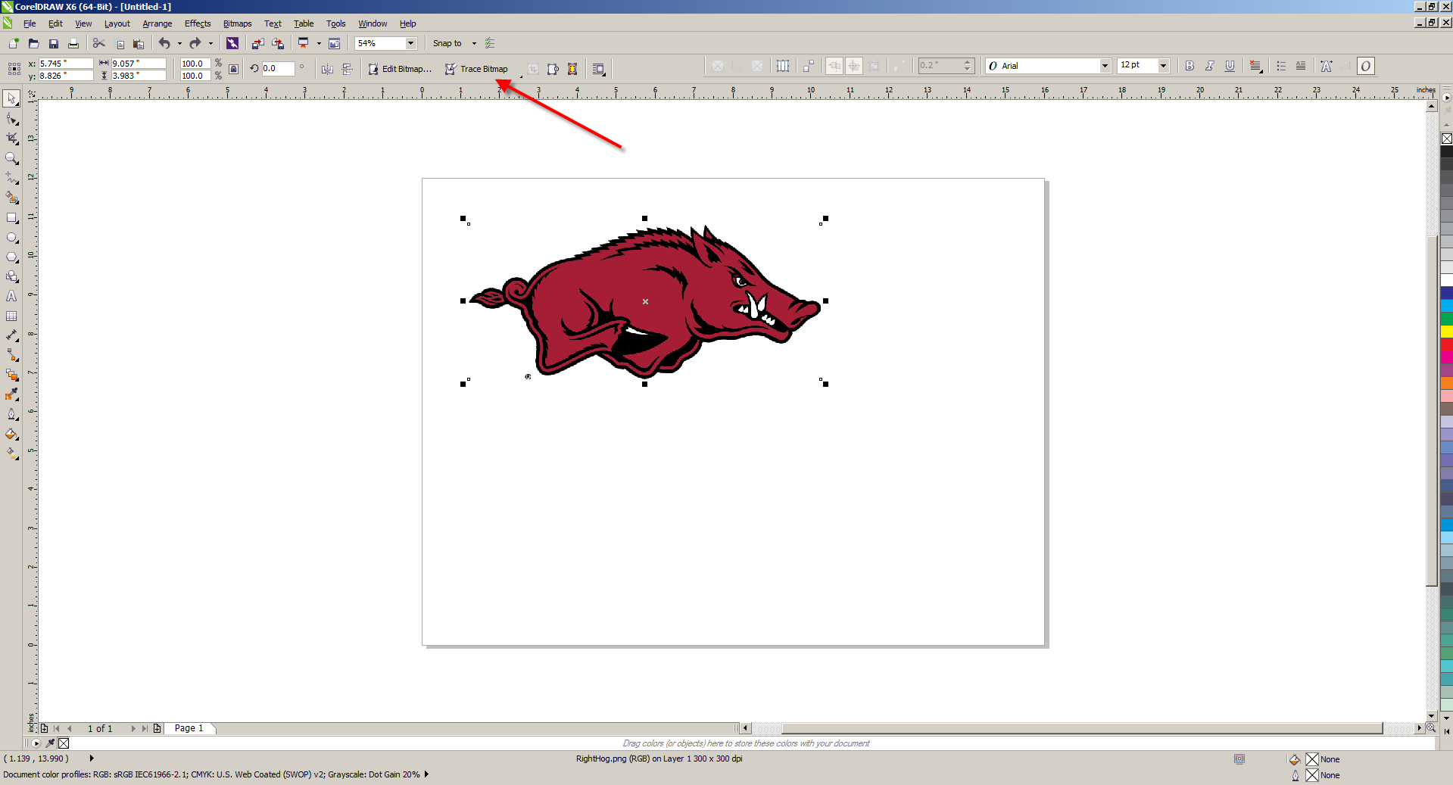
- You can now save your file in CDR format to be edited later. You may also export an EPS format from CorelDRAW by going to File Menu and choosing Export which open the Export Dialog. Choose EPS from the dropdown and hit the Export button.
To learn more about Vector Tracing see: https://www.coreldraw.com/en/tips/vector-images/vector-tracing/

